Black Dog Meet

No. 120 Knoydart

Friday 20th - Monday 23rd April 2012

In Attendance
Charles Alexander David Cameron
Valerie Inglis Kirsty McLaren
George Norman John Pickering
Andy Robb Alan Sewell
Lorna Smith Tony Smith

Mountains Climbed

Saturday All Present Ladhar Bheinn (1020m)
Valerie and Sgurr Coire Choinnichean (796m)

Sunday Valerie, David, George,
Andy & Tony Meall Buidhe (946m)

Valerie & Tony and Luinne Bheinn (939m)

Charles & Alan Sgurr Coire Choinnichean (796m)

Weather

The weather was very good. Most hills were clear throughout although there were the odd pockets of cloud on the summits. Very occasional rain showers.

Notes / Highlights

Actually getting to Inverie is always a significant part of the weekend and this trip was no different. The crossing was beautifully calm and the dolphins added to the superb views. Unfortunately a communication issue meant that our pier-to-hostel luggage transport failed to appear but thanks to a neighbour and the postie/warden almost all was eventually resolved. (A bag and boots unfortunately left at pier head!)
The hostel was not the best with rather limited kitchen facilities, very restricted drying arrangements (fortunately not needed) and a non-user-friendly layout (through kitchen to dorm and outside to facilities).
The best meal of the weekend was undoubtedly that which we provided for ourselves (despite the broken cooker!). Thanks to all who contributed. In contrast the food in the pub was rather disappointing, and definitely not up to previous standards. (Still has good beer and ‘interesting’ local entertainment though)

Saturday
A rare and welcome event today: The arrangement that we all climbed the same hill! In this case a great circular route on Ladhar Bheinn. Easy going initially north from the village to Gleann na Guiserein (even easier for the Lodge guests in the Landrover) then direct to An Diollaide on steep grass. The ridge to the summit thereafter was straightforward and gave fantastic 360 views to the islands, Barrisdale and the other Knoydart Munros.
We await the outcome of the “calendar” photo shoot with interest.
Most of us tackled the steep descent to the Dubh Loch and then returned via the path but Valerie was determined to complete the full horseshoe ridge in order to add the Corbett (and a visit to the pub – in passing)

Sunday
Feeling the effects of yesterday some more modest objectives were set. Kirsty and Jon took in Doune and Alan and Charles enjoyed the Corbett.

The rest of us set off up the Gleann Meadail path heading for at least one more Munro. Lorna elected to turn back after about 5 miles and visited the monument as a diversion on the way back. From Meall Buidhe Val and Tony set off for Luinne Bheinn whilst the others headed west along the ridge before descending back to the glen and home.

Monday
Another wonderful sunny morning for the team photograph at Long Beach (we wish!) and an uneventful journey home.
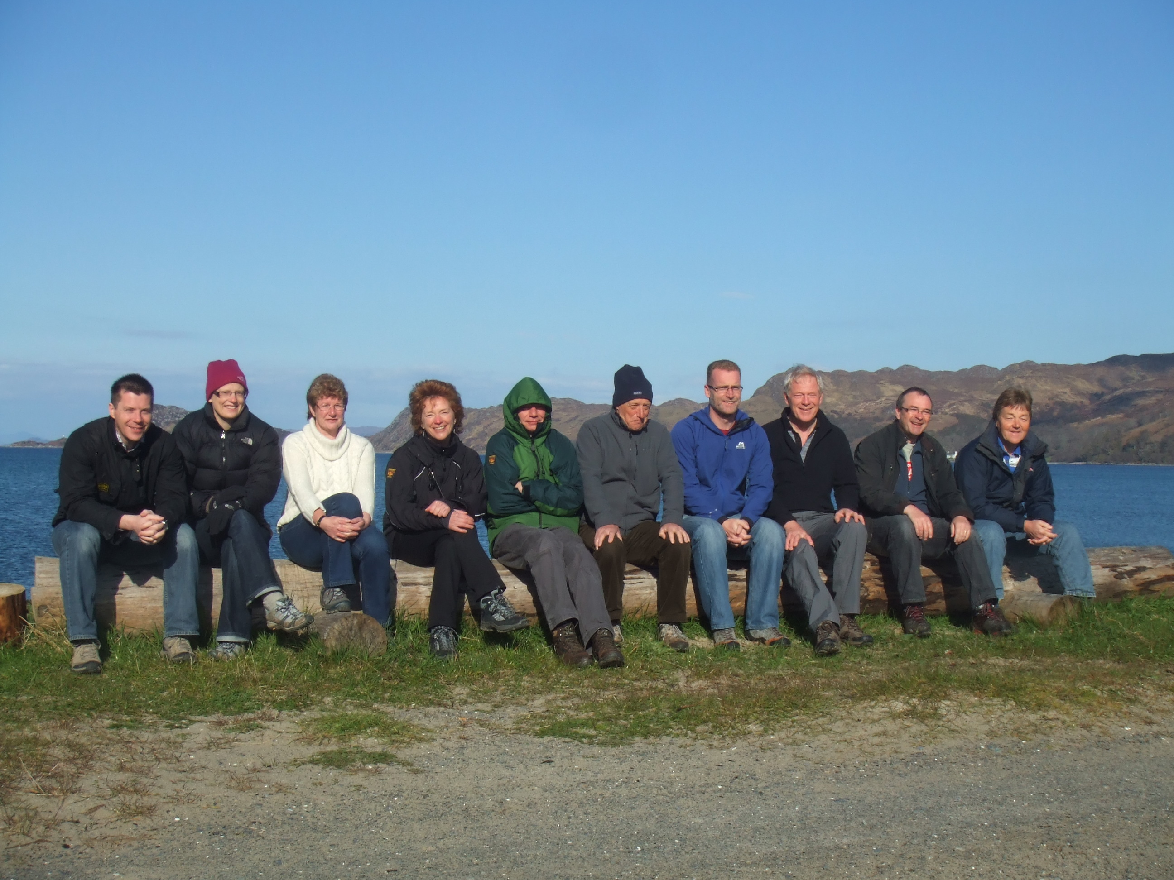

Conclusion

The natural Knoydart never disappoints even if other aspects of the trip weren’t quite in keeping. For all else “what’s on the meet stays on the meet” applies.

Next meet: Great Glen. 26th May. Meet organiser Alan

Tony Smith

