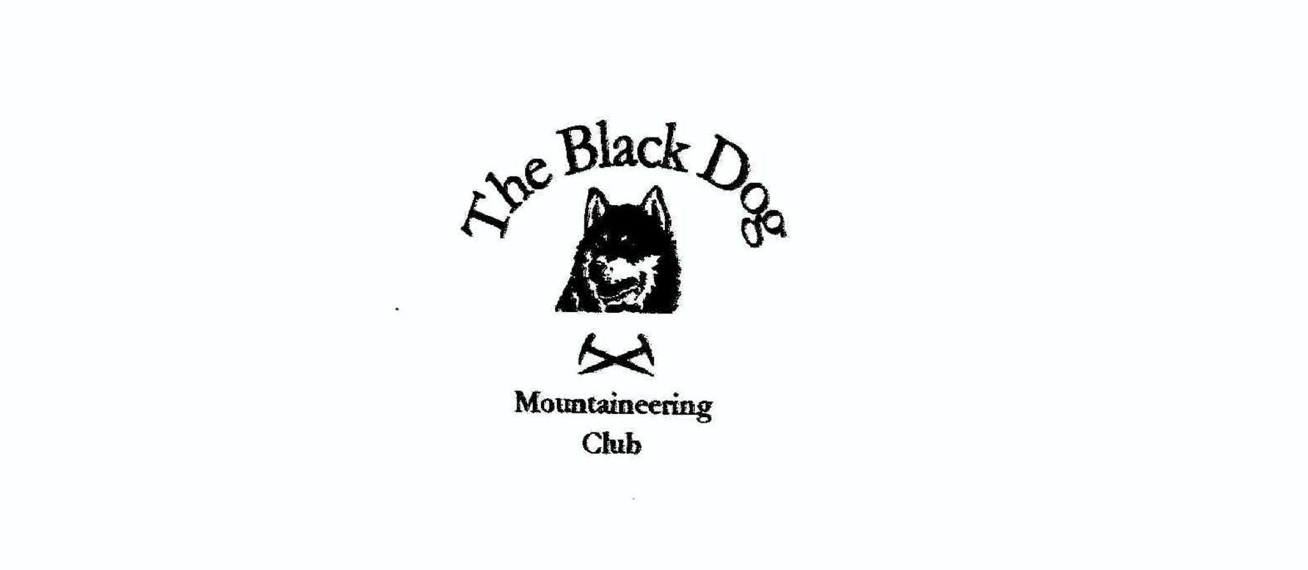

Black Dog Meet

No. 146 Skye

Friday 6th to Sunday 8th June 2014

In Attendance

Valerie Inglis | Michael Ruby
Russell Shanks | Davie Cameron
Bill Clark | Charles Alexander
Gerry Feeney | Steve Smart
Steve Davis | Lorna Smith
Pat Davis | Alan Sewell
Richard Marwood | Fiona O’Neil
Tony Smith

Mountains Climbed

Friday: Sron na Ciche (via Central buttress - ** Diff)
Ben Tianavaig (413m)

Bruach na Frithe (958m)
Sgurr na Banachdich (965m)
Beinn a'Chapuill (755m)

Saturday: Sgurr Dubh Beag (733m)
Sgurr Dubh Mor (944m)
Sgurr na Banachdich (965m)
Bruach na Frithe (958m)
Sgurr a Fionn Choire (935m)
Bla Bheinn (928m)
Marsco (736m)
Ruadh Stac (493m)
Sgurr nan Caorach (280m)
Sgorach Breac (299m)

Sunday: Ben Meabost (346m)
Beinn a'Chuirn (603m)
Schoolhouse Buttress VS 4C** (Elgol)

Weather

Friday was mist but soon cleared. Saturday the weather was glorious sunshine and then clouded over and Sunday was dry and bright. Good visibility.

Notes / Highlights

Val, Davie, Steve, Michael, Richard
Val reports: David and I went up to Skye a day early and on Friday the 6th June we climbed Sgurr na Banachdich. It was dry but thick clag so not much to report really. Then on Saturday 7th we climbed Bruach na Frithe with Steve, Richard and Mike. We went via Fairy Pools and up the gully on the left-hand side of water pipe gully. The gully was steep at the top with lots of loose stones and loose hand holds but we got there. Great route along the ridge with Steve navigating and leading the way. After the summit of Bruach na Frithe we climbed the top Sgurr a Fionn Choire before descending and traversing round back to the cars at the Fairy Pools car park.

Steve and Pat
Steve reports: On Friday we were up Ben Tianavaig (413m), Saturday was Marsco (736m) and Ruadh Stac (493m) and on Sunday, after dropping off Alan and Fiona at Elgol, we did a quick up and down on Ben Meabost (346m).

Tony, Lorna and Charles
Tony reports: On Friday Lorna, Charles and I travelled to Glenelg and climbed Beinn a'Chapuill (759m), the Graham adjacent to, and with great views of, Beinn Sgritheall before taking the little ferry over to Skye.
On Saturday Gerry joined us for two minor Marilyns on the Sleat peninsular, Sgurr nan Caorach (280m) and Sgorach Breac (299m). Each of these was reasonably straightforward but involved the usual tramp over rough pathless ground. Whole Cuillin ridge and many other islands very clear from summits. That's the 48 Skye Marilyns (and 2 on Raasay) completed for me, now only Scalpay to do.
OnSunday we returned over the ferry and Charles and I did Beinn a'Chuirn (603m) above Ratagan. Again a lot of rough, undulating ground (not to mention the trees - only found the track on the way down) but a very fine rocky summit viewpoint.

Michael and Gerry
Friday - headed up Bruach na Frithe from Glen Brittle.

Bill
Climbed Bla Bheinn (Blaven) on Saturday.

Alan, Fiona and Russell
Friday. Climbed Central Buttress on South Crag Sron na Ciche (Diff **) having come up to Invergarry hostel the night before. Great route in sunshine all day.

Saturday. We got the boat from Elgol to Loch Coruisk and climbed the Dubh’s ridge to Sgurr Dubh Beag - with an abseil and on to Sgurr Dubh Mor. We headed back to Glen Brittle via Coire a Grunnda, where we had left Russell’s car the night before.

Sunday. After being dropped off by Steve and Pat at Elgol, Fiona and Alan had a training day, climbing at Schoolhouse buttress where we climbed Schoolhouse Buttress VS 4C**, before heading home.

Alan Sewell

