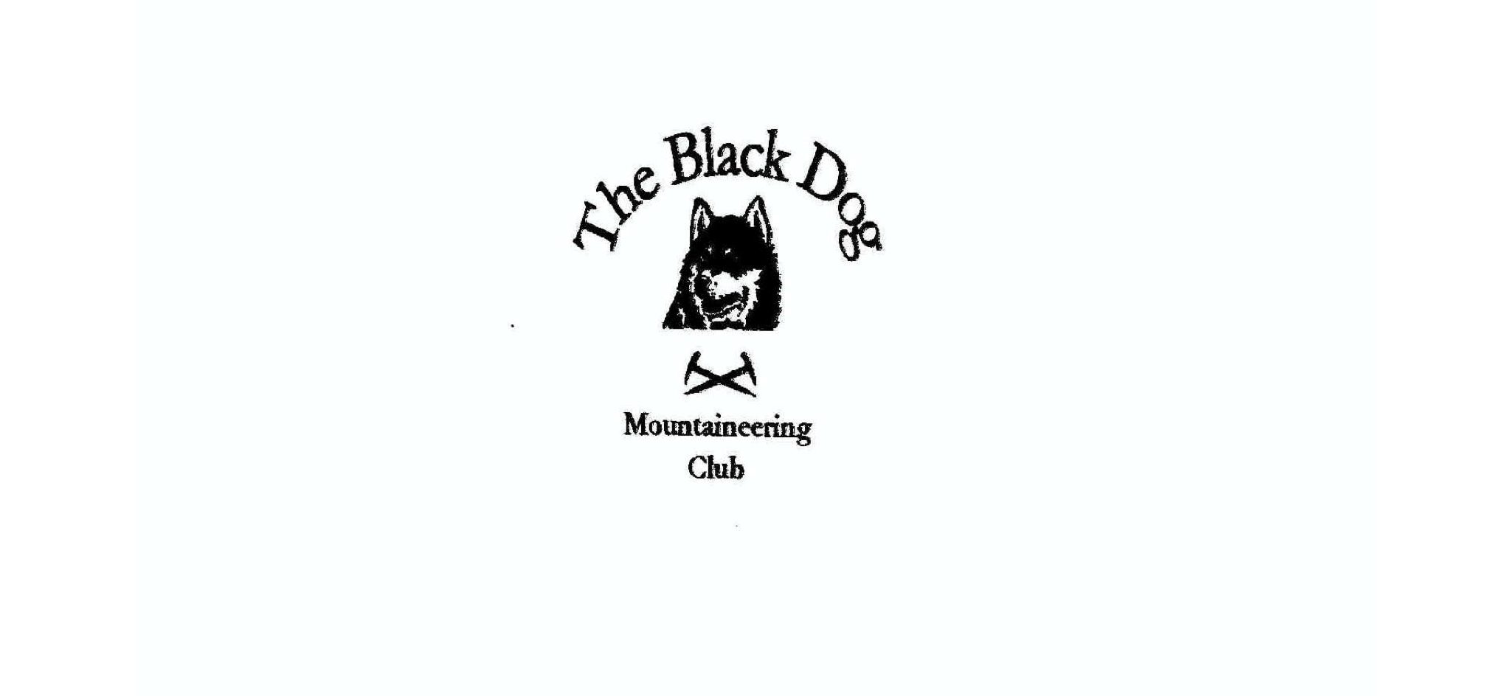
Black Dog Meet

No. 168 Lochinver

Thursday 12th - Sunday 15th May 2016

In Attendance

Alan Sewell Gerry Feeney
Tony Smith Wull Clark
Lorna Smith Bill Clark
Val Inglis Liz Kennedy
David Cameron Fiona O’Neil
Charles Alexander John McGill
+ 4 Saturday “Marilyner” guests

Mountains Climbed

Thursday
Val, David, Gerry, Bill & Wull Beinn Liath Mhor Fannaich (954m) Sgurr Mhor (1110m), Meall Gorm (949m) and An Coileachan (923m)
Val & Wull Carn na Criche (961m)

Friday
Lorna, Tony & Charles An Lean-charn (521m)
Liz Beinn Liath Mhor a’Ghiubhais Li (766m)
Val, David, Gerry, Bill & Wull Sgurr an Fhidhleir (705m) and
Ben Mor Coigach (743m)
Fiona & Alan 8 Climbing routes:
Rock Garden Arete – V Diff**, Rock Garden Right – V Diff*, Rock Garden Left – V Diff, Stone Flowers – Severe 4a*, Flower Power – Hard Severe 4b*, Archean Perfection – Hard Severe 4b*, Old Stones – V Diff* and
Dianthus – V Diff*

Saturday
All Ben Stack (721m)

Weather

The weather was good all weekend.

Notes / Highlights

After initial forays into the Fannichs, Coigach and Loch Eriboll we all gathered in Lochiver at the Mission Bunkhouse as usual.

The main event of the weekend was Tony’s planned Graham and Marilyn (aka The Relative Hills of Britain) completion. We all therefore headed north to Achfary and climbed Ben Stack via the Strath. Four members of the Marilyn ‘club’, including Martin Richardson one of the five previous completers, joined us for the occasion. All enjoyed the usual summit celebrations and an awesome cake (see below) provided by Lorna.

We spent the evening in the Lochinver Larder eating their excellent pies and another cake, this time decorated with a “girl in a white frock”. It took a moment or two for all to realise this was a very relevant Marilyn Munroe.

A fantastic weekend and a fantastic achievement. Well done Tony.

Wull

