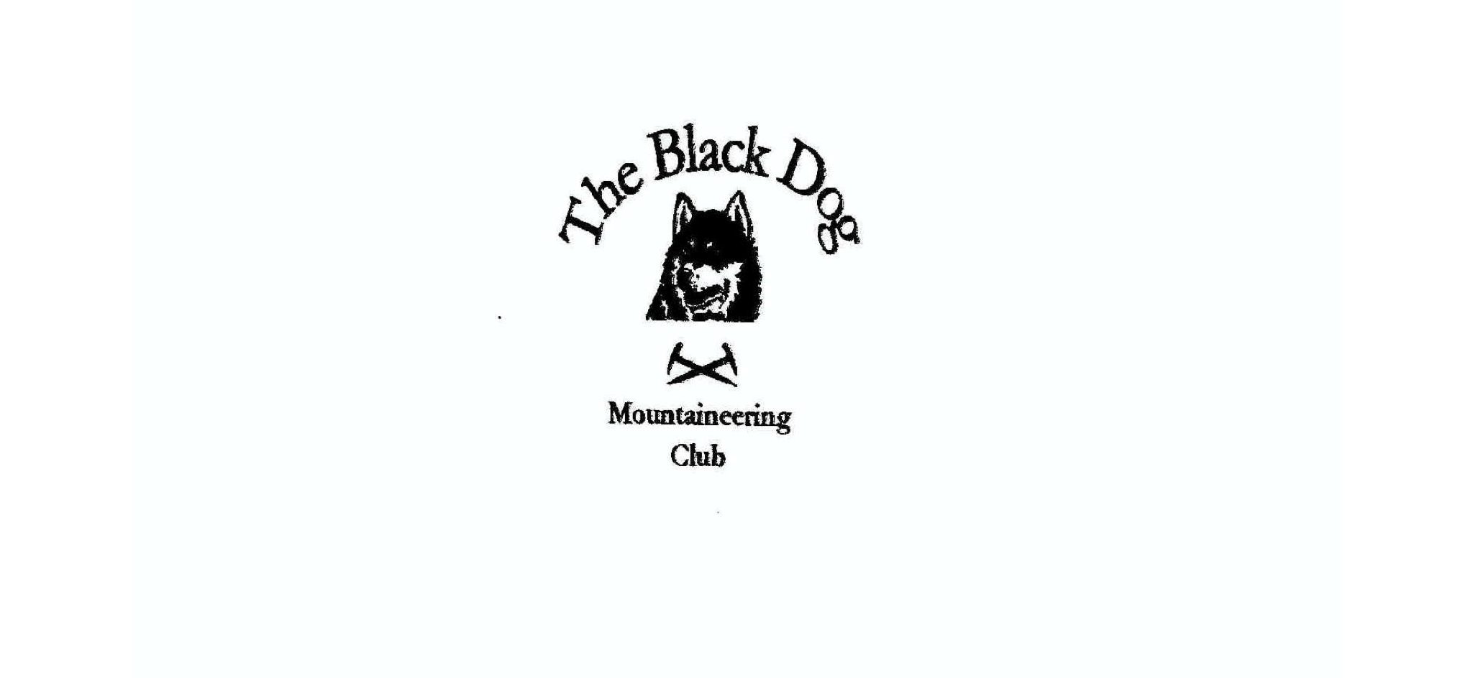
Black Dog Meet

No. 170 Rum

Friday 29th July - Monday 1st August 2016

In Attendance

Alan Sewell
Tony Smith
Lorna Smith
Val Inglis
David Cameron
Richard Marwood
Robin Nicolson (Guest)

Mountains Climbed

Saturday Hallival (723m)
Barkeval (591m)

Sunday Bloodstone Hill (Sgurr Mor) (388m)
Sron an t-Saighdeir (523m)
Orval (571m)
Ard Nev (556m)

Weather

Weather was a mixed bag of heavy showers or longer spells of rain with occasional sunny spells. The two best days were when we arrived by ferry and when we left - typical!

Notes / Highlights

Friday

We all met at the ferry terminal in Mallaig at 12.30pm with some cutting a bit fine to catch the only sailing. However we all made it and set of for Rum in the sunshine. The Rum Cuillin was looking appealing as we sailed in to Loch Scresort. We managed to find the harbour master who took our bags along to the hostel for a pound a head in the back of his buggy. It had been several years since we had been on Rum with a number of new developments springing up, including the hostel.

The hostel was good, albeit in need of a good clean. What can you expect when you put a bunch of Geology students in residence for a couple of months? We settled in for the night after some exploring of the local tat shops on the island - their candle selection comes highly recommended!

Saturday

We had agreed to meet Robin from the early morning ferry on Saturday morning and then we set off for the Cuillin. At the top of Coire Dubh we decided that the main group would go over Hallival and Askival whilst Lorna and Alan would traverse Atlantic Corrie and we would all meet at Bealach an Oir. The weather wasn’t great with wind and rain now set in for the day. After waiting an hour Lorna and Alan began to get worried. It turned out Robin had taken a fall on Hallival and the party decided to descend into Atlantic Corrie. Fortunately Robin was ok with just some cuts and bruises. We all met at Bealach an Oir but decided to bail out at this point. So it was back across Atlantic Corrie. At the top of Coire Dubh the weather had improved, so Tony, Val and Alan continued on to Barkeval as the rest descended back to the hostel. The rock on Barkeval is something to behold - Peridotite apparently - so the geology student assured us.

Sunday

Sunday had all the promise of Saturday, with the weather starting ok but going downhill fast. We all headed for Bloodstone Hill, while Robin headed for the ferry home (apparently you can get a ferry on a Sunday, you just need to decipher the code of Cal Mac timetables).

It was a long way to Bloodstone hill in the pouring rain but we stuck with it and were rewarded with some sunshine in the afternoon just as we approached the summit. We all then headed for Orval over Sron an t-Saighdeir and on to ‘Hard Nev’ while Richard headed directly back to the hostel.

Monday

After a number of plans being discussed everyone opted for an early sailing to Canna then back to Rum, Eigg and then Mallaig. The sun was glorious as we sailed the ocean blue. If only it could have been like this on the hills. Oh well, a good excuse to go back I suppose.

Next Meet

Inchree. 26th - 28th Aug, meet organiser Charles Alexander

