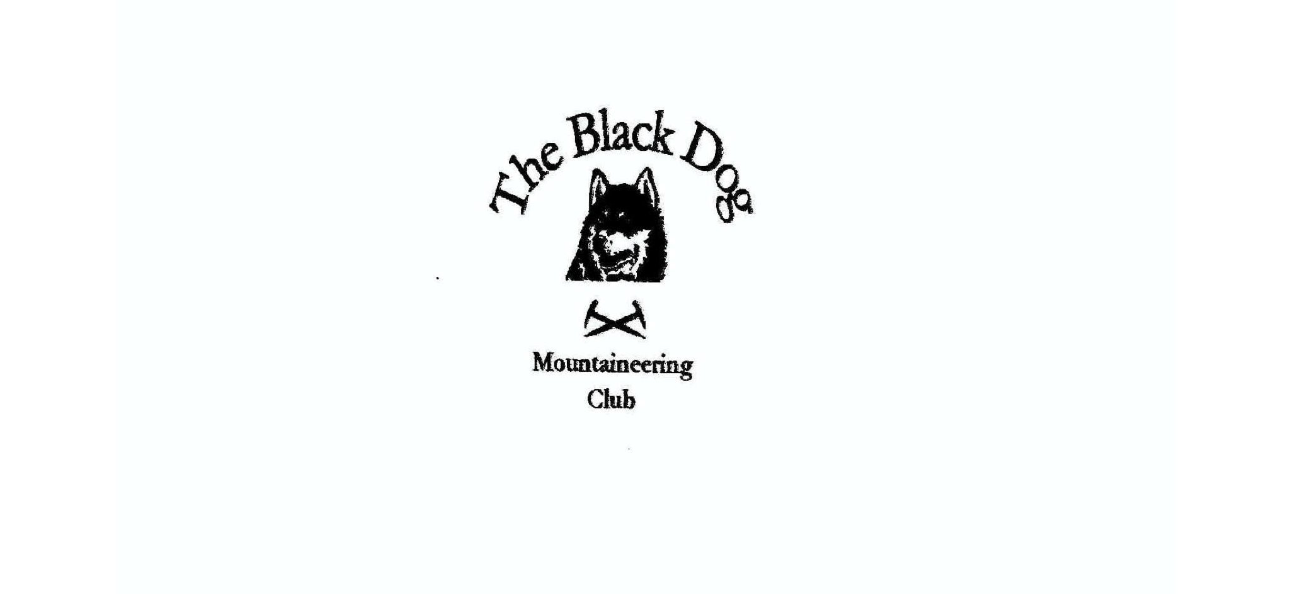
Black Dog Meet

No. 171 Inchree

Friday 26th July – Sunday 28th August 2016

In Attendance

Alan Sewell Wull Clark
Tony Smith Charles Alexander
Lorna Smith Jean Alexander
Val Inglis Liz Kennedy
Davie Cameron Brian Barron
Stuart Donald

Mountains Climbed

Friday Sgorr Bhan (947m)
Sgorr Dhearg (1024m)
Sgorr Dhonuill (1001m)
Sgorr a’ Choise (663m)
Meall Mor (676m)

Saturday Binnein Beag (943m)
Sgurr Eilde Mor (1010m)
Binnein Mor (1130m)
Meal Dearg (953m)
Sgorr nam Fiannaidh (967m)
An Toiseach VDiff* and Beths Route VDiff* on Meall An Fhir-Eoin

Weather

Friday’s weather was disappointing, Saturday rather midge infested and Sunday was fine.

Notes / Highlights

Friday’s group (Lorna, Liz, Valerie, Davie and Tony) did the Munro circuit from Ballachulish, following the Walk Highlands route with a slight “deviation” because of a simple navigational error in poor summit visibility thus making a long day even longer. Meanwhile Alan and Wull were on the nearby Grahams.

Saturday’s big group (Jean, Lorna, Liz, Valerie, Charles, Davie and Tony) set off up a damp track from Kinlochleven with half the midge population of the West Highlands in hot pursuit, undeterred by various repellants. Once we got out of the woods the biters were not so bad if you kept moving. The group gradually split up with the hares doing three Munros, Davie two and the tortoises only one. All had a good long day’s walking.
Stuart and Brian did the Aonach Eagach ridge in non-ideal conditions, a bit damp to make it more interesting, whilst the climbers (Alan and Wull) headed over to Ardnamurchan.

The beer and the food in the pub were good and the lodges well equipped. The six-person lodge had a reasonable sized sitting area, which could squeeze everybody in to partake of lovely birthday cake (Val’s Birthday) and various celebratory drinks. There was a rumour that the cake had been made by the birthday girl’s fair hands but this did not get much credence. The accommodation split detracted slightly from the socialising and next year’s meet will, therefore, be back in the Corran Bunkhouse on the changed date of 18th and 19th August.

Charles Alexander

