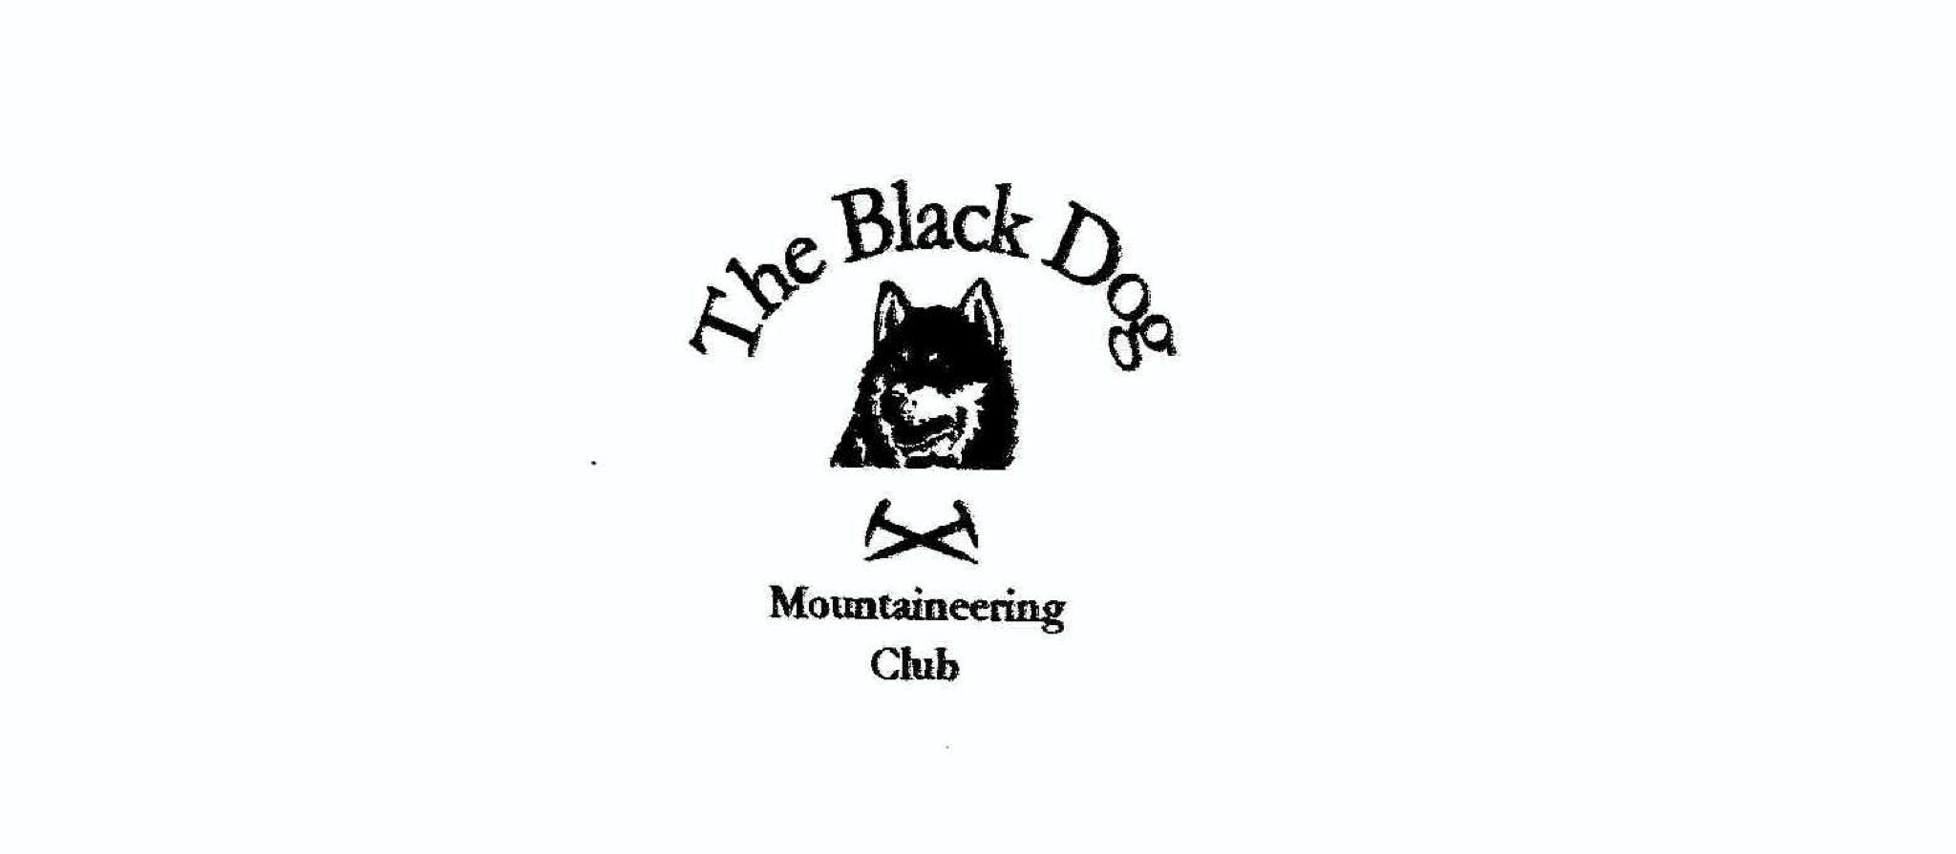

Black Dog Meet

No. 192 Mull

Friday 27th to Sunday 29th April 2018

In Attendance

Valerie Inglis | Richard Marwood
Davie Cameron | John McGill
Gerry Feeney | Tony Smith
Bill Clark | Charles Alexander
Wull Clark | Lorna Smith
Alan Sewell | Stuart Donald

Hills Climbed

Thursday: Being Fhada (702m)

Friday: Ben Buie (717m)
Creach Beinn (698m)
Beinn Challuim (1025m)
Beinn Charsaig (449m)

Saturday: Cruach Choireadail (618m)
Corra Bheinn (704m)
Beinn a'Mheadhoin (602m)
Cruachan Beag (601m)
Ben More (966m)
Beinn Fhada (702m)
Dun da Ghaoithe (766m)

Sunday: Beinn Talaidh (761m)
Sgurr Dearg (741m)
Cruach Sleibhe (166m)
Beinn Mheadhon (637m)
Beinn Thunicaraidh (648m)

Monday: Dun I (101m)

Weather

Thursday was sunshine and hail showers. On Friday and Saturday the weather was glorious sunshine with the odd hail shower, good visibility. Sunday was dry but dull with hail later.

Notes / Highlights

Thursday

Alan head over early to get away from DIY projects, catching the 12.20pm ferry from Oban and climbing Beinn Fhada from Loch na Keal, where he camped the night in the back of the car. Any thought of a peaceful night were shattered when John arrived and pitched his tent alongside (only joking John!).

Friday

After a leisurely breakfast in Craignure, Alan and John headed around to Loch Buie where they climbed the two rocky Grahams, Ben Buie (717m) and Creach Beinn (698m). Apart from a couple of hail showers they were rewarded with fantastic views of the rest of the Mull hills, along with Skye, Rhum, Jura etc.

Wull and Bill climbed Beinn Challuim from Crianlarich - dry with a couple of snow shower, before meeting up with Val (at the Crainlarich lavies) and heading for Oban

Tony, Lorna, Charles and Gerry had a fine trip over on the ferry, quick luggage drop at the hostel and off down to Carsaig to wander up Beinn Charsaig (449m) Hump. Excellent visibility to give fine views of the Paps of Jura etc.

Saturday

Tony, Lorna, Charles, John and Alan headed around to Glen More to climb
Cruach Choireadail (618m) and Corra Bheinn (704m), with Tony adding (5 in total but principally Beinn a'Mheadhoin (602m) Simm/Hump and Cruachan Beag (601m) Simm) made for a long tough, but very enjoyable, day. Back to the car just in time to hear the football results (Montrose Div 2 champions!).

Wull, Val, Bill & Stuart did Beinn Fhada and Ben More, a nice day with one snow shower when they got to the summit of Ben More. The temperature switching between hot and cold all day and wonderful views over mull and out to sea - Jura, Skye, Eigg and the outer Hebrides.

Gerry and Richard climbed the Corbett Dun da Ghaoithe from Craignure with the highlight seeing a pair of Golden eagles.

Davie still recovering from a chest infection had a great day in Tobermory - although the bus prices were a bit steep. It was great to see him back to his (almost) usual self.

Sunday

John bagged Beinn Talaidh & Sgurr Dearg on Sunday. Best ‘col’ of the trip at 100m, which was slightly lower than the start point!

Tony, Lorna and Charles did the tourist bit in the morning with an 'interesting' drive round to Calgary Bay via Loch Tuath. Tony did a quick bag of Cruach Sleibhe (166m) Hump just above the bay whilst Lorna and Charles admired the view from the car (it was raining for about the first 10 min of the walk - wimps!). The area is well worth a visit, particularly Calgary Farm cafe, art gallery and woodland walk.
Back at Craignure Lorna and Charles again decided to skip the planned afternoon walk so Tony set off to do Beinn Mheadhon (637m) Simm and Beinn Thunicaraidh (648m) Simm alone. The hitherto fine weather came to an abrupt end with a vicious hail storm at exactly the wrong time (right on the summit).

Monday

Tony, Lorna and Charles had a very pleasant trip out to Iona before catching the ferry back to Oban. On Iona they all admired the very fine views from Dun I (101m) Hump before walking out to the west coast by the golf course (no obvious greenkeeping just sheep to prepare the 'greens').

The hostel was a fantastic base, with great facilities, albeit the kitchen is a bit small, the pub is always available next door. The island has a lot of hillwalking to offer and I would certainly support a trip back here soon!

Next Meet

Strawberry Cottage Glen Affric 25-27th May
Organiser Wull Clark

Alan Sewell

