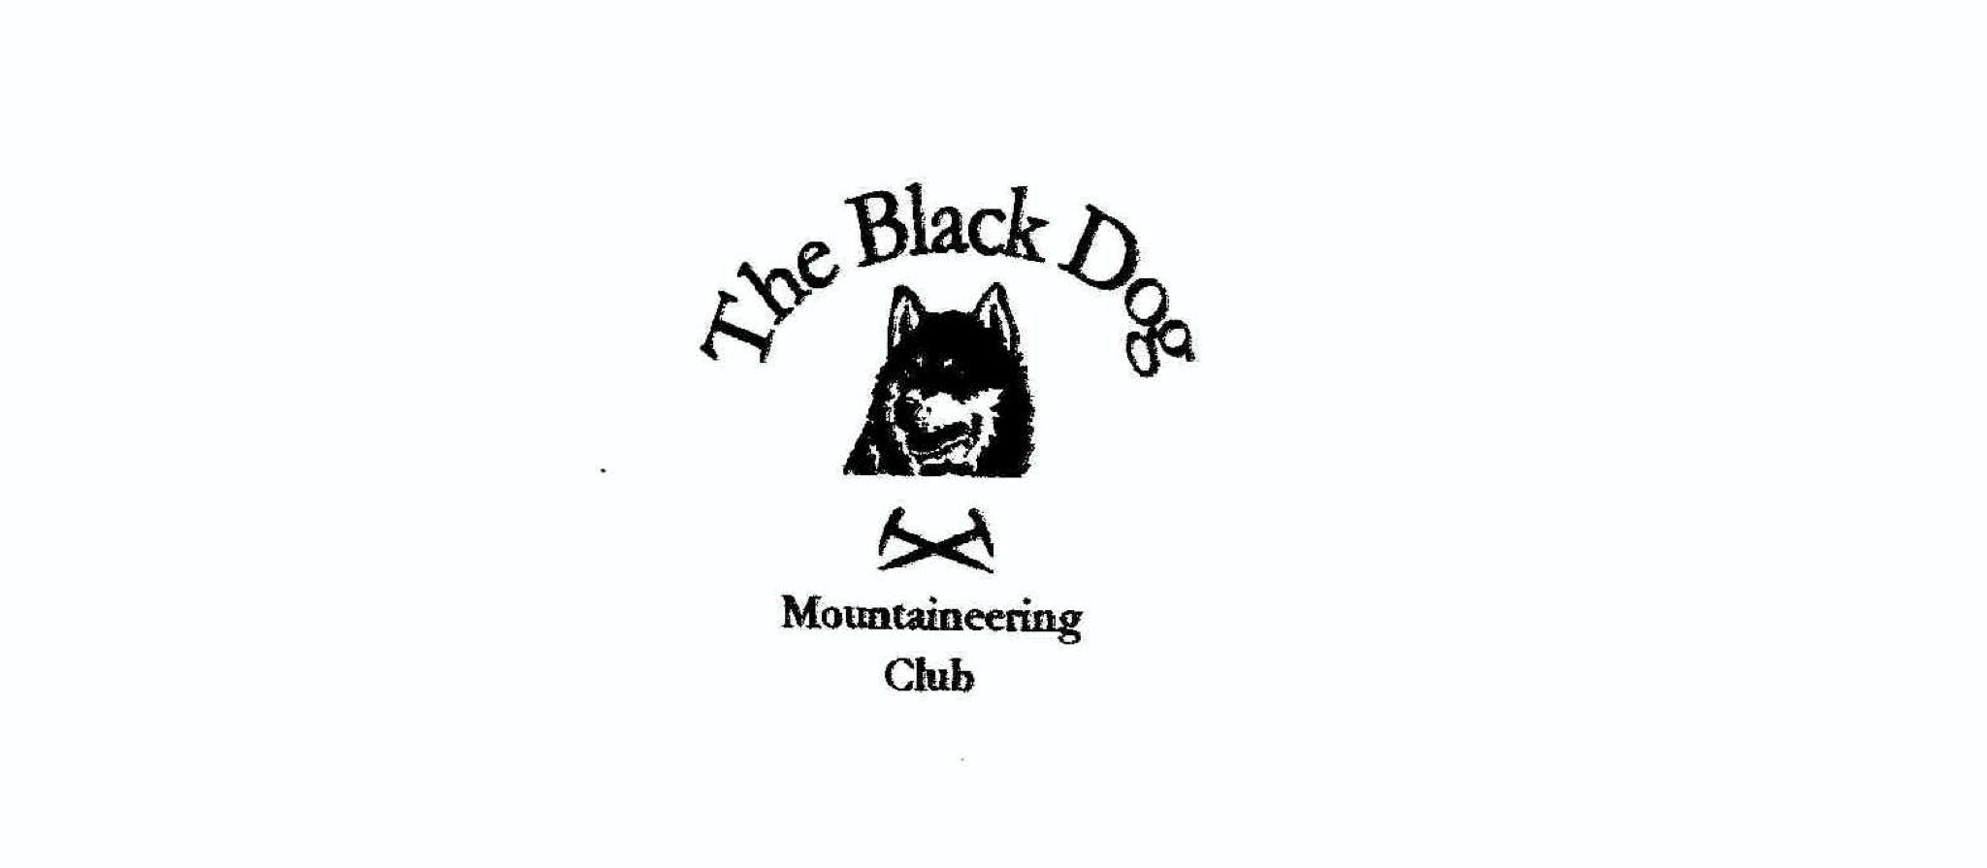
Black Dog Meet

No. 194 Skye

Friday 8th to Sunday 10th June 2018

In Attendance

Valerie Inglis | Richard Marwood
Davie Cameron | John McGill
Gerry Feeney | Tony Smith
Lorna Smith | Charles Alexander
Wull Clark | Michael Twigg
Alan Sewell

Hills Climbed

Thursday:
Lorna, Charles & Tony Beinn Sgritheall (974m).

Friday:
Wull & Alan Sgurr Mhic Chonnich (948m) (via Jeffery’s Dyke V. Diff)
Lorna, Charles & Tony Bheinn Shuardail (281m),
Tony Braon a'Mheallain, (267m) and Stroc-bheinn, (400m)
Gerry Sgurr an Airgid (841m)
Val & Davie Marsco (736m)

Saturday:
Lorna, Charles & John Marsco (736m)
Tony Ben Killilan (757m) and tops
Val, Wull & Alan Sgurr Alasdair (992m)
Davie Dun Caan (443m)
Gerry Sgurr na Stri (494m)

Sunday:
John Carn Breac (678m) and Beinn na Feusaige (627m)

Weather

Thursday and Friday were warm and sunny. Saturday and Sunday were dry but with cloud on the summits.

Notes / Highlights

Thursday
Lorna, Charles and Tony travelled over to Kintail a day early and did Beinn Sgritheall (974m). A hot day and a steep ascent on a reasonable path from a cairned start about 3k west of Arnisdale. This route comes recommended by Tony.

Val, Wull and Davie headed over Thursday evening and stayed at Saddle Mountain hostel.

Friday
Wull and Alan headed into Coire Laggan where they climbed Jeffery’s Dyke, a nice long route from the Coire Laggan floor to the summit ridge of Sgurr Mhic Chonnich. This was Wull’s penultimate Skye Munro. Weather was great
.
Instead of Friday's planned ascent of Bla Bheinn Tony, Charles and Lorna opted for a much more modest hill Bheinn Shuardail, a Hump which gave a pleasant circuit south of Broadford. Thereafter they went over to Carbost and Tony added two Humps on a solo afternnon trip.

Val and Davie claimed Marsco from Loch Ainort whilst Gerry climbed the Corbett Sgurr nan Airgid on his way to Skye. Due to an ankle injury Richard was restricted to a cycle tour of Loch Long/Dornie area.

Friday evening at the hostel was interrupted when the dining area was completely taken over by other guests (a combination of folks staying at the hostel and those in the lodges). This was due to the Skye marathon taking place around Portree the following day. This unfortunately set the tone for the weekend.

Saturday
On Saturday Lorna went (despite the blisters!) to Marsco (736m) with Charles and John (“Up the steep front ridge & down the sensible way”), whilst Tony set off for the Relative Hills Society AGM & dinner in Aviemore. En route Tony stopped off at Killilan and walked the very fine Ben Killilan and its neighbouring Simms. He was just off the hills before the thunderstorm struck but driving on the resultant flooded Strathcarron roads was still a bit interesting.

Davie headed over to Raasay and climbed the shapely highest point Dun Caan.

Val, Wull and Alan headed for Wull’s final Skye Munro, Sgurr Alasdair, via the Great Stone Shoot. How quickly you forget how laborious this route is particularly on ascent. Swirling mist at the summit spoiled any chance of a view.

Gerry walked through Glen Sligachan and climbed Sgurr na Stri above Loch Coruisk.

Richard had a cycle tour around Carbost/Fiscavaig in the morning and then was joined by Michael in the afternoon for a sight seeing (SkyeMarine) tour - 3 hour tour from Carbost to Neist point. Where they saw – “Dolphins, porpoises, seals, cormorants, shags the lot!!” „I’m not sure what this has to do with mountaineering, but given post viral fatigue and ankle injuries any other plans (Mhadaidh and Ghreadaidh) were clearly out of the question.“

Saturday in the hostel our patience was wearing thin with the arrival of a Karaoke machine. In the end this took place in the pub.

Sunday
John headed for Glen Carron, with the rest of us heading home.

John stayed in the Kintail area until Friday climbing Creag Dhubh Mhor, Sgurr a Gharaidh, Beinn a Chlachain, Carnan Cruithneachd & Boid an Fhithich.

It was good to see the hostel improvements at the Old Inn, but perhaps we should try and avoid the same weekend as the Skye Marathon in future!

Next Meet

Mill Cottage, Glen Feshie 29th June – 1st July (Meet Organiser John McGill).

Alan Sewell

