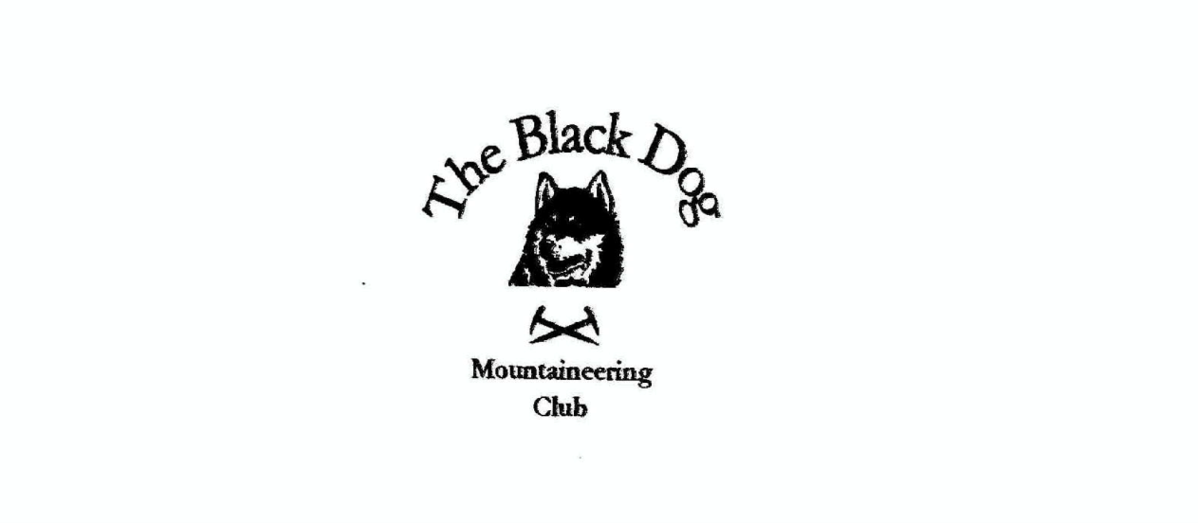

**Black Dog Meet**

**No. 207 Skye**

Friday 14th to Sunday 16th June 2019

**In Attendance**

|  |  |
| --- | --- |
| Valerie Inglis | Wull Clark |
| Davie Cameron | John McGill |
| Gerry Feeney | Tony Smith |
| Lorna Smith | Bill Clark |
| James Yeats | Peter Robertson |
| Alan Sewell | Mike Twigg |

# **Hills Climbed**

Friday: Beinn Sgritheall (974m)

A’ Ghlas Bheinn (918m)

Saturday: Sgurr na Banachdaich (965m)

Beinn Dearg Mhor (709m)

Beinn na Caillich (732m)

Sunday: Beinn Dearg Mhor (731m)

Am Meall (193m)

Creag Strollamus (266m)

**Weather**

Friday, Saturday and Sunday were all a mix of sunshine and showers.

### Notes / Highlights

**Friday**

Wull, Val, Davie, James, Gerry and Mike set off from Saddle Mountain Hostel to climb A’ Ghlas Bheinn from Morvich where they managed to avoid the showers.

Alan headed for Beinn Sgritheall and the elusive NW Top (928m), choosing a direct approach from the west, followed by an enjoyable crossing on the Kyle Rhea ferry. Although expensive at £15 it is worth it purely for the historical interest.

**Saturday**

James, Peter and Mike headed for the Black Cuillin and climbed Sgurr na Banachdaich from the Glen Brittle hostel, while the rest headed to the red Cuillin to climb the two Grahams at Broadford, from Old Corry. Unfortunately Bill had to turn back due to a calf injury, but the rest had an enjoyable round of these two overlooked hills.

**Sunday**

Alan headed off to do the other Beinn Dear Mhor, the Graham above Sligachan, while Wull and Tony went ‘Humping’ along at Strollamus.

John and Alan continued their adventures by getting the ferry on Sunday evening from Uig to climb Beinn Mhor on South Uist. A successful mission.

Note - the Old inn hostel has improved the facilities this year, although some (not club members) can’t hold their beer (and other substances), and ended up puking at the front door before trying to start a bit of boxing on Saturday morning. A great weekend was had by all!

### Next Meet

Corran. 28th-30th June (Meet Organiser Charles Alexander).

#### Alan Sewell