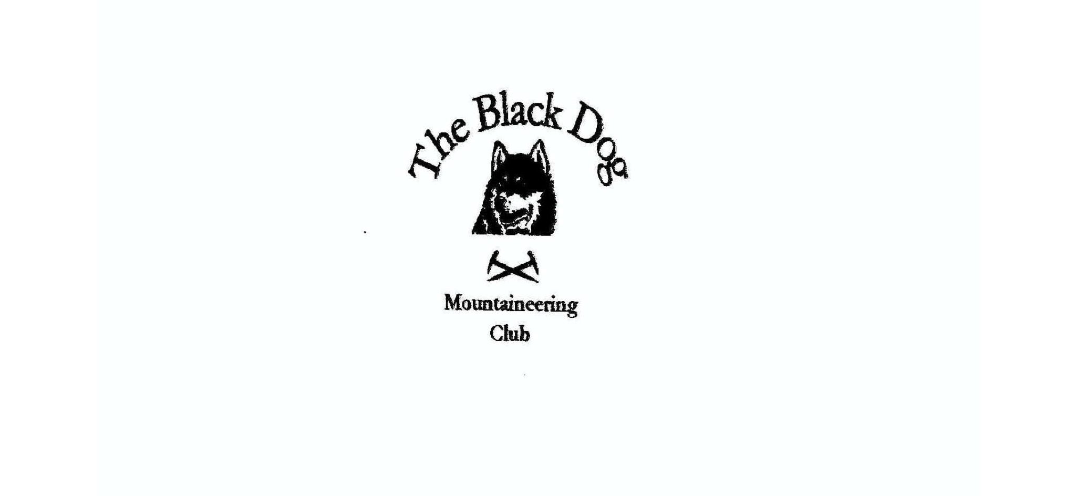
Black Dog Meet

No. 208 Corran

Fri 28th - Sun 30th June 2019

In Attendance

Charles Alexander Andy Robb
Bill Clark Barry Smith
Wull Clark Lorna Smith
Gerry Feeney Tony Smith
Val Inglis James Yeats
Liz Kennedy

Mountains Climbed

Friday
Andy Beinn Achaladair (1038m) and Beinn a'Chreachain (1081m)
Lorna, Barry & Tony Stob a'Choire Mheadhoin (1105m) and
Stob Coire Easain (1115m)
Liz, Gerry & Charles Beinn Mhic-Mhonaidh (796m)
James Gulvain (987m)
Bill Carn Dearg (945m)

Saturday
James, Liz, Val & Wull Carn Mor Dearg (1220m) and Ben Nevis (1344m)
Tony Beinn Bhuidhe (161m) & Beinn an Leathaid (401m)
Lorna Beinn an Leathaid (401m)
Barry Meall Dearg (953m) and Sgorr nam Fiannaidh (967m)
Andy Mullach Nan Coirean (939m)
Charles & Gerry Sgurr a'Chaorainn (761m)

Sunday
Barry & Tony Sgor na h-Ulaidh (994m) + top and
Aonach Dubh a’Ghlinne (845m)
Liz Sgurr An Utha (796m)

Weather

The weather on Friday was fine. Saturday was very mixed with strong wind, heavy showers, cold at times and even some sunshine. The main feature was a patchy thunderstorm - see later. Sunday was pretty wet.

Notes / Highlights

The hostel still gets voted as one of the best.

Saturday. From Valerie: - “A dramatic account of a day on a hill”
Wull, Liz, James and I set off for Torlundy to do Ben Nevis via the Carn Mor Dearg Arete. The forecast hadn't been brilliant but not the worst by any means. The climb onto Carn Mor Dearg was good, but James, who had been out on the Friday on quite a big day in hot sun, decided to call it a day after the first hill. The rest of us carried on and had a fantastic walk around the arête in clear dry conditions with good views of Ben Nevis with some cloud drifting around. The summit of The Ben was, as always, choc a bloc with probably hundreds of people in a range of 'hill gear'. We stayed long enough to touch the summit and then set off for the outlying top Cairn Dearg (1221m). Just before the top there was a loud rumble which we wondered was maybe a plane or even maybe thunder. Ten minutes later the storm hit. The rain started to batter down and the thunder came loud and frequent followed by frequent flashes of lightning. The storm was obviously right overhead and we very quickly realised we had to get off the mountain as soon as possible. We shot off the mountain hopefully heading for the col at half way lochan, occasionally hitting the ground and sitting on our rucksacks to try to stay safe from the lightning. The terrain was horrific and we slid down scree slopes quite literally throwing ourselves down the mountain. The storm seemed to move away from time to time but would suddenly hit again right over our heads. Most of the lightning had been sheet lightening, but Wull saw a huge fork of lightning hit the ground at Half Way Lochan. It was possibly the most frightening few hours we have had on a day out on the hill. The thunder rumbled away all the way back to the car and when we got back to the bunk house it turned out the electricity for the whole of Ardnamurchan, Corran and Ballachullish had been taken out by a lightning strike. There was enough hot/warm water for showers and the fridges retained some chill on the beers which were much needed. The power finally came on about 9 pm. What a day!!

Barry reported a similar “highlight” with an epic traverse of the Aonach Eagach ridge. The first Munro was achieved in fine weather. However, he then encountered the thunderstorm which he sheltered from as best he could, getting very wet - "not the most enjoyable experience" and not recommended. He enjoyed his beer in the Clachaig!

When Gerry and I got back to the hostel after a long day out people were looking for something to light the gas with - there was the power cut. Fortunately power was restored in time to get a meal at the Inchree and at least they could serve beer during the outage.

Tony and Lorna enjoyed a ‘tourist’ day exploring the Ardnamurchan peninsula (well away from any storms) but of course taking in a couple of non-tourist Humps on the way home.

The Smith brothers got soaked again on the Sunday and the drying room at the B&B was ineffective to say the least!

Charles

Next Meet
Torridon 19th – 21st July. Meet organiser Tony

