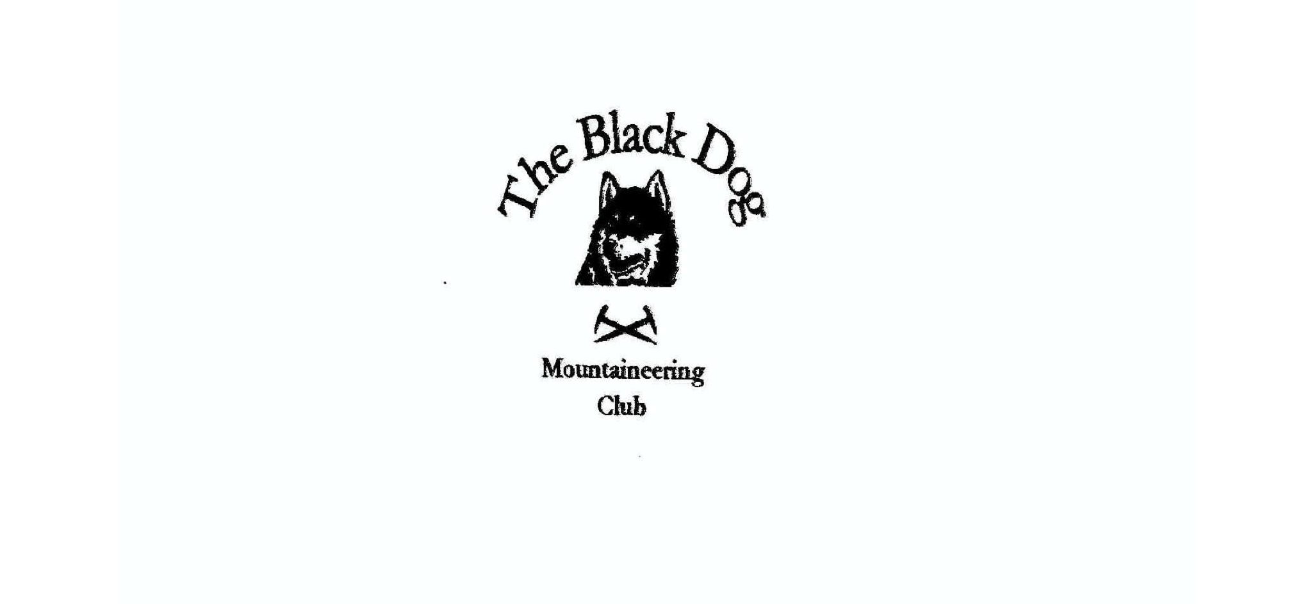
Black Dog Meet

No. 212 Invergarry

Fri 25th - Sun 27th October 2019

In Attendance

Alan Sewell Charles Alexander
Tony Smith Val Inglis
David Cameron Peter Robertson
Mike McLaggan Janey Andrews
Buster

Mountains Climbed

Friday Meall Blair (656m)
Creag Coire Doe (729m) + tops
Cairn Vungie (715m)

Saturday Drium Fhada (744m)
Ben Tee (901m)
Sean Mheall (888m)
Meall nan Dearcag (693m)
Stob Coire Sgriodain (979m)
Chno Dearg (1046m)

Sunday Marg na Craige (834m)
Meall na h-Uinneig (745m)
Binnien Mor (550m)

Weather

Weather was a mixed bag of blustery snow, sleet, hail and rain showers with occasional sunny spells.

Notes / Highlights

Friday

Alan climbed Meall Blair from Loch Arkaig. A new bulldozed track as part of a hydro scheme made the ascent easy up to Loch Blair before the boggy ATV track led to the summit. Good views, with the first significant snow fall of the winter making a perfect contrast with the autumnal colours lower down.

Charles and Tony walked Creag Coire Doe + tops and Cairn Vungie by Fort Augustus. Breezy, good visibility and some snow underfoot above about 600m. We encountered two familiar problems:- 1. Footpath on map but not in reality, and 2. "Which of the many options is actually the true summit?”.

Saturday

Alan climbed Drium Fhada from Glen Loy via Coire and Lightuinn. Again, an ATV track made things relatively straight forward in the snow showers.

David and Val did the Corbett Ben Tee from Kilfinnan. Had a lovely walk up the glen beside the river and waterfalls. Lovely we hill. Clear most of the day but lots of weather all around. Quite deep snow on top 200-300 metres. Wind battered the falling snow at us in the snow showers but a great day out.

Charles and Tony headed for Sean Mheall (888m) and Meall nan Dearcag (693m) from Kilfinnan . Wet initially and showers thereafter. Easy walk in (as for the Loch Lochy Munros) then very steep and rough direct ascent to the ridge. Significant snow and very breezy but a pleasant high level walk before a steep descent back to Kilfinnan.

Mike, Janey and Buster climbed the Munros Stob Coire Sgriodain and Chno Dearg from Fersit. Blustery wintry showers on and off but when clear good views. 6.5 hours round trip.

Peter managed to watch the rugby before having a drive around the Scottish highlands with Rutger Hauer.

To get us into the Halloween spirit Val carved a scary pumpkin and blagged a couple of tea lights from our hosts. but unfortunately we had no dressing up box to join in the celebrations, so we settled for a piece of Lorna’s prize winning shortbread instead.

Sunday

Charles and Tony climbed Marg na Craige (834m) and Meall na h-Uinneig (745m) before Tony added Binnien Mor (550m)(Hump), from Laggan. Clear with showers and a cold wind but an excellent finish to the weekend (taking account of tea and cake in Dalwhinnie).

Next Meet

Newtonmore 22nd - 24th Nov. Meet organiser Bill Clark

