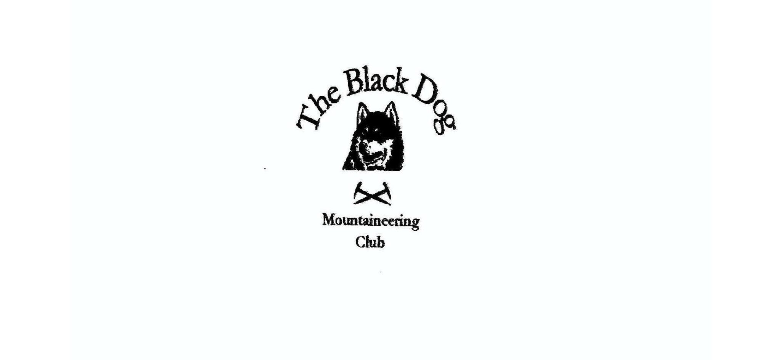
Black Dog Meet

No. 213 Newtonmore

Fri 22nd - Sun 24th November 2019

In Attendance

Charles Alexander Liz Kennedy
David Cameron Mike McLaggan
Bill Clark Lorna Smith
Wull Clark Tony Smith
Gerry Feeney Alan Sewell
Val Inglis James Yeats
Buster (dog)

Mountains Climbed

Friday The Sow of Atholl (803m)
The Fara (911m)
+Aladdin’s Couloir

Saturday Gairbeinn (896m)
Carn Sgulain (920m)
Meall na Teanga (918m)
Carn Dearg (835m)
Meall na h-Aisre (862m)

Sunday Meall Chuaich (951m)

Weather

Friday was at least dry but with a fresh wind and poor visibility above ca650m. Saturday was cool but less windy and again no visibility at high level. Sunday was wet, cold and misty.

Notes / Highlights

Friday

For Val, Liz, Davie, Charles, Lorna & Tony the first stop was House of Bruar (not to everybody’s liking!) for coffee. All then joined Wull at Dalnaspidal and climbed The Sow. Easy track initially before wet ground and snow. It was very cold during a brief stop on the summit. No view.

James and Gerry set out from Dalwhinnie station along the shore of Loch Ericht. Having overshot the turn off (not obvious due to logging operations) they climbed a steep grassy firebreak and then headed directly across moorland. Hard going in the final snow. A later start meant it was almost dark on the return to the car (photographic evidence available!).

Meanwhile Alan travelled via the Cairngorms and did a solo ascent of Aladdin’s Couloir (Coire an t-Sneachda). Icy conditions for the walk in and mist down into the coire didn’t make for perfect conditions but navigation of the plateau proved the hardest part of the day.

Saturday

James and Gerry’s plan to include Corrieyairack Hill with Gairbeinn was hastily modified when they realised they had started from Garva Bridge rather than Melgarve (nothing like a good long road tramp!). The walk over boggy moorland was made easier with the discovery of an ATV track and the walk back was fortunately completed before the late rain came on.

Val, Liz, Wull and Davie also headed out to Garva Bridge for Meall na h-Airse ‘by the book’.

Carn Dearg (East of Glen Roy) was the achieved target for Alan, Mike and Buster.

Lorna, Tony and Charles took a very short drive to the Glen Banchor car park and walked almost due North on, successively, a track, a path and a bog. At the head of the glen they elected to turn west up the “deep little glen” between the two Munros although, in hindsight, this was probably not the best option. A clockwise circuit over the summit, at times on (and in!) snow brought them back to the river for the return bog-hop.

I set off early for the drive over to Loch Lochy and my start point for Meall na Teanga at Kilfinnan.

Sunday

Only Mike and Buster ventured out on what looked, from the warm and dry car, to be a thoroughly miserable day.

A very enjoyable weekend.

Bill

Next Meet

Braemar 13th to 15th December. Meet organiser Valerie

