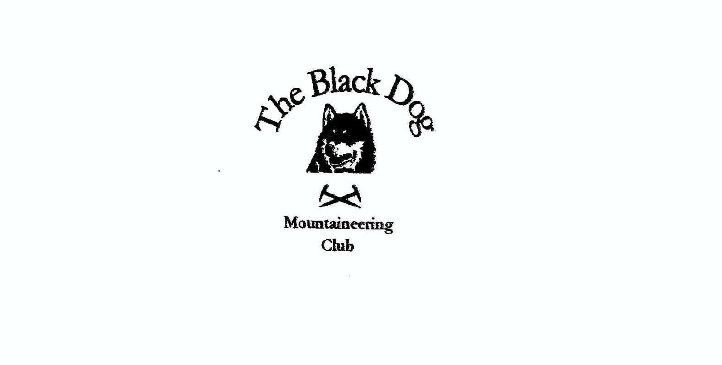

**Black Dog Meet**

**No. 216 Tulloch**

Friday 6th – Sunday 8th March 2020

**In Attendance**

John McGill, James Yeats, David Cameron, Alan Sewell, Liz Kennedy, Lorna Smith, Peter Robertson, Owen Clark, Rachael Clark, Valerie Inglis, Wull Clark

# **Hills Climbed**

**Friday**

Lorna, James Sow of Atholl (803m)

Valerie, Wull Creag Dhubh (658m)

Al Beinn a’ Chaorainn (1052m) via the east ridge – grade 2

**Saturday**

Lorna, Owen, Rachael Carn an Fhreiceadain (878m)

James, David, Liz, Wull

Peter Corrour to Fersit via Loch Ossian

**Weather**

Good dry largely bright weather on Friday with largely good visability on the lower hills. Miserable cold with very low cloud on Saturday.

**Notes / Highlights**

On Friday Lorna and James set off from Dalnaspidal around 12 pm to climb The Sow of Atholl. Walking the track into the hill was awkward, with narrow wheel ruts and a combination of soft and hard snow. At the end of the track no path was visible, so the pair set off uphill through the snow until they encountered fresh tracks made by a snow vehicle. The compressed snow allowed easier walking and took them indirectly towards the top. After a brief stop, they headed directly to the track making fast progress through the soft deep snow, arriving back at the car at 2.45 pm

Alan solo climbed the East Ridge (Grade 2) of Beinn a’ Chaorainn. The summit white out conditions proved rather tricky in navigating a safe path back to the glen.

Valerie & Wull climbed Creag Dhubh from the graveyard at Achluachrach – a short and pleasant route, weather fine but the bigger hills were covered in cloud.

The Station bunkhouse was a bit odd, but Lorna, who had recently celebrated a birthday had kindly brought along gins and tonics and all sorts of naughty goodies for us all to have a belated celebration and this soothed the pain of the surroundings.

John arrived from work on Friday evening in a bit of a flap having realized he had left all his gear for the weekend in the car porch at home. He was all set to turn round and drive home but he was persuaded to stay for the night and drive home in the morning.

On Saturday Lorna, Owen, Rachael, James, David, Liz & Wull climbed Carn an Fhreiceadain from the Kingussie golf club. After a false start they all got back on track. The hill was on track all the way, and the group got to the summit in clag, wind and snow but on the way back found a nice wee shelter where they stopped for a bite to eat.

Peter caught the train to Corrour and walked back passed Loch Ossian and Fersit. Alan went to Kinlochleven for a spot of climbing.

**Next Meet**

Was supposed to be Arran but this was cancelled due to the Covid pandemic.

*Wull*