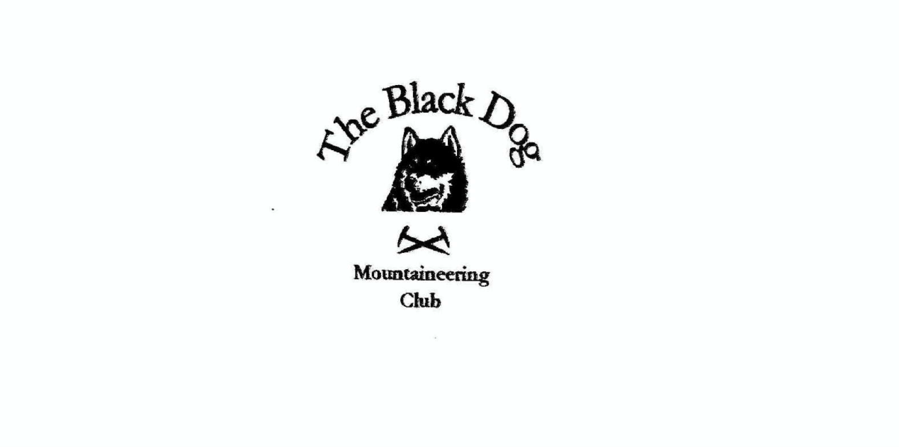

**Black Dog Meet**

**No. 221 Glen Shee**

Saturday 26th September 2020

**In Attendance**

Charles Alexander Wull Clark Gerry Feeney Valerie Inglis

Liz Kennedy Richard Marwood Alan Sewell Tony Smith James Yeats

# **Mountains Climbed**

Valerie, Wull, Gerry, Liz and James Carn Aosda (917m),

Carn a’ Gheoidh (975m)

Carn Bhinnein (917m)

The Cairnwell ((933m)

Richard Carn a’ Gheoidh (975m)

Alan, Charles and Tony Creag an Dubh Shluic (728m)

Ben Earb (801m)

Meall a’ Choire Bhuidhe (868m)

Meall Ruigh Mor Thearlaich (815m)

Carn Dearg (786m)

Carn Dearg N Top (770m)

**Weather**

On the whole a bright day, but cold and very windy.

**Notes / Highlights**

Due to covid restrictions this meet was a rearrangement of the scheduled Skye meet.

After a pleasant, socially distanced, and thoroughly necessary expedition planning meeting outside a derelict hotel at Spittal at 0900, several cars ‘raced’ up the hill to the Glenshee ski car park. Richard thought it wise not to join the other five BDMC walkers due to pacing issues, but he certainly wasn't expecting to become hypothermic in the car park. He found he was unable to tie his bootlaces because he couldn't feel his hands. Not known for being under-equipped he put on every item of clothing and emergency clothing that he had. He then went into the cafe until his body temperature had normalised and he could secure his footwear.

Rather than take the rather industrial and circuitous track round to the north of the Cairnwell ridge he headed straight up the route of the Ski Tow onto the ridge in an attempt to cut the other group off at the pass. A cunning plan that failed, but was never intended to be a requirement of the day. He could see them ahead but in time they were gone. He stuck with the simple objective of summiting Carn a’ Gheoidh in the superb but unforgiving (particularly unforgiving on the day) uplands, away from the ski area. His hat was useless for the 50mph winds and he will be seeking technical advice from club members in due course.

Despite the mostly solitary nature of his walk, he believes it was symbolically definitely a club meet, and is keen for more when possible. Weirdly on his way down he met some good friends from Edzell on their way up. Or maybe that was a hallucination born of loneliness and hypothermia...

Gerry, James, Wull, Liz and Val started from the main car park in Glenshee and climbed Carn Aosda (917m), Carn a’ Gheoidh (975m), Carn Bhinnein (top 917m) and The Cairnwell ((933m). The weather was clear and bright but very windy and cold. The most severe wind was at the outlying top where the average wind speed was

48 mph, with gusts of 60 mph, measured with Wull's wind meter. It was so cold that nearly everybody they saw was wearing a buff, not to prevent the spread of Covid, but to try to prevent frost bite. From the summits they could see a fine covering of new snow on the tops of the bigger of the Cairngorm hills in the direction of Ben Macdui.

Gerry noted that they hunkered down below the top of Carn Bhinnen to have lunch out of the houllie which was blowing around the summit. When it came time to leave our tranquil spot Val remarked "this is going to be like going over the top in the First World War". Gerry responded that he would be Blackadder and the others could work out who would be Baldrick, but can’t remember the decision reached. Answers/suggestions on a post card please!

The hills were very busy with walkers making the most of the weather. From the summit of The Cairnwell they dropped straight down to the cafe where they were all treated to a very welcome coffee by Liz (the only one with the means to pay as the others had all conveniently not taken cash or card).

From the Spittal of Glenshee Tony, Charles and Alan headed up the Cateran Trail to An Lairig, where they headed NW over six SIMMS (one of which is a Hump, or so I’m told). This is a good walk, particularly over Ben Earb and Meall a’ Choire Bhuidhe, with stunning views out west beyond Ben Vrackie and Beinn a’ Ghlo to Ben Lawers, Ben More and Stob Binnein. Large herds of deer were seen, along with the odd vole and buzzard.

Although the forecast was for a fine day, albeit breezy, I don’t think any of us had predicted the severity of the wind on the summits. This made for very difficult walking conditions.

**Next Meet**

Boat of Garten. 23rd to 25th October. The meet organiser is James.

**Note** - Again due to Covid restrictions this is likely to be rearranged as a day meet - with the venue to be decided. Please look out for further e-mail communications.

*Alan*