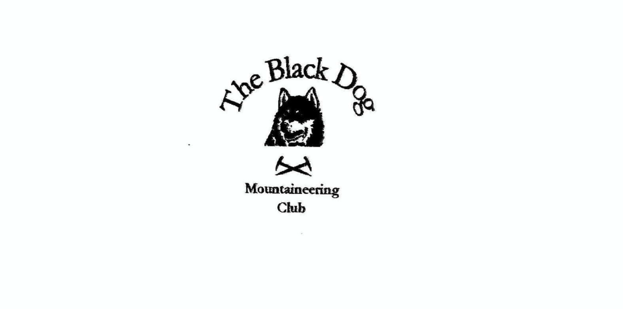

**Black Dog Meet**

**No. 224 Corran**

Friday 25th to Sunday 27th June 2021

**In Attendance**

Charles Alexander John McGill

David Cameron Alan Sewell

Wull Clark Russell Shanks

Valerie Inglis Barry Smith

Liz Kennedy Tony Smith

Richard Marwood James Yeats

# **Mountains Climbed**

**Friday**

Charles and Tony Beinn Eilde (674m), Creag nan Adhaircean (649m) and Meall nan Eagan SW top (588m).

Davie Sgùrr Èilde Beag (956m) and

Na Gruagaichean (1054m).

Valerie & Wull Buachaille Etive Beag - Stob Dubh (958m) and

Stob Coire Raineach (925m)

James Sgurr an Fhuarain (901m) and Sgurr Mor (1003m)

Liz & Gerry Ben Ledi (879m) then Gerry added Benvane (821m)

**Saturday**

Davie Garbh Bheinn (885m)

Wull, Valerie & Liz Stob Ban (999m) & Mullach nan Coirean (939m) along with the adjacent tops.

James & Barry Stob Coir an Albannaich (1044m) and

Meall nan Eun (928m)

Charles, Richard & Tony Maol Odhar E top (715m), Meall a'Choirean Luachraich (537m) and Meall a'Bhraghaid (510m)

Charles & Tony added Maol Odhar (794m)

John Aonach Beag (1234m) and

Aonach Mor (1221m)

**Sunday**

John Meall na Teanga (918m)

Barry & Tony Sron a'Choire Ghairbh (937m), Meall na Teanga (917m) and Meall Coire Lochain (906m)

(Tony added Meall a'Choire Ghlais (901m) and

Meall Dubh (837m))

James Sgor na h-Ulaidh (994m)

**Weather**

As is usual in Scotland, the weather depended on exactly where you were. Friday was generally fine with the occasional shower and variable wind. Davie reported a shower of sleety snow in the Mamores on Friday and his first sunburn in over a year on the Saturday, which was mainly glorious sunshine.

**Notes / Highlights**

First the climbers’ (Alan & Russell) report.

Friday

To avoid most of the showers we decided to head to Glen Nevis for an afternoons cragging, where we climbed “Resurrection - VS 4c ***” and “Right wall VD **” on Styx Buttress. We starting up “Damnation VS 4c ***” when the heavens opened - fortunately before the crux roof and the delicate upper slab - which meant having to bail by down climbing and retrieving the gear on an abseil. A local guide who was running a crag rescue training session nearby commented on our text book (?) reversal.

Saturday

We caught the ferry and cycled around to Glen Gour to the bottom of Indian Slab Crag where we climbed “Millennium Direct Severe 4a ***” and “Indian Slab VS 4b ***”. The rough cycle was made up for by 9 beautiful pitches of slab climbing on rough gneiss. We never saw another soul all day.

Sunday

We went back to Glen Nevis for the unfinished business of “Damnation VS 4c ***”.

After powering through the roof and the bold top slab I was so glad we had bailed on Friday rather than push on under the wet conditions.

And a few words from the hill walkers:

Friday

Charles. “Lots of heavy going between hills but good tracks in and out.”

David walked from near the ice factory towards Loch Eilde Mor, over the hills (a fine ridge) and back by the abandoned Mamore Lodge hotel.

James climbed Sgurr an Fhuarain & Sgurr Mor from the Loch Arkaig carpark. “The path, although boggy in places wasn’t too bad, and the rivers were no problem crossing. The pathless slope up Sgurr an Fhuarain was a bit of a slog. On reaching Sgurr Mor I retraced my steps for the return route.”

Valerie and Wull “had a lovely day on the Wee Shephard, taking it easy after a full week of climbing hills in the area. It was a bit breezy but completely clear and the views of Glencoe were stunning.”

Saturday

David, Richard, Tony and Charles caught the ferry to Ardgour where David experienced his first sunburn in over a year whilst bagging the Corbett. Meanwhile Richard joined Charles and Tony for a fine horseshoe round the Allt Coire Mheall Challuim glen starting from a new hydro scheme on the B8043 (useful adjacent parking and a new track up to the dam). Richard was delighted with his improved fitness which is still “a work in progress”.

John enjoyed the Aonachs, doing the two tops coming back down into Glen Nevis. “Sgurr a Bhuic is particularly disconcerting as Glen Nevis started clearing I could see it from the other top & you are thinking that is a long way down. I decided against the two tops on the spur to the north. They were in cloud & I was quite happily standing above a high inversion that day.”

James and Barry climbed Stob Coir an Albannaich & Meall nan Eun. “Setting off from the bunkhouse at 07:00 to ensure we could get a parking space at the Coiletir track. The southern end of Glen Etive is currently undergoing major ground works for hydro electric dams with scars of new tracks and pipes going up the side glens. We initially overshot the parking space as it is now looking more like an industrial site.

We followed the path alongside the Allt Meirleach through the bracken but improved as we progressed. Topping both Stob Coir'an Albannaich and Meall nan Eun, with a descent through crags and rough, tussocky terrain to meet up with a new bulldozed road at the end.”

Wull, Liz and Valerie “climbed up the usual route over Mullach nan Coirean first. It was claggy and cold initially all the way up to the first Munro, but conditions improved as the day went on and as we traversed from the first Munro to the second the clouds cleared and the views over the Mamores and over to Ben Nevis were fabulous. I always forget just how long a walk off the hill it is. Great day”.

Sunday

Barry and Tony took the Loch Lochy Munros starting from the Arkaig road at the Eas Chia-aig waterfalls car park to allow easier inclusion of the outlying Simm. The initial new forest/hydro road soon gave way to an undulating path and latterly some rough ground. Certainly not the best way to the main col!

James climbed Sgor na h-Ulaidh from Glencoe. This walk omitted the Corbett Meall Lighiche as fatigue from the previous days’ efforts was being felt. The climb up to the Aonach Dubh a Ghlinne ridge bealach was hard going in the sun with no real path. Was happy to reach the top Stob an Fhuarain and onwards to the summit in excellent visibility.”

With the variety of hills climbed over the weekend, all types of terrain were encountered. Heavy slogs were mentioned a few times and the relatively new phenomenon of tracks associated with hydro schemes got a couple of mentions. These tracks are generally not shown on maps.

Some photographs are on the web but please share others if you have.

[Corran photos](https://flic.kr/s/aHsmWaEGti)

Signing off from meet reporting, hooray!

*Charles*

**Next Meet**

Aultguish, 23rd to 25th July. Organiser is Valerie