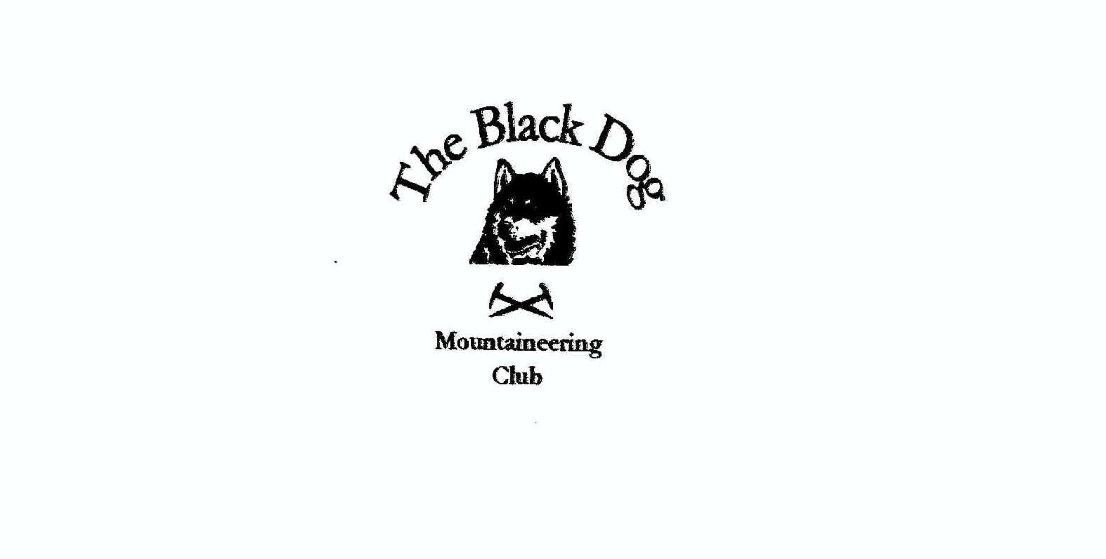 **Black Dog Meet**

**No. 225 Aultguish**

23rd – 24th July 2021

**In Attendance** Charles Alexander, David Cameron, Bill Clark, Owen Clark

Wull Clark, Gerry Feeney, Valerie Inglis, Liz Kennedy,

Alan Sewell, Tony Smith , James Yeats

# **Hills Climbed**

**Friday**

David, Valerie, Wull Breabag (815m)

Charles, Gerry, Liz Beinn a’ Chaisteil (787m)

James Ben Klibreck (961m)

Owen Beinn Dearg (1084m),

Cona’ Mheall (980m)

Meall nan Ceapraichean (977m)

Eididh nan Clach Geala (928m)

Tony Meall a'Chuaille (629m),

Carn Gorm Loch (909m)

Creag Clachach (705m)

**Saturday**

Alan Beinn nan Ramh (711m)

Bill, David, James, Valerie, Wull Biden a' Ghlas Thuill (1062m)

Charles, Gerry, Liz Sgurr Breac (999m), A’ Chailleach (997m)

Owen, Tony Am Faochagach (953m)

Sron Liath (761m)

Tom Ban Mor (742m)

**Sunday**

Tony Meall Mhic Iomhair (606m),

Meallan a'Mhuthaidh (513m),

Beinn a'Bhric (442m)

Beinn nan Cabag (474m)

**Weather**

Hot, very hot. An extraordinary spell of weather.

**Notes / Highlights**

# It was, without exception, the hottest Blackdog MC meet I can recall with an unprecedented spell of intense sun and high temperatures and little breeze to alleviate the symptoms.

The Aultguish Inn was very welcoming, and it was lovely to be able to sit outside in the sun to enjoy a few beers. Unfortunately, it was the last weekend that they will offer budget accommodation with self-catering facilities, as they are upgrading to hotel accommodation only to meet with the changing market, so potentially the last Black Dog meet at that location.

**Friday**

**Tony** - A cycle up Strath Vaich from Black Bridge to about 3k beyond Lubachlaggan the steep direct ascent of Meall a'Chuaille (629m) via unmarked and obviously little used stalkers' path. Thereafter fine horseshoe (deep bog, despite dry weather, at the col I could have done without) round to Carn Gorm Loch (909m) and the fine monument on Creag Clachach (705m). A rather tiresome cycle/walk back out given the conditions.

**Gerry** - Charles, Liz and I climbed Beinn a Chaisteil from Black Bridge on Friday. We cycled to as far as Luibachlaggan then set of to the summit and back the same way.

**James** – I climbed Ben Klibreck. The parking space at the Vagastie Bridge is now the site entrance for a large windfarm project so had to park 200m south from here. Took the usual route via Cnoc Sgriodain, initially mist making visibility very poor however broke through clouds at around 400m into blue sky. A hot day battling with clegs, midges and flies got back after a 5 hour walk without incident.

**Valerie** – David, Wull and I climbed Breabag in scorching conditions, starting with a walk up the glen past the Bone Caves. It was so hot, there were a couple of times we had to stop to breathe and regroup. The most wonderful part of the day was on the way off, when we took our boots off and bathed our feet in the cold waters of the water well, followed by an icy cold elderflower cordial at the refreshment van.

**Owen** – 06:00 Set off before breakfast to get height before the heat of the day.

Followed the forestry track through the plantation along the River Lael shortly breaking through the trees out into Gleann na Sguaib. Continued up the glen mostly in shade as the sun had yet to clear the peaks arriving at Lochain Uaine at 08:30; now in full sun.

The vistas to the East and North were amazing with full cloud inversion; quite breath-taking.  One was compelled to take a moment of reflection almost reverently so.

The sojourn to Beinn Dearg continued with the promise of even better views arriving at the summit 09:30 the views continued to delight. From here in the heat of the day began to build. Dropping from Beinn Dearg and heading towards Cona’ Mheall should have been straight forward but the heat and walking into the sun took its toll and my pace dropped off.  Arrival at the summit of the second Munro of the day was blighted by a blizzard if flies who had no right to be part of such a beautiful vista.

Returned to Lochain Uaine and looked up at Meall nan Ceapraichean for a while contemplating my water consumption against the remaining route in front of me. Knowing that there was water about and that I had several escape routes should I have need of them I continued onwards and quickly summitted Munro #3 of the day.

Despite my pace dropping as the heat of the day continued to rise I made steady progress towards the bealach below Ceann Garbh Meall nan Ceapraichean.

Arriving at the lochans scattered around the bealach I found that the water was too inviting to be ignored.  I limited myself to submerging only my feet into to the cool waters.

Boots back on and a stern self-motivating chat I set off up the last Munro of the day.  Coming across an Owen sized overhang was too good an opportunity to pass and I enjoyed a wee break from the pounding heat of the sun while enjoying my now vastly depleted liquids and a wee bite to eat.  Eventually prising myself from my hiding spot I continued up onto the summit of Eididh nan Clach Geala arriving at approx. 15:00; Munro #4 of the day with stunning views to the North and West.  Seana Bhraigh to the North East looking particularly inviting under the blue skies. Last mouthful of carried in liquid was my reward for completing the Munro tally with just the wee task of getting down left to sort out. Priority was finding a water source which had not spent the last week baking in the sun.  A suitable candidate was found on the southern slope, below Creag Tuath a’ Chapaich, which was just deep enough to allow me to submerge my straw and drink deeply.  Refreshed I soon joined the stalkers path below Lochan a’ Chnapaich which follows a larger stream allowing me to replenish my water and continue my sojourn back down the glen.

Day ended in the grand company of smiling Black Dogs and a well-deserved beer!

**Saturday**

**Tony** - With Owen up Am Faochagach (953m) via crossing of the almost non-existent Abhainn a' Gharbhrain. We returned down the wide ridge over Sron Liath (761m) and Tom Ban Mor (742m) before decending to the Glascarnoch dam where we had left the second car.

**Alan** - I climbed Beinn nan Ramh from Kinlochewe. An early start was rewarded with a temperature inversion in the glens which burnt back quickly to give a soaring midday heat for the steady pull up to the summit of the graham. A fantastic view point for the Torridon, Fisherfield and Fannich hills.

**Gerry** – Liz, Charles and I set off to climb Sgurr Breac and A'Chailleach. We reached the ridge linking the two from Leitir Fhearna.  Sgurr Breac was climbed by the three of us but Charles decided to give A ' Chailleach a miss. We returned by the same route. It was taps aff weather, as proved by a couple of guys not wearing a t-shirt.

**Valerie** – Five of us set off early for an Teallach, starting at a layby just east of Dundonnell. Our route took us up the glen by the burn which provided welcome relief from the heat which was intense and made the walking quite arduous. We made it to the top of our first Munro where we bumped into Mike McLaggan and his friends from the Tayside MRT who were out on a leisure day. Shortly before the ascent to our second Munro of the day, one of our party became unwell with the heat and it was clear we were in need of assistance. A passing walker alerted Mike and his colleagues, including the team GP and paramedic, who were soon in attendance. Whilst our casualty thankfully recovered well, the MRT decided it was unsafe to try to walk him off the mountain due to the continuing heat, so the chopper was scrambled and our friend was lifted off to Raigmore Hospital where he was checked over and later discharged with no further treatment. The remaining party was escorted safely off the hill.

Our heartfelt thanks goes to the Tayside MRT along with a token of appreciation from the BDMC.

**Sunday**

**Tony** - A full exploration of the hills south of Aultguish round the Lochluichart wind farm and its new (as yet unmapped) neighbour Corriemoillie. The turbines ruin what would be a fantastic view west to the Fannichs, particularly the spectacular Garbh Coire Mor on An Coileachan but the roads do make access to these hills much easier.

Alan has created a photo album to upload your photos.

[Aultguish photos](https://flic.kr/s/aHsmWgAVKu)

Thank you 😊

**Next Meet**

Ratagan SYHA, 20-22 August, 2021 Meet organiser – Tony

*Valerie*