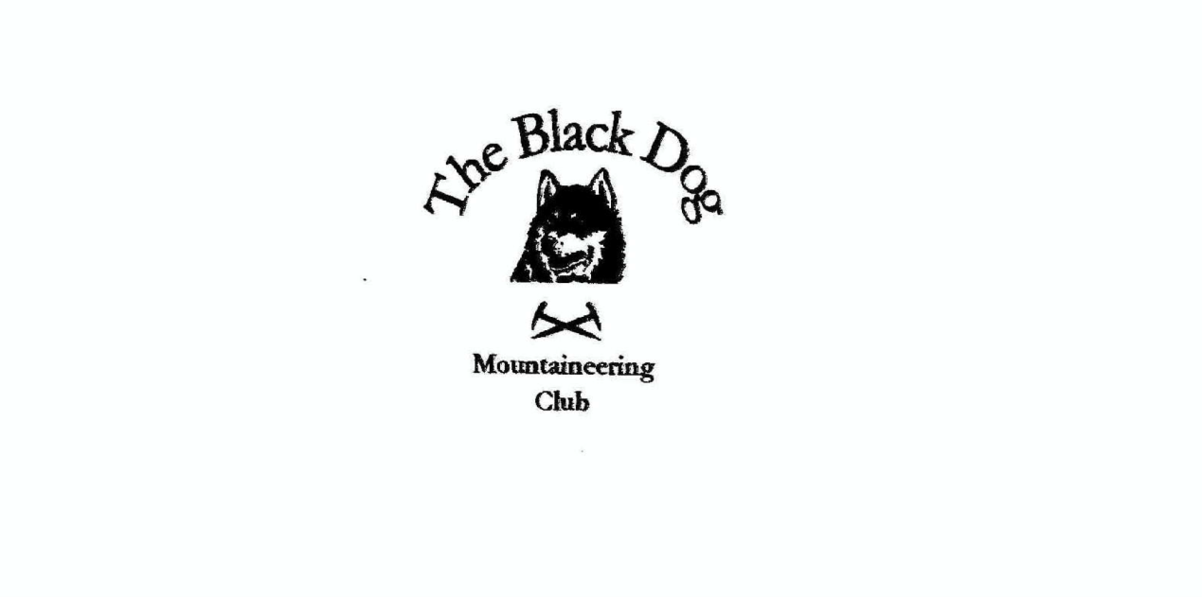

**Black Dog Meet**

**No. 226 Ratagan**

Friday 20th to Sunday 22nd August 2021

**In Attendance**

Charles Alexander Richard Marwood

David Cameron Peter Robertson

Gillian Clark Alan Sewell

Owen Clark Lorna Smith

Wull Clark Tony Smith

Ruth Cranswick Matthew Spencer

Valerie Inglis Rachel Yeats

Liz Kennedy James Yeats

# **Mountains Climbed**

**Friday**

James Beinn Fhada (1032m)

Alan Mullach Coire nan Geur-oirean (727m)

Lorna & Tony Glas Bheinn (729m) & Creag na h-Iolaire (706m)

Charles & Matthew Am Bathach (798m)

Valerie, Wull, David & Liz Sgùrr a' Mhaoraich, (1027m)

**Saturday**

James, Alan, Richard, Ruth,

Matthew, Gillian & Rachel Biod an Fhithich (644m)

Lorna & Tony Beinn a’Mheadhoin (263m) & Beinn Bhuidhe (278m)

Charles, Peter & Owen “The Five Sisters of Kintail”

Valerie, Wull, David & Liz “The Brothers”

**Sunday**

Tony Beinn Raimh (448m)

**Weather**

The weekend was a bit of a “mixed bag”. It was warm, claggy at times, with both clear views and very heavy rain. You just had to avoid being in the wrong place at the wrong time.

**Notes / Highlights**

**Friday**

Alan climbed the Graham having cycled in from the east end of Loch Arkaig. “I would have cycled further than I did but I was diverted by some stalking taking place far up Glen Mallie. All in all this was a nice 30km round trip with some pleasant views of the surrounding hills.”

James climbed Beinn Fhada, setting off from Morvich toward Bealach an Sgairne and around Coire an Sgairne to the top. “The mist came in at the top so returned the same way.” Meanwhile Rachel walked from Morvich on the Affric Kintail Way to Glenlicht House and back.

Charles and Matthew started up through a gate on to an old forestry track through the felled and replanted forest. We climbed a deer fence to get on to the open hillside then struck a path up the ridge. The sun came out and it was a lovely day but we did not see any wildlife. We met one walker on his way down and a small family group at the summit. They went on to do the Munro but we turned off at the Bealach a’ Choinich and down the An Caorann Mor path. A pleasant four hour walk without taxing navigation skills or stamina.

The Glasgow ‘crew’ parked at the bridge over the River Quoich and headed north up the track, and up the shoulder at the back of the Munro taking in Am Bathaich on the way. The clouds cleared from time to time and it made for a great route. Good views, but the loch is a bit ugly as the water levels are quite low.  Interesting replacement of the old rusty transmission line pylons with a more solid metal design more akin to the likes of Switzerland.

Lorna and Tony travelled via slightly circuitous route to take in two hills just north of Lochcarron. “We parked by the tricky looking first tee of the golf course and gained access to the hills from Tullich House. After a couple of miles on the reasonably obvious path it was a steep ascent to the col, from which we visited each summit in turn before descending by the same route to join a new hydro scheme track leading back out to the main road. By coincidence the more northerly of the hills shares its name (Hill of the Eagle) with my recent final Angus hill in Glen Esk – and we again didn’t see the bird.”

**Saturday**

The Biod an Fhithich group report a very pleasant hill with a stalkers path giving easy access almost all the way to the summit although Rachel and Gillian opted to turn back at around 350m. They were rewarded with some views and luckily managed to get back to the car before the heavens opened.

Charles, Peter and Owen tackled the Five Sisters West to East parking at the Kintail Lodge Hotel at approx. 08:00 to head onto a good track on the West side of the Allt a' Chruinn stream. “After a short distance the path crossed the stream on to a very well built NTS footpath (Tony and Charles saw this under construction several years ago).

Having been warned that if the bridge was out we would be waist deep in a river crossing we were very disappointed to encounter a water depth that barely wet our boot treads. Our route followed the water providing a long steady ascent to the ridge, fuelled by jelly babies. Under the disdainful gaze of a solitary sheep we continued to gain height following the now distinct ridge. The ascent to Beinn Bhuidhe offered fine views back towards the west and glimpses to the north and south.  Jackets were donned to fend off rain that soon moved on and left us dry for our continued ascent.  We quickly gained height on the ridge and arrived at Sgurr nan Saighead (929m) in good order approx. 10:30.  Following the ridge south (and “hamstering” more jelly babies) we moved on to Sgurr Fhuraran (1067m) our first Munro of the day.  Fine views from the summit between the banks of mist and the sound of dogs barking down in the Glen.  Quick bite to eat and onwards. The route south offered a fine scramble on the up which would have been trickier on the down.  On this section we met our first fellow walker of the day coming towards us from the south.  We reached the summit of our second Munro, Sgurr na Carnach (1002m) at approx. 12:00.  No stopping here (Peter was imagining steak pie for his evening meal by this point) and moving quickly on, passing two ptarmigan, to descend to Bealach na Craoibhe where we encounter two more fellow walkers this time moving along the ridge in the same direction as us.  The ascent to our final Munro Sgurr na Ciste Duibhe (1027m) reached, for well earned lunch, at approx 14.00) offered up some more opportunities to holster our walking poles and put our hands to good use helping us gain height. Off to the East now with our final descent and re-ascent to gain Sgurr nan Spainteach (990m) this section of our day saw an increase in rain which became more persistent as we continued towards Beinn Odhar. On this stretch we met our fourth and final fellow walker of the day; this time walking towards us along the ridge.  From here the weather gave brief respite and some fleeting glimpses of the Brothers further along the ridge.  The final section offered some fine ridge walking as we approached our route down at Bealach an Lapain which was reached at approx. 15:45.  Unfortunately our path down had been turned into a watercourse by the rain and the going was tricky.  Not a dry rear in the party by the time we hit the Glen Shiel car park.  Our walk was completed at approx. 16:40 and our weary souls (and soles) were collected by Mrs Clark and Mr Yeats; both a welcome sight.”

The Brothers group took advantage of having two cars and did a south to north walk over the Munros. There were odd glimpses of the ridge through the clouds which made it worthwhile. The rain started for real just before we got back to the cars. The ridge never fails to please although one member of the party commented “when you are on the ridge it feels like five Munros rather than three."

Lorna and Tony ventured over to Skye but stayed well clear of the obvious tourist spots. “Leaving the car by the Suardal grave yard we did a good loop heading south by the Boreraig track (interesting geology and remains of old marble workings) before crossing the hills and returning north on the old Suisnish coastal road. Despite the very modest heights involved the hill crossing was hard work given the wet nature of the long grass and deep heather. The area is well worth exploring but unless you’re bagging minor hills stick to the marked trail!”

Sunday

My comment for Sunday is “More long and rough wet grass with a stretch of thick pine forest added in for good measure so that I could claim one of the more notoriously awkward Humps. Been there, done that and definitely will not be going back.”

To celebrate a certain “Presidential” significant milestone we had a wee Birthday party on the Saturday evening. Thank you to Lorna for the cake. One related comment “too puggled and went to bed at 22:15, I think the party carried on, but I cannot remember as I was out like a light.”

Photographs are on Flickr as usual. Additions welcome.

[Ratagan Photos](https://flic.kr/s/aHsmWyiQpC)

*Tony*

**Next Meet**

Lochinver 1st to 3rd October. Organiser is Wull