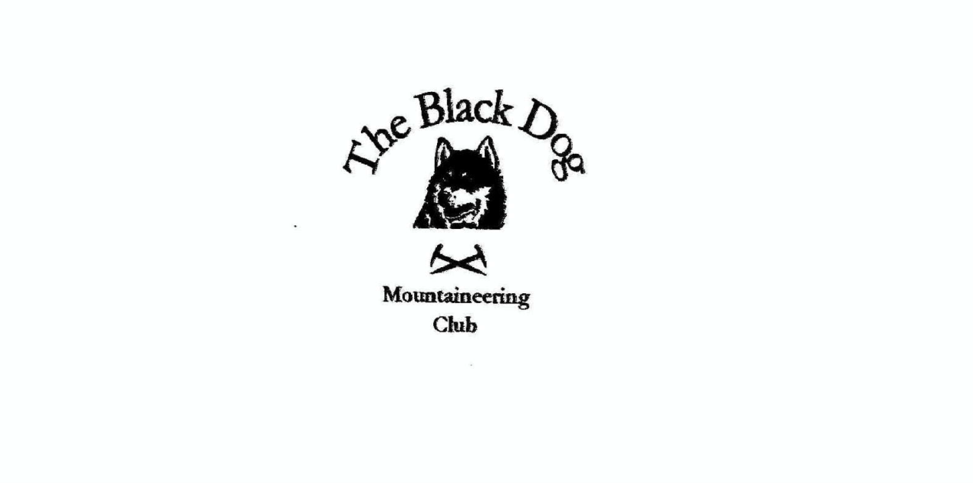

**Black Dog Meet**

**No. 227 Lochinver**

Friday 1st to Sunday 3rd October 2021

**In Attendance**

Charles Alexander David Cameron

Owen Clark Wull Clark

Gerry Feeney Val Inglis

Liz Kennedy Peter Robertson

James Yeats Rachel Yeats

# **Mountains Climbed**

**Friday**

Peter Cairn na Caim (941m)

Liz Ben Hope (927m)

Gerry & Charles Meall Daimh (532m)

Wull, Val & David Meall Doire Faid (730m)

**Saturday**

Owen & James Suilven (731m)

Peter Ben Stack (721m)

Liz, Charles & Gerry Ben More Assynt (998m) & Conival (987m)

Val, Wull & David Beinn Spionnaidh (772m) & Cranstackie (800m)

**Sunday**

Peter Ben Wyvis – Glas Leathad Mor (1046m)

**Weather**

A mixed weekend!

**Notes / Highlights**

**Friday**

Peter climbed Cairn na Caim at Dalwhinnie.

Liz was on the most northerly Munro, Ben Hope.

Gerry & Charles set out to climb the Corbett Beinn Liath Mhor a’Ghiubhais Li but due to the high winds and driving rain decided to turn back on the summit of Meall Daimh 532m, (Editor’s note. This is a Tump).

Just along the road a wee bit Wull, Valerie and David climbed Meall Doire Faid. “We seemed to miss most of the bad weather that we could see all around us.”

**Saturday**

Saturday brought in some slightly better weather Liz, Gerry and Charles spent the day on Ben More Assynt and Conival on reasonable tracks with the weather mostly fair and cold.

Peter headed out to climb Ben Stack where he had a great day with very little climbing, traversing the ridge from east to west having excellent views to the coast.

David, Valerie and Wull set off north to climb Beinn Spionnaidh and Cranstackie. “We ascended Cranstackie first then back along to Beinn Spionnaidh with great views all day. Got back to the track and about 30 minutes from the car the rain came on.”

James and Owen went out to do Suilven as Owen reports:

“Set the alarm early to catch the best of the weather enabling us to set off at 08:00 from Glencanisp Lodge. James still doubtful of the day’s choice and the 7 plus hours of hiking that went with it.

An early morning stag roaring from up the glen, our starter’s gun, as we set off with Suilven in front of us, backlit by the rising sun. Long trek on an improving track (that frustratingly never appears to quite point in the direction of the mountain) all to ourselves until we neared the bothy at Suileag where we encounter two fellows, walking out, thoroughly defeated by the previous days weather.

Along the way we noted a wee brown bird too fast to be identified properly and conversely a cormorant too lazy (or more likely too full of fish) to evade being recognised.

The path finally turns towards Suilven just NW of Loch na Gainimh.  This section to the foot of the mountain was superb underfoot speeding us towards the gully where our ascent begins in earnest. Zigzagging our way up to Bealach Mor fuelled by jelly babies and stopping briefly to admire a pulpit like rock formation just below the bealach.

We were ready to see the view and expected it to be good but the reality on stepping out of the gully and onto the ridge was simply breath-taking. In full sunshine the wind momentarily forgotten we stood transfixed taking in the vista to the south; James now thoroughly convinced of the choice of hill. Cameras down and food in the belly we set off once more to the summit Caisteal Liath.

Our early start had rewarded us with the mountain all to ourselves as we ascended the ridge dropping in and out of wind at the whim of the mountain topography.

The summit itself (reached at approx. 11:00) was bizarrely calm allowing us to enjoy another bite to eat while taking in Quinag to the north and Stac Pollaidh to the south.

Brief discussion and decision made to move towards Meall Meadhonach while assessing the effect of the wind on us as we neared. Just at the drystone wall we encounter our first fellow hikers and then at the bealach a further group of six.

The next piece of the ridge traverse continued to supply stunning views and small sections of exposure with more unpredictable pockets of wind and calm.

At Meall Meadhonach the path disappeared as the terrain underfoot became the bare rock of the mountain. We persevered until faced with an exposed 2+ metre wall (within 15 metres of the summit) which neither of us particularly wanted to down climb on the return.

The day was cooling and the wind more constant at this point on the mountain persuading us to leave the second top for another day. We set off back along the ridge to the bealach enjoying the views west as much as we did the views east.

Our descent (fuelled by a delicious chocolate brownie) soon caught us up with the first couple we had met and as we descended deeper into the gully two ravens flew above and around us.

Passing another couple on the ascent as we descended we soon were back on level ground retracing our earlier steps along the path (did I mention it was superb?).

At the junction with the main path though the glen we met back up with the party of six as they recovered their heavy gear which proved to be our last encounter of the day.

Marching back along the long and now more noticeably undulating approach path we made good time arriving back at our start point at 15:00 (approx.).

All in all a glorious October day on my first deliberate Graham.”

Sunday

Peter was the only one to venture out. A foul day on Ben Wyvis.

The bunkhouse was much better than the last time we stayed, thankfully some people chose to eat out as the kitchen and seating area is very small.

*Wull*

**Next Meet**

Boat of Garten 29th to 31st October. Organiser is James