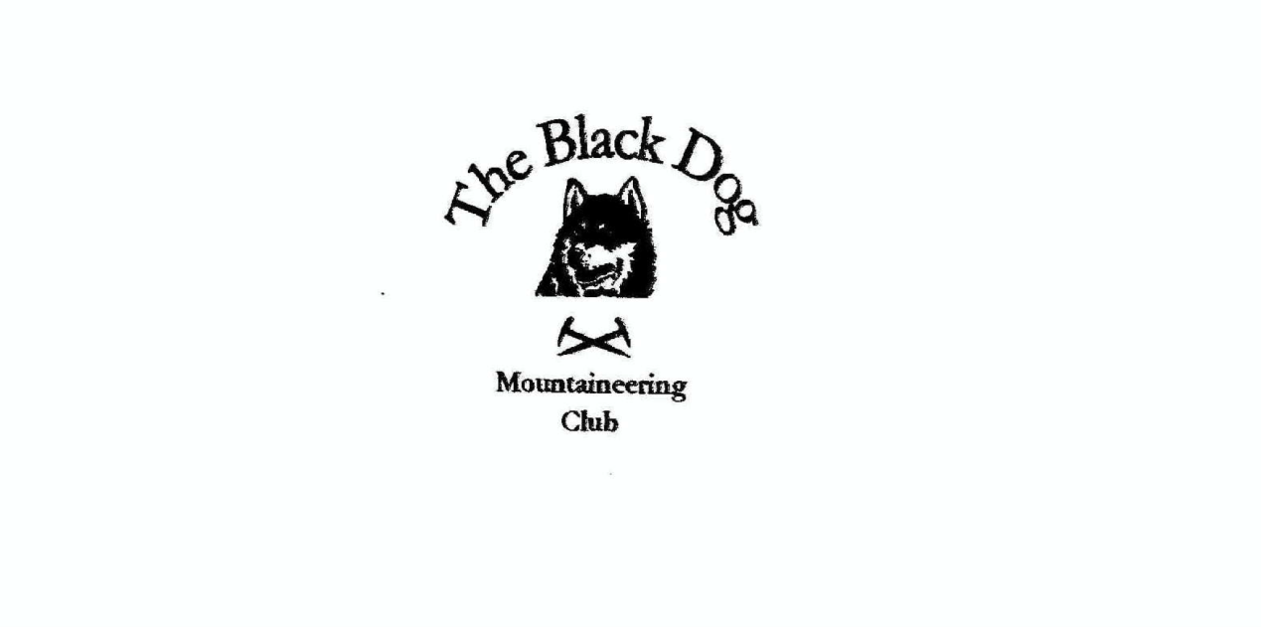

**Black Dog Meet**

**No. 228 Boat of Garten**

Friday 29th to Sunday 31st October 2021

**In Attendance**

James Yeats Rachel Yeats

Alan Sewell Liz Kennedy

Tony Smith Lorna Smith

Wull Clark Valerie Inglis

Gerry Feeney Matthew Spencer

# **Mountains Climbed**

**Friday**

Alan Beinn na Muice (693m)

Gerry & Matthew Carn Mor (804m)

**Saturday**

Alan Beinn Tharsuinn (692m)

James & Owen Mullach Clach a' Bhlàir (1019m)

Liz, Gerry & Matthew Creag Mhor (895m)

Tony, Lorna & Rachel Cregan Gorm (732m), Creag a'Chaillich (711m) and Craiggowrie (687m)

Val & Wull Carn Ealasaid 792m

**Weather**

Generally wet weekend with some clear spells

**Notes / Highlights**

**Friday**

Alan climbed Beinn na Muice from the head of Glen Strathfarrer, A little drizzle but some views of the surrounding Munro’s.

Gerry and Matthew climbed the Corbett Carn Mor from Chapeltown. Poor conditions, rain and poor visibility. It was an achievement thanks to good teamwork that we located the trig point on the summit

**Saturday**

Alan climbed Beinn Tharsuinn from Strath Rory. It was dry with some shifting cloud. Good views of the Cromarty and Dornoch firths.

James and Owen climbed Mullach Clach a' Bhlàir Setting off from Glen Feshie carpark at 08:20 following the road towards Auchlean. Deciding that the heavy rain from the previous day (and the continuing rain as we walked) would make the river crossings tricky we decided to detour away from the suggested Walkhighlands route.

Heading off the main Glen Feshie track we followed the hill path running parallel to Allt Fhearnagan making for the plateau.

The path underfoot was well defined and with some help from a jelly baby sped our elevation reaching the plateau just below Carn Ban Mor at 1028m; two hours in with little let up from the rain and wind. The plateau was featureless under a grey sky; small patches of snow individually too small to make a projectile but collectively perhaps could. From here our route made a steady south easterly descent to intercept a land rover track which turned us onto a south west trajectory. Visibility remained very poor but the track is too obvious to lose and we made steady progress towards Coire Caol. Two snow buntings the only other sign of life on the mountain.

Heading due south, we reached the summit cairn of Mullach Clach a' Bhlàir approx. 11:30; no views just relentless cloud.

Lunch was required prior to the decent and the fork at Coire Caol provided some shelter. Deciding that we were already wet the route back along Glen Feshie was more appealing than spending more time upon the plateau. Descending under the gaze of a buzzard we encountered our first humans of the day; father and daughter ascending from the Ruigh Aiteachain bothy.

The weather improving step by step we now had views of Glen Feshie and even some sunshine lighting up Lochan an t-Sluic in the distance. Taking time to admire the beautiful Scots Pine, remnants of a forest long gone. The day was heating up and we were drying off. Soon we found ourselves in full sunshine as we make our way down the glen flushing a Heron and then in the distance a Golden Eagle circles the high trees above us. Our path takes us through regenerated forest filled with the song of Coal Tits onwards to the first of two river crossings. A fallen tree helps keep us dry as we channel our inner monkeys and nimbly cross its limbs above the swollen waters of Allt Garbhlach. Not so lucky 2km later at Allt Fhearnagan where an initial promising route stopped and some evasive (channeling our inner kangaroo) action was necessary. And then returning along the road to the car park (arriving approx. 14:30) without further adventure.

Liz, Gerry and Matthew climbed Creag Mhor from Glenmore Lodge. An unexciting Corbett but good paths most of the way, a couple of burns to jump, great visibility and excellent views of the surrounding more interesting Munros made for a pleasant day out.

Tony, Lorna and Rachel walked from a surprisingly quiet, and free, car park by Loch Morlich, using the marked path though The Queen's Forest to reach the ridge between the target Sims and the adjacent Corbett (Meall a' Bhuachaille). Thereafter we followed a well-defined trail along the ridge before a steeper and, in places, muddy descent back to the trees and a forest road return via the extensive Badaguish holiday park.

Conditions were better than expected with only minimal transient precipitation, although there was a cool wind. We shared some suitable (bubbly) refreshment on the summit of Cregan Gorm to mark Lorna's 1000th Tump (a 30m prominent hill).

Wull and Val drove over to the Lecht and climbed Carn Ealasaid from the north via Beinn Chrunnich. Set off in light drizzly rain which soon cleared to a lovely day with smashing views. Short and sweet but really enjoyable.

[Boat of Garten photos](https://flic.kr/s/aHsmX3JvHN)

*James*

**Next Meet**

Galloway, 19th to 21st November. Organiser is Alan