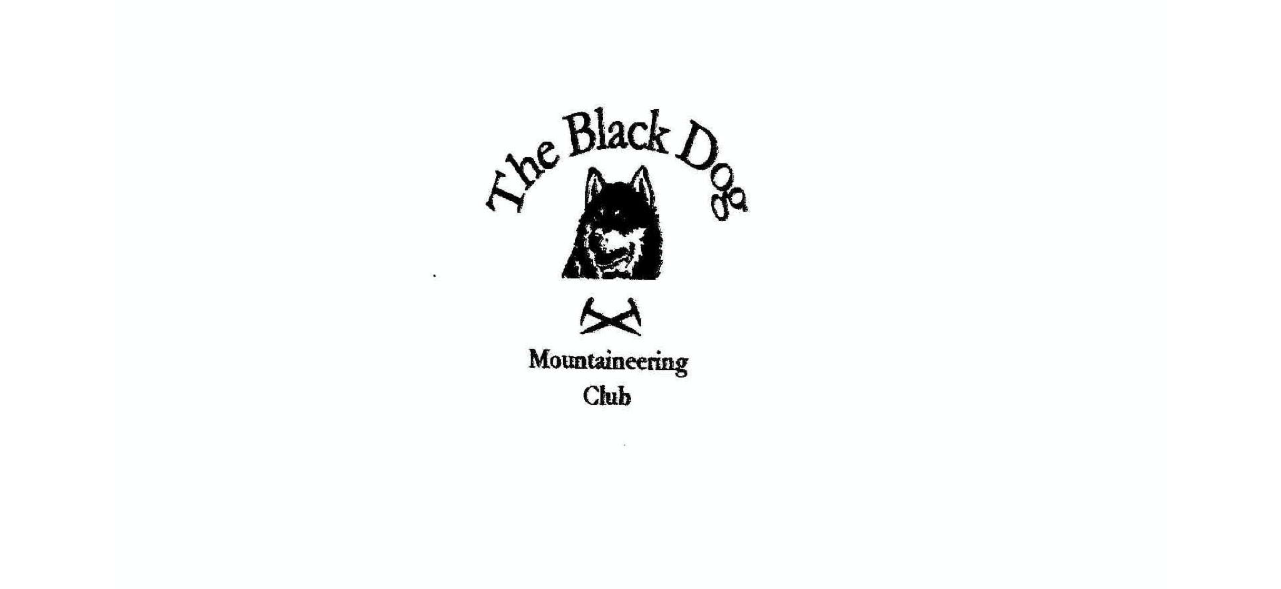

**Black Dog Meet**

**No. 229 Galloway**

**Fri 19th - Sun 21st November 2021**

**In Attendance**

Peter Robertson Liz Kennedy

David Cameron Matthew Spencer

Wull Clark Tony Smith

John McGill Alan Sewell

Val Inglis James Yeats

# **Mountains Climbed**

**Friday** Queensbury (697m)

Millfore Hill (602m)

Cairnsmore of Carsphairn (797m)

**Saturday** Knee of Cairnsmore (656m)

Cairnsmore of Fleet (711m)

Meikle Mulltaggart (612m)

Dugland (611m)

Benyellary (719m)

Merrick (843m)

**Sunday** Hare Hill (601m)

Moorbrock Hill (650m)

Keoch Rig (611m)

Dugland (611m)

### Weather

Friday and Saturday were showery with no visibility at high level. Sunday was cold and bright - a clear blue sky day.

### Notes / Highlights

This meet had been almost 2 years in the making, after the accommodation had been booked in Jan 2020 (pre pandemic) and was cancelled and carried over from Nov 2020. We had never stayed at the Galloway Activity Centre bunkhouse at Loch Ken before, and based on this experience are unlikely to again. The hostel was small, basic and lacking facilities - eg drying room, pots and pans for cooking, seats etc - only everything you would expect from an outdoor orientated hostel facility.

Anyway, after the initial shock of the state of the accommodation, we all had a few drinks and things look a whole lot rosier.

Friday

Val, Wull and Davie climbed Cairnsmore of Carsphairn from Carsphairn.

Alan headed for some unfinished business on Queensbury, looking for an easier day after having been distracted by some Donalds and Donald tops the previous couple of days. Starting at Mitchellslacks the walk was straight forward on good landrover and atv tracks all the way to the summit.

Friday afternoon (evening?) Tony climbed Millfore Hill (602m) starting from Murray's birthplace (Alexander Murray, 1775 to 1813, a local shepherd boy who became Professor of Oriental Languages at Edinburgh University). Initial rough going through the felled forest improved (?) to an uphill slog in seemingly endless wet long tussocky grass. About the only plus point was that I did manage to get back to the car just before the final light faded into total darkness. One to forget.

Saturday

Val, Wull, Davie, John and Alan drove round to the Big Water of Fleet viaduct ( a scene from the Hitchcock movie The 39 Steps) to climb Cairnsmore of Fleet. The route around this Graham and its Donald Tops is described in the SMC guide book from this direction, however has little to recommend it. The going is rough across the moor, both in ascent and descent, and is the roughest grass/bog to equal anything in the west highlands. The round took longer than expected, finishing just before dark back at the car.

Tony climbed Dugland (611m), another Sim, on Saturday and was much more straightforward with only the final few metres being off the forest/wind farm road. Weather of course was dire.

Liz, James, Matt and Peter headed for the Merrick.  The route passed the Bruce's Stone in Glen Trool  commemorating a 1307 victory over an English army lured into the Glen and set upon  initially by a  volley of stones. The first use of the guerrilla tactics adopted by the Bruce and culminating in victory at Bannockburn 7 years later. Nothing like this awaited today's party as they began the ascent past the very uninviting Culsharg Bothy.  On the climb it became increasingly wet and windy but it relented noticeably on the flattish dome shaped summit (presumably due to the effect of the topography). After a brief stop for lunch the route of ascent was retraced and a with a quick look at the  Stone ( see photo) the party were first back for a cuppa and the superb showers in the Activity Centre.

Sunday

Liz, James, Matt, Peter. Proposed climb of Corserine was aborted due to overly officious petrol heads who were holding a motor rally and denying access. Guerrilla tactics were considered but ruled out.

To round off the weekend Tony walked his final SW Scotland Sim (Hare Hill, 601m) in glorious sun. The wonderful view to Ailsa Craig, Arran and Arrochar/Lomond compensated for the inevitable and rather intrusive turbines.

On Sunday John did a linear walk from Craigengillan to take in Moorbrock Hill, Keoch Rig & the newly promoted Donald Top Dugland. A nice enough walk, mainly on tracks in the sunshine. So much better than Saturday.

Alan

[Galloway photos](https://flic.kr/s/aHsmXaPPfj)

### Next Meet

Pitlochry (Xmas) meet 17th to 19th December. Meet organiser Valerie