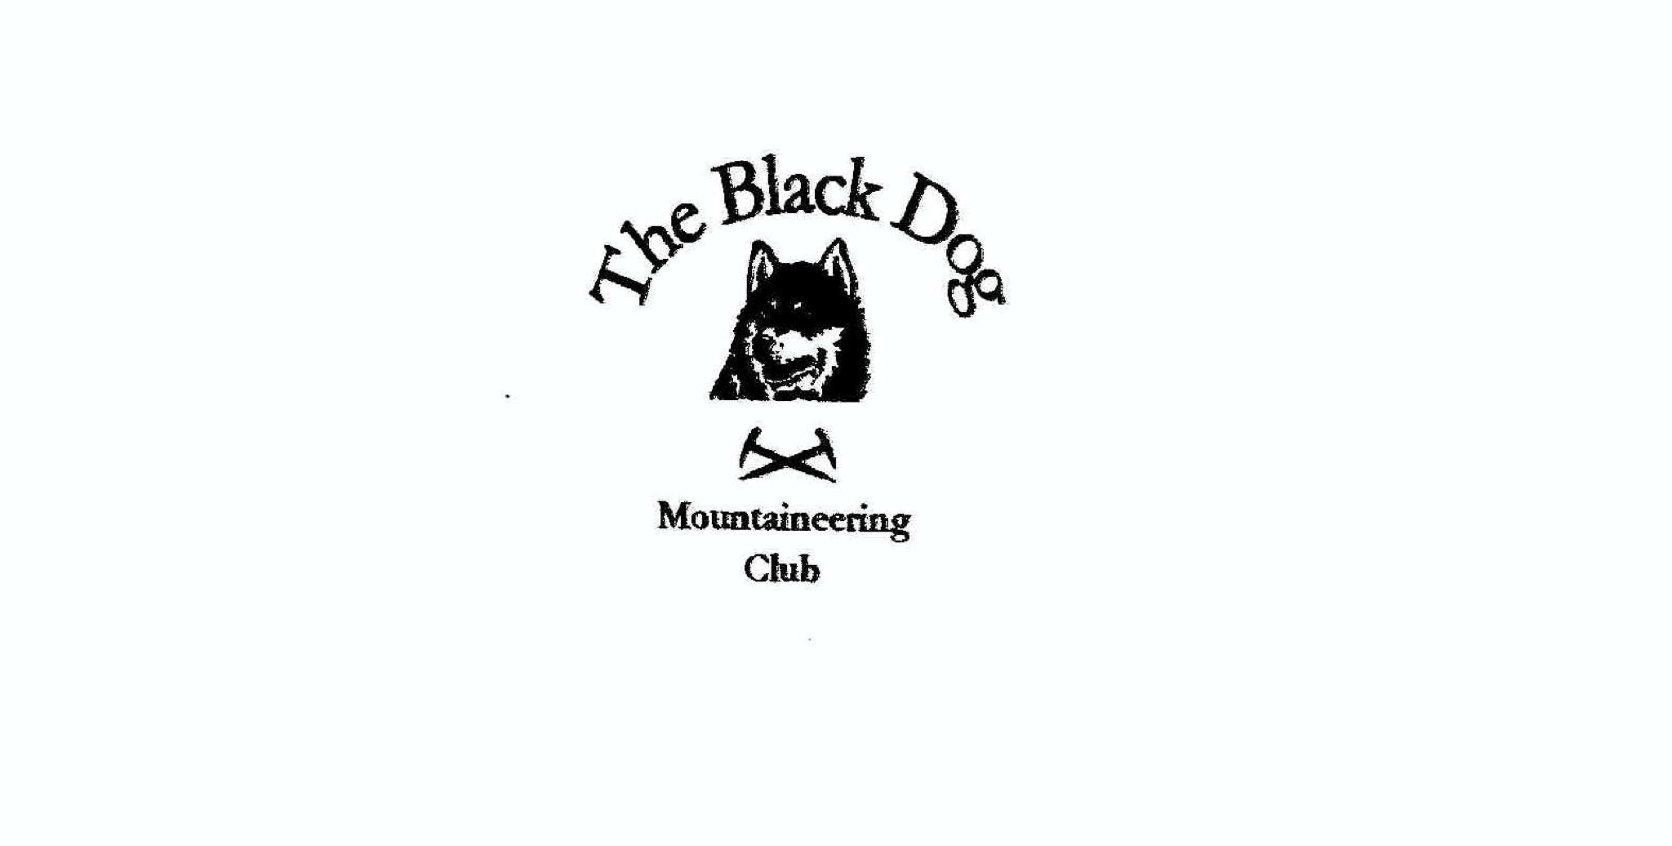**Black Dog Meet**

**No. 230 Pitlochry**

18th December 2021

**In Attendance** Charles Alexander, Wull Clark, Gerry Feeney, Valerie Inglis, Liz Kennedy, Peter Robertson, Alan Sewell, Tony Smith, James Yeats and Rachel Yeats

# **Hills Climbed**

All Meall Breac (802m), Meall Dearg (555m) & Creag an Fhithich (414m)

Peter Meall Breac (802m), Meall Garbh (968m) & Carn Mairg (1001m)

**Weather**

Freezing fog at start and brilliant sun and blue sky thereafter. The hills were completely clear of any snow which was quite astonishing for December

**Notes / Highlights**

Due to the unfortunate last minute cancellation of the Christmas weekend meet at Pitlochry, we made the most of the situation with a day walk from just outside Kinloch Rannoch.

The day started with an interesting drive through banks of fogs and areas of crystal clear skies and hills.

The group met at the designated car parking area in thick freezing fog and set off for a walk up the road to the nearby Glen Sassunn. Within half an hour we walked through the cloud and into the most fantastic clear sunny day with blue skies and extensive views and some very welcome heat from the sun.

It was a delightful walk up the glen, sweetened only by the best ever chocolate brownies provided by Rachel and James. We enjoyed a leisurely walk, in perfect conditions, up the track until the point where we struck off directly up the hill to the summit of Meall Breac. The views of surrounding hills in the most amazing temperature inversion, with the moon hanging low in the sky, were simply stunning.

At this point, Peter took advantage of the superb day, and set off for the nearby Munros. The rest of the group wandered down the NE ridge taking in the remaining high points on the way back to the final peak and a quick descent down to the road. Peter bagged a couple of Munros and enjoyed a beautiful moonlit walk back to the carpark. Well done!!

Great day out in every way.

[Xmas meet 2021 photos](https://www.flickr.com/photos/190421987@N07/albums/72177720295376254)

Thank you 😊

**Next Meet**

Logierait 14th -16th January 2022

Meet organiser – Valerie Inglis

*Valerie*