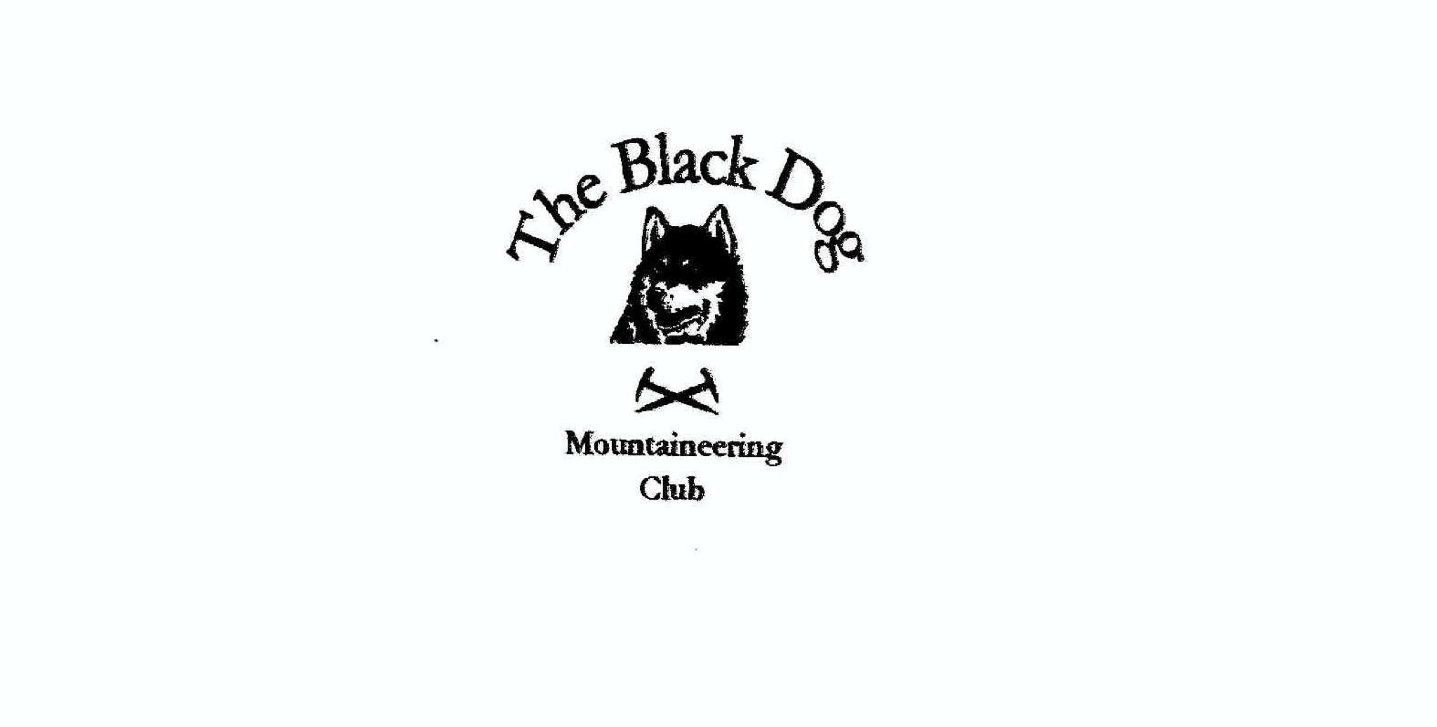**Black Dog Meet**

**No. 233 Crianlarich**

**25th - 27th March 2022**

**In Attendance**

Owen Clark, Wull Clark, Gerry Feeney, Valerie Inglis, Liz Kennedy, Alan Sewell, Lorna Smith,

Tony Smith and James Yeats

# **Hills Climbed**

**Friday**

Alan: Drum Sgriodain (734m)

Tony & Lorna: Creag nan Eun (852m)

Valerie & Wull: Meall Greigh (1001m) and Meall Garbh (1118m)

Liz: Stob Coire a’ Chairn (981m) and Am Bodach (1032m)

Gerry: Beinn Chuirn (880m)

**Saturday**

Alan: Beinn Bhreac (681m) and Tullich Hill (632m)

Tony & Lorna: Ben Inverveigh (639m) and Dun Riobain (225m)

Owen & James: Beinn Achaladair (1038m) and Beinn a'Chreachain (1081m)

Valerie & Wull: Beinn Ghlas (1103m), Ben Lawers (1214m) and An Stuc (1118m)

Gerry: Meall Buidhe (908m) and Sron a’ Choire Chnapanaich (835m)

**Sunday**

Tony & Lorna: Eilreach (642m) and Meall na Cloiche (663m)

**Weather**

The weather was good for the time of year. Plenty of sun and clear hills, a bit cold at Munro height in the wind but otherwise quite warm. Still some big snow patches at high level.

**Notes / Highlights**

Unfortunately, we had 3 cancellations for the weekend due to ill health, so no Charles, David or Rachel. The hostel was really quite busy and we only had use of the one tiny wee kitchen which wasn’t great to cater for all those people. Nice to be back none-the-less.

**Friday**

**Alan:** Having had a couple of days climbing in Ardnamurchan’s “ring of fire” we awoke to drizzle. Our initial plan was to head to Glen Nevis to climb but the weather was no better there. We decided to cut our loses and bail, where I then headed to do the Graham Drum Sgriodain at Corran. The weather improved as the day went on, to give good views of the surrounding hills - particularly around Glencoe.

**Tony and Lorna:** An easy walk from a busy Invergeldie car park (by Comrie) up to Loch Lednock dam then steep track to open hillside. OK going in very warm conditions to clear summit. Whole area totally deserted apart from two guys watching heather burning.

**Valerie and Wull:** Wull and I parked up at the Ben Lawers Hotel and followed the usual route on to Meall Greigh and over to Meall Garbh. Beautiful conditions, if a bit cold, and saw not a soul all day.

**Gerry** climbed his Corbett alone in the absence of his hill walking chum Charles.

**Liz** headed for Stob Coire a Chairn and Am Bodach from Kinlochleven, carefully choosing the anti clockwise route to ensure I was going up the very steep east face of Am Bodach rather than down. A beautiful day, but there was still some snow and ice about and the east face of Am Bodach was a bit challenging. I thought I was doing quite well getting two Munros until I met a couple who had come down the east face. They were jogging round the Ring of Steall (plus add-ons ) in training for the Ramsay Round - so that put me in my place!

**Saturday**

**Valerie and Wull:** We set off early to get parked at the Ben Lawers car park before the throngs arrived. Even at 7am, in the beautiful conditions, the car park was filling up. Having seen the amount of snow on the back end of Ben Lawers, and remembering how cold the wind chill was the day before, we were fully dressed in winter gear and equipped with ice axes and crampons and big rucksacks accordingly. Feeling ridiculously over-dressed compared to the younger groups in their leggings, trainers and handbags, we set off for Beinn Ghlas. The lovely spring weather at the car park soon changed to clag and very cold with a fair bit of snow still on the path. The mountain was none the less hoaching with folk who must have been freezing and who we quickly left behind after summiting Ben Lawers and heading over to An Stuc, our third Munro of the day. And yes! We saw a guy climbing Ben Lawers in Dolce & Gabbana trainers!! They looked good with the jeans. A great day out but definitely one for mid-week if I ever go back.

**Owen and James**: Set off from the carpark at 07:47 heading anti-clockwise on the recognised circuit. The ground underfoot quickly became boggy and wet.  Eventually once beyond the railway underpass the path began to improve and dry. As we headed towards the bealach, Beinn an Dothaidh loomed magnificently above and to the right of us.

Our path now followed the main watercourse which skipped and leapt down the mountain in beautiful waterfalls and cascades. Distracted by the water and helped by the bedrock underfoot we soon reached the bealach which offer views east and south. A bite to eat while we admired the views and then off towards Beinn Achaladair following its southerly ridge.

On our approach a raven glided overhead hopefully not considering us as potential next meal!

*Black are the ravens high on the cliff*

*Calling loudly through the mountain rift*

*Always a surprise to find them here*

*High above the grouse and deer*

 Beinn Achaladair soon reached without incident and the raven being off elsewhere we paused again to take in the stunning views over Rannoch Moor with a buzzard suddenly drifting into sight patrolling the northern cliffs and surveying all below.

Deciding to drop off the summit before refuelling we followed a now snowier ridge to a sheltered spot that offered a breath taking view of Beinn Achaladair’s northeast facing cliffs.

With the snow hanging in the corries somehow enhancing their depth and grandeur this was a fantastic backdrop to a wee snack and a cuppa.

Descending now to Bealach an Aoghlain (813m) involved some small steps of scrambling and some larger snow patched to cross. The steepness was a challenge and although the snow was soft care was needed at the edges as they were prone to be icy. Once the Bealach was reached the route again eased and we pushed on towards Meall Buidhe.

 Beinn a Chreachain is dominating the view almost menacingly so. The snow buntings seemed out of place here perhaps the raven would have been more appropriate but clearly the drama was lost on our avian friends.

At this point on our route we had a clear view of other walkers around us taking the more traditional clockwise approach to the day. The final climb up on to Beinn a Chreachain robbed the last of the strength from my legs; only the promise of a brownie at the top kept them ascending. Second Munro reached approx. 13:00 and brownie and last of the coffee consumed while gazing to the north and west.

At this point one group of fellow walkers caught our eye as they made slow progress up the snow covered northeast ridge. Brownies now fuelling spent legs we descended towards them as we made for the bealach above Lochan a Chreachain. The group revealed themselves to be hardy souls ascending in shorts on a March day that still gave bite to the wind. Drifting between bewilderment and admiration we bid them good luck and continued our descent.

A pause at the lochan to take some pictures could not be resisted as the snow contrasted with the black corries and dark waters below (see picture).

 Now begins the long walk out which starts with a steady and speedy descent over soft but stable ground before the inevitable bogginess creeping back in and slowing us down.

Just after the railway underpass we met the last walkers ascending of the day; prepared for a dark descent.

Next the river crossing successfully made by both before the march back along the land-rover track and eventually our starting point. As we turned around the second to last bend a small herd of red deer appeared before us grazing in the early evening sun.

Back at the car approx. 16:20 thoroughly exhausted but equally delighted with the day.

**Alan:** I headed to the Luss hills and climbed Beinn Bhreac and Tullich Hill. The weather was fantastic albeit a little hazy. Good views the length of Loch Lomond, with some red deer and a golden eagle for good measure.

**Tony and Lorna:** Good parking by Inveroran Hotel (Victoria Bridge) giving direct access to West Highland Way, which we followed up to Mam Carraigh. Thereafter up the obvious ridge, initially on a good track but latterly only an intermittent (animal?) trail. A great viewpoint but unfortunately it was rather hazy. Our second hill was a trivial stroll to the communication mast by Auchessan in Glen Dochart.

**Gerry** again went solo to Glen Lyon for his two Corbetts.

**Sunday**

**Tony and Lorna:** Two more unfrequented hills for me. These are accessed directly from A85 in Glen Ogle on a fantastically well-built track which seems to lead precisely nowhere other than very usefully quite close to the hill summits.

 This was an altogether fantastic weekend.

Thank you 😊

*Valerie*

**Next Meet**

Torridon, April 22-24, 2022

Meet organiser – Tony