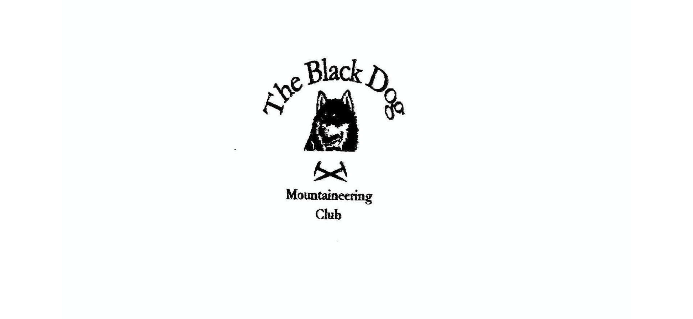

**Black Dog Meet**

**No. 235 Skye**

**Fri 6th - Sun 8th May 2022**

**In Attendance**

Russell Shanks Liz Kennedy

Davie Cameron Owen Clark

Wull Clark Gerry Feeney

John McGill Alan Sewell

Val Inglis James Yeats

Charles Alexander Bill Clark

Richard Marwood David Mackay (Guest)

# **Mountains Climbed**

**Friday** Spidean Mialach (996m)

Gleouraich (1035m)

Sgurr Mhic Bharraich (779m)

Glamaig (775m)

**Saturday** Am Bhasteir (934m)

Bhasteir Tooth (917m)

Blabheinn, (928m)

Sgurr Alasdair (992m)

Dun Caan (444m)

**Sunday** Glamaig (775m)

Sgurr na Sgine (945m)

Blabheinn, (928m)

Creag Lundie - Routes climbed

Deviation Crack (Severe 4a**)

Photo Bomb (Severe 4a*)

### Weather

After heavy rains on Thursday night, Friday morning continued in the same vein. Eventually brightening up about lunchtime. Saturday and Sunday were light clouds with sunshine.

### Notes / Highlights

This meet had been 2 years in the making, due to the Covid pandemic. It was good to be back at the Old Inn where some improvements to the hostel were noted. As always the beer and food at the hotel went down well too. The consensus was to book again for next year.

May’s weather, for the moment, kind and still

And we are off to Skye to climb the hill

Fairy Pools sparkling bright

Majestic mountains black as night

The soaring Cuillin enchant and thrill

Friday

Val, Wull and Davie climbed Sgurr Mhic Bharraich. Due to the poor weather forecast, we decided to stay on the mainland and climb the Corbett at the back of the Shiel Bridge campsite. Lovely walk in up the stalkers path with great views into the glens and glimpses of the ridges through the clouds. It was mainly dry until 150m from the summit when we walked into clag and rain. Soon walked back out of it and had a pleasant return to the cars.

Alan and Russell headed to Suidhe Biorach from Elgol to do some climbing, but unfortunately the cliffs were wet, so went for a recce of the Prince Charles’s Cave area.

Liz, Gerry and Charles did Spidean Mialach (996m) and Gleouraich (1035m) on Friday. Good path up to the first one initially but last third a slog up roughish ground. Some interesting stream crossings as the steppingstones were all well under water due to heavy overnight rain. Only one wet foot out of six. Overcast with occasional heavy showers and all clothes from the rucksack on. Occasionally misty. Good walk along the ridge to Gleouraich and excellent descent on a stalker’s path, as described in the Munros book. Met only one other person.

James & Owen:-  Glamaig

Parked up in a layby on the A87 at Tormichaig approx. 12:00 pm.

The day was grey and threatening and after the long drive to get here the enthusiasm was low.  Nevertheless we set off towards what looked like a very steep climb.  After a short wet and muddy approach, where the path looked more accidental than a deliberate route towards the mountain, the path turned (what felt like) straight up.  Here our route became dotted with violets, like a trail of breadcrumbs guiding our way up the mountain.  The near vertical path occasionally eased to a mere very steep giving the legs some respite.

We quickly gained height and the views below the cloud-line across to Raasay and Dun Caan, with its distinctive flat top, were beautiful in the broken spring light between the clouds.  The relief at cresting the ridge and reaching An Coleach (673m) was short lived as here we met the teeth of the wind and our visibility was about to be swallowed up as we entered the cloud line.  From single layer to fully clad out in hat, gloves and waterproofs in a few footsteps.  The upside was the rucksacks were suddenly a lot lighter on the back.

On a good day this walk along the ridge towards the summit of Glamaig would have offered spectacular views in all directions but today we were offered mere glimpses of what might have been.  The going is much easier now and we soon navigate to the summit at 775m, on one of only two Corbets on Skye, Glamaig at 14:30 (approx.).

Retracing our footsteps we headed back along the ridge encountering a ptarmigan pretending to be a rock but soon moving aside to allow our passing.  The steep terrain was no easier on the descent and care and concentration was needed to ensure our safe passage.  As we descended the views opened up once more and our violet breadcrumbs guided us back.  As we neared the base we flushed a snipe from the heather our second avian encounter of the day.

Back to the car approx. 15:30.

Saturday

Val, Wull, John, Russell and Alan headed off to climb Am Basteir and the Bhasteir tooth. Unfortunately, due to cramp, Wull had to turn back at Coire Bhasteir and Val accompanied him safely back to Slig. The rest pushed on, and John was delighted to be able to bag the hardest Munro Top - The Tooth. A quick abseil down Kings Cave chimney and it was back to the hotel for beer and medals!

Davie headed around to Coire Laggan and climbed Sgurr Alisdair via the great stone shute.  Very clear, still and warm day.

Richard climbed Dun Can (Dun Cana), “Hill of the Bucket”, on Isle of Raasay.

A Marilyn, it is surely a “must do hill” even for non-baggers like myself. 444m up to the flat top of an extinct volcano. He was rewarded with the best of days, a sunny ascent, and a spectacular 360 view of the Cuillin, Kintail, Applecross, and Torridon from a wind-free summit. James Boswell climbed this hill in 1773 and did a jig at the top. I stayed at the top a fair while, unusual for a Scottish hill. But I now realise that I failed to dance, although there were so many reasons for me to do so.

I had time for some biking round the south of the island, and arguably essential refreshment at Raasay House, before the return ferry to Skye on flat and yet sparkling water.

Liz; Bill; Charles; David Mac; Gerry; James & Owen:-Blabheinn

Our starting point is the carpark on the shore of Loch Slapin.  The John Muir Trust has done a fantastic job on creating not only a suitable carkpark with facilities for the hiker but also a great approach path in towards the mountain.

Our magnificent seven under a magnificent blue sky  set off towards a magnificent blue mountain.  Easy going at first as the path gently takes you through a birch forest alongside a deep ravine distracting you from the change in gradient by offering waterfalls and deep pools to please the eye.  A river crossing (always a crowd pleaser) signalled a change in terrain and our easy path became more staircase like as we steadily ascended towards Fionna Choire.

At approx. 400m  our route steepened once more as we began  our ascent in earnest up a prominent shoulder over very loose ground.  Zigzagging up favouring first right and then left we carefully left the scree behind us and stopped for a brief rest and photo opportunity at an opening in the ridgeline.  Not for the faint hearted a sojourn to the edge of the opening offered up stunning views of the Sgurr nan Gillean ridge and the complex ridges and corries of Bla Bheinn.

The next section offered up some brief scambling before easing off and gently bringing us within sight of the trig point atop Bla Bheinn. Now the views are a full 360o and it is hard to decide what to let the eyes settle on first; Cuillin Ridge, isles of Rum and Eigg; the mainland to the south and east, just spectacular and breath taking.  Liz declared “lunch” and our party enjoyed a bite to eat in the warm May sunshine atop what must be one of Scotland’s finest mountains.  Certainly today it was a popular choice with several parties scattered around the summit enjoying the views, weather and the contents of their various lunch boxes.

We were in no rush to leave such a wonderful spot and when David Mac suggested a visit to the South Top I (Owen) was only too happy to agree.  Our party split, five heading back down our route of ascent and David and I making the short scramble between the North and South tops.  From the angle of our approach an obvious (if narrow) ledge offer an alternative to the chimney to link the two tops together.  The ledge would have been easy to miss if coming South to North and indeed two fellow walkers had opted to descend the chimney and make the brief climb back up to the bealach.  Our ledge was far more direct and brought us across just below the top of the chimney and then an easy path on to the less populated south top.

Here we could see down to the beautiful western beaches of Skye and took some time to wonder at a weather station perched on the Northwest corner of the summit.

The descent from the South Top should have been straightforward (loose, steep but straightforward nonetheless) however I edged us to far West and a small but enjoyable scramble was required to set us back towards the bealach at Fionna Choire.  From here we could make out our party making their way steadily down the original route (Charles’ white hat making the spotting all the easier).  As we left the scree behind as and approached the huge boulder it became obvious that we would reunite at the natural intersections of the two paths as if deliberately planned and timed.

Reunited as the magnificent seven once more a pace maker was appointed to ensure we were off the mountain in good time to catch Amy’s Place.  The well constructed path again beneath our feet we quickly put the height of the mountain behind us and returned to the carkpark in good order.

Our day was finished with coffee and cake at Amy’s Place (a wee café above the eastern shore of the loch) and we enjoyed our well deserved treat while taking in the view of Bla Bhienn.  A fantastic day in great company on Skye.

Sunday

Liz and Gerry climbed Glamaig from the Broadford road. Steep ascent, but rewarded with great views to the east. Took three and a half hours, Gerry was pleased with that.

Brutally steep is what Gerry meant to say. Only redeeming feature was the excellent views according to Liz!

Russell and Alan headed around to Loch Clunie and climbed on the slabs at Creag Lundie. The routes were noted for their lack of protection which made for a fun couple of routes.

David Mac; James & Owen:- Sgurr na Sgine

Starting off from Malagan approx. 10:30 and electing to take the direct approach as a nod to our long car journeys home, we crossed flat ground to the river where James was disappointed that there was no bridge.  This was not a disappointment to all of the party.  River crossing under our belts we quickly gained the first fence line for the plantation and pasted through a gate that had seen better days.  The route remained wet and quickly became steep gaining height at good pace as we passed through the plantation and the inevitable second fence line (300m).  Here we came across a style that had also seen better days.  Sending James over fist to test its integrity seem the right approach and James dually pronounced said style safe-ish.

Now the hill opened up before us and we found ourselves on the very steep shoulder trying to gain height in the face of a strengthening wind.  Legs fatigued from the previous days did not enjoy yet more steepness and although height was quickly gained there were noticeably more stops than on the previous hill.  Thankfully Faochag (909m) was reached and from here we were on an easy ridge with brief yet delightful elements of exposure and truly fantastic views of The Saddle and Forcan Ridge.

Soon we were ascending once more the final push towards the summit of Sgurr Na Sgine reaching it at approx. 13:30.  Here we took a well earned break for lunch and chocolate brownie before retracing our steps and making for Faochag once more.

The steep descent on tired legs was not quite as tough as the ascent and the wind, although still present, was less problematic.  It felt like we were losing height quickly and making good progress but when the 500m mark was declared it sparked some heated (but light-hearted) debate on the accuracy of a certain device… It took another 200m of descent to where the style awaited patiently for our return for the debate to be conceded in the device’s favour.

Carefully through the plantation and a welcome refresh at the river crossing before returning to the cars at approx. 15:30.  Another great day on the hill.

Wull and Val had a lovely but breezy day on Bla Bheinn. The cloud came and went most of the morning but cleared as the day went on and we finally had views from the summit. Clach Glas looked amazing (and terrifying!) first time in four trips up the mountain I’ve had a view from the top - well worth it!!

It was good to meet David Mackay who joined us a guest of Richards, and hopefully a potential new member.

[Skye photos](https://www.flickr.com/photos/190421987@N07/albums/72177720298784264)

Alan

### Next Meet

Alltbeithe (Glen Affic) meet 2nd to 5th June. Meet organiser Tony