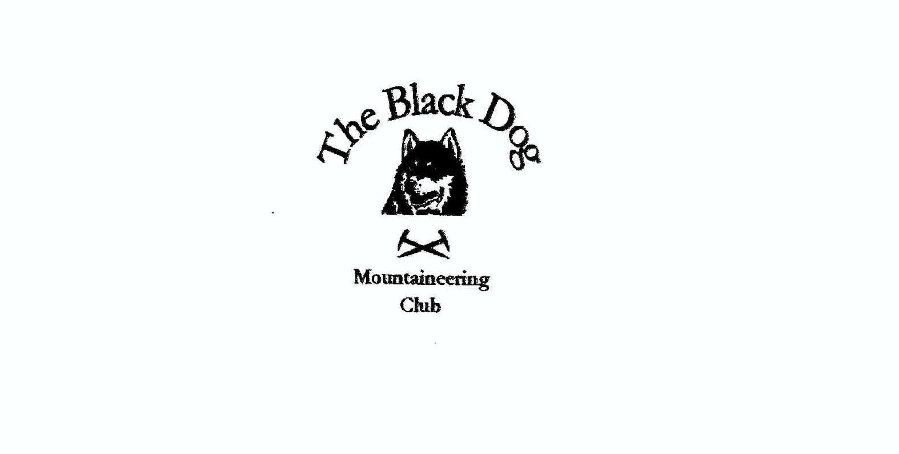 **Black Dog Meet**

**No. 236 Affric (Alltbeithe)**

**2nd – 5th June 2022**

**In Attendance**

David Cameron, Bill Clark, Owen Clark, Wull Clark, Valerie Inglis, John McGill, Barry Smith,

Tony Smith and James Yeats (plus John’s two guests, Jamie & Andy for one night)

# **Hills Climbed** (+ numerous ‘tops’, deleted and otherwise)

**Friday**

James & Owen An Socach (921m); Mam Sodhail (1181m); Carn Eige (1183m) and Beinn Fhionnlaidh (1005m)

Barry & David Mullach na Dheiragain (982m) and Sgurr nan Ceathreamhnan (1151m)

Valerie & Wull Sgurr nan Ceathreamhnan (1151m) and

Sgurr Gaorsaic (839m)

Bill Beinn Fhada (1032m)

Tony Sgurr nan Ceathreamhnan (1151m) and Creag Ghlas (856m)

**Saturday**

Bill, James & Owen Mullach na Dheiragain (982m)

Valerie & Wull Mullach na Dheiragain (982m) and

An Socach (921m)

John & guests An Socach (921m), Mam Sodhail (1181m) and

Carn Eige (1183m)

Barry Beinn Fhada (1032m) and A’ Ghlas-bheinn (918m)

Tony Beinn Fhada (1032m) and Meall a’Bhealaich (782m)

**Sunday**

John & guests Tom a’Choinich (1112m) and Toll Creagach (1054m)

Tony Torran Beithe (305m)

**Weather**

A bit damp for the later arrivals on Thursday and some early low hill cloud but otherwise an absolutely fantastic weekend.

**Intro (thanks for this Owen)**

**Affric**

Bonnie Glen Affric where the Scots pines grow

This sunny June is where the Black Dogs go

Off to the mountains rocky spire

Walking on legs that shall not tire

And then return to Alltbeithe far far below

**Notes/Highlights**

**Thursday 2nd June**

**Val, Wull, Davie, Bill, James & Owen**

Early starts from our various abodes resulted in second breakfast at the Ness Deli Café in Drumandrochit which also served as a loose meeting point before heading in to Glen Affric car park.

After a thorough bag check (i.e. who had the heaviest pack?) and picking up a straggler (whose bag was somewhat lighter due to a whisky escape)…

**Davie**

Davie is not known to do things briskly

But there are times when his actions prove risky

Like when the task

Was to fill the flask

And then his rucksack was reeking of whisky

…we set to the walk up Glen Affric to Alltbeithe. Our route follows the Affric to Kintail trail along the southern banks of Loch Affric. Initially we are walking among the Scots Pine forest the area is so famous for, stepping aside every once and a while to allow the passing of the occasional mountain bike. Soon the glen opens up and we see the river and Strawberry Cottage ahead of us. On this visit our base lies further up the Glen at Alltbeithe Hostel. After Strawberry Cottage the path deteriorates somewhat transforming from a compacted (and dry) land rover track to a loose and often submerged track which finishes the task of tiring out the legs that the heavy packs had started. Approx. 3.5 hours in saw us arrive at the Hostel happy, dry and very relieved to be out from under those packs.

The hostel held some nice surprises; my last visit was some 30 years previous and at that time the facilities were very basic. This time round we have electrics running from wind and solar plus indoor toilets and even a shower with hot water. Kitchen is well equipped and has two gas stoves.

Our group had agreed small cooking subsets to ease the pressure in the kitchen. There was great interest in what these subsets had hauled in for the three night stay. While there was some consistency in that most were adding pasta to water (or indeed water to pasta) that was where the commonality stopped and things like pac-choy, venison, chorizo (real and otherwise), spicy Italian sausage, cheeses, mushrooms (in various forms) and just add water packets came in. Despite the extremes presented on tables we all ate well and were fully fuelled for the next day’s walking.

**Friday 3rd June**

**Valerie and Wull**

On Friday we set off from Alltbeithe at 7am and climbed in the clag and cold to the col between An Socach and Sgurr nan Ceathreamhnan. As we climbed up the ridge to Sgurr nan Ceathreamhnan the wind started to blow the weather through and we were rewarded with glimpses of the surrounding peaks through the clouds. By the time we reached the summit over various tops and deleted tops, our targeted ridge was clear. We took in the west top and then headed down the ridge to point 918m taking in 2 tops en route. There we met up with Tony and shared some lunch. Wull and I then made an interesting contour round steep ground to Coire Lochan and picked up the north ridge to Creag nan Clachan Geala at 999m. Deciding this wasn't enough for the day, and considering it would be rude not to include it, we took in the Corbett Sgurr Gaorsaic on the way back down to Gleann Gniomhaidh and the walk back to the hostel.

**James & Owen**

We know we have a long day in front of us, so we set out at 06:00 making for the ridge directly behind the youth hostel. The weather forecast promised a good day so the early clag hanging up on the tops and ridgeline did little to deter us as we gained height along a good stalkers path. Passing through an enclosure where rowans (mountain ash) and willow were beginning to take hold and moving into the mist below An Socach. At some point below the bealach we miss-placed the true path and veered east before steeply ascending and arriving (much to my surprise) at the summit of An Socach (921m) at approx. 08:00. No views, as we were fully in the mist, we did not hang around and made for the next bealach having been reunited with an obvious path.

As we dropped towards the bealach the cloud finally began to break up and started to give us glimpses of the views to come. One of those glimpses was the distinctive top of Mam Sodhail, our next target. Legs still fresh the pull up to the summit at 1181m was achieved by following the stalkers path as it contoured ever higher up the side of the mountain until the ridgeline came in sight. Passing a platform with the remains of a stone hut and on to a feature which I have been told was an observatory. More importantly today it marked the summit of our second Munro. A wee bite to eat at the summit was rewarded by the clouds finally burning off and clearing revealing the majesty of the ridges and peaks of Affric and beyond.

Now our day is clearly laid out in front of us in the warm June sunshine we set off towards Munro number three. A short down and then back up sees us on the top of Carn Eige where we encounter our first human of the day approaching from the east. Brief wave and we are off again heading north. The paths on the ridges are now sparkling with mica looking like someone had scattered glitter along them to show us the way.

12:00 sees us finally at the summit of Beinn Fhionnlaidh our fourth and last Munro of the day. We take some time to enjoy the views, Torridon, Skye and the Loch Monar hills standing out. As we linger we are joined by more likeminded souls and our remote Munro becomes the most populated of the day. We would happily have stayed longer but the small matter of the return journey could not be ignored and we set off electing to contour around the peaks and hit the ridge to the south of Mam Sodail’s peak. At first the path was obvious but soon disappeared leaving us to pick our way towards some obvious snow patches in the distance. Hard work but finally regaining the ridge and allowing James to target several Munro tops on the return leg.

We left the ridge at Creag Coire nan Eag (1055m) with the intention to “avoid” the wettest areas of those western slopes. Intentions were good but in practice we ended up right in the thick of the watercourse and only the sight of two Red Deer in the distance made up for the conditions underfoot. Wetter, tired but otherwise no worse for wear we arrived at the bridge leaving us the march back along the land rover track to the hostel; arriving approx. 18:00.

**Tony**

07.30 from the hostel with Barry and David up the path to the main ridge where I headed west taking in Ceathreamhnan and its tops eventually meeting Valerie and Wull on Stuc Fraoch Coire. From here I continued north to the first of two Simms (decided the second will wait for another day and a bike into Iron Lodge). This summit felt a lonely spot today.

A long, and at times tedious, contour back south brought me almost to Coire Lochan and access to the rather fine north ridge of Creag nan Clachan Geala. From here a simple traverse (apart from the failed attempt to jump a particularly boggy patch!) took me to Beinn an t-Socaich and an easy descent almost directly back to Alltbeithe.

**David and Barry**

Having split from Tony we contoured across and regained the ridge between Ceathreamhnan and Mullach na Dheiragain just in time for any remaining early clag to lift, giving us great views as we plodded on to the summit of Mullach na Dheiragain at 11.20. We took time for a bite and a chat with some other folk and then decided to take a stroll out to the, even more distant, Munro Top. We were hoping that we might get a view over Loch Mullardoch but that didn't prove to be the case. Having retraced our steps back to the summit and spent more time chatting, we left at approx 12.30. We then decided that it was such a wonderful day that we would take in Ceathreamhnan on our return. We stopped for a drink break at which point the wind speed picked up briefly and blew my cap off. Davie kindly retrieved it for me and I tucked it under my leg as I sat admiring the view. Unfortunately it wasn't until we had been walking for a few minutes that I realised that I forgot to put it back on when I stood up. Oh well, that is that gone then, or so I thought (later returned thanks to a kind fellow hosteller). We arrived at the summit of Ceathreamhnan just about at the same time as a chap who tried his best to impress by claiming to be able to identify just about every peak in view. David wasn't convinced!

Unfortunately David exacerbated a nasty wee blister on his RHS pinky toe and had to perform a little bit of ‘surgery’ that evening.

**Saturday 4th June**

**Val, Wull, Bill, James & Owen**

A somewhat more civilised 08:00 start today; retracing Friday’s route to the ridge up the stalkers path to the bealach below and to the west of An Socach. This morning we are in bright sunshine from the start and the immediate test is to find clothing cool enough for the climb while still giving protection from the sun. Some early wardrobe adjustments aside we made steady progress up to the bealach with the path today more easily kept to.

Form the bealach we contour round and slowly descend into the bowl beneath Sgurr nan Ceathramhnan aiming for the lochans contained therein. The wee frog that lowped out of the way of my boot testament to the wet environment we were passing through. A brief rest at a prominent stone platform allowed for some creative juices to flow and a wee stone structure was built marking our passing. A point of note was the violets growing in this bowl are a far lighter shade than those seen at the previous meet in Skye. This observation sparked a flora conversation and Wull put his knowledge on the topic to good use pointing out and naming many of the wee flowering alpines that we were walking through. Soon we were ascending again aiming for the ridge at bealach nan Daoine (approx. 840m).

Our route continues northwards along the ridge, the path sparkling with mica, to another of Affric’s remote Munros, Mullach nan Dheiragain, which we reached at approx. 12:00. This summit offers fantastic views of the previous day’s hills and beyond. Despite its remoteness we were not alone on the hill with various individuals and wee groups dotted about the mountain. One fortunate encounter saw the finding (and later reuniting) of a lost hat from the previous day thought forever lost to the whims of the mountain winds. Those who were also collecting tops (deleted or otherwise) marched on along the ridge line to fulfil their dreams; while others rested (well deserved) in the beautiful June sunshine, occasionally disturbed by a friendly hello as others made it to the summit.

All too soon we were retracing our steps back along the ridge, watched by a pair of Ravens, and across the bowl to once more pause at the rocky platform now decorated by our stone art. A single deer running down the bowl behind us; our backdrop to the short climb back to the bealach below An Socach.

Here our party split with Valerie and Wull heading up to gain An Socach while three headed to the hostel, arriving back hot and puggled at approx. 16:00. A wee dip in the stream, the only restorative cure for puggled feet, could not be resisted.

**John** and guests (Jamie Wright and Andy Turnbull)

Having arrived Friday evening we headed up onto the ridge, over An Socach, Mam Sodhail (diverting for the tops) and Carn Eige then continued on to pitch camp on Sron Garbh (1131m)

**Tony and Barry**

Going west from the hostel we tackled Beinn Fhada head on from the main trail bridge, crossing maybe 600m of wet ground to reach the east ‘ridge’ of the hill. Grassy slopes then took us reasonably easily (given yesterday’s unfamiliar exertions) to an obvious path via the top Sgurr a’ Dubh Doire to a surprisingly quiet summit. Had I been aware at the time this might have been cause for a small celebration as my 500th Munro summit (only realised later when updating my log!).

We headed NW down the main path and parted company at the head of the corrie with me heading further out to the Simm whilst Barry took the main route down.

Barry followed the good path down and round to the bealach between Beinn Fhada and A’ Ghlas-bheinn. At the cairn I met the first few folk descending from A’ Ghlas-bheinn following a Munro compleation. I then stepped aside several times while small groups of them descended. A slow plod up and then over the false summits and a sit to admire the views saw me leave the summit at 16.30 and get back to the hostel at 19.50. A long day but with great weather and loads of daylight hours I didn't see any point in doing anything but take my time and enjoy.

**David**

In view of the blister my only accomplishment was to the water falls of Allt Grannda on the Affric to Kintail way, and it was "Taps Aff" on a solitary rock for 30 minutes. Walk test successful and confidence was gained for the walk back out.

**Sunday 5th June**

**Val, Wull, Davie, Bill, James & Owen**

Fantastic (too) few days in Affric comes to an end on an overcast morning as we pack up and head back down the glen in loose formation as breakfasts are had sitting or on the hoof. The 3.5 hour hike out under lighter packs than on the way in sees us arrive back at our cars just as the day clears once more to bright June sunshine. Off to return to Drumnadrochit for another second breakfast and farewells before heading off towards our various abodes.

**John** and guests

Awoke to a great inversion (see photographs on web) and simply continued along the ridge taking in the two further Munros before descending to the car park.

**Tony**

I couldn’t resist the temptation of adding another “molehill” (Tump) to my tally (now just over 3300 as you ask) so took a 10-15min detour to the summit just behind Strawberry Cottage (Torran Beithe) to admire the view down the loch.

[Glen Affric June 2022 4 photos](https://www.flickr.com/photos/190421987@N07/albums/72177720299665147)

*Tony*

**Next Meet**

Corran, 24th – 26th June

Meet organiser – Wull Clark