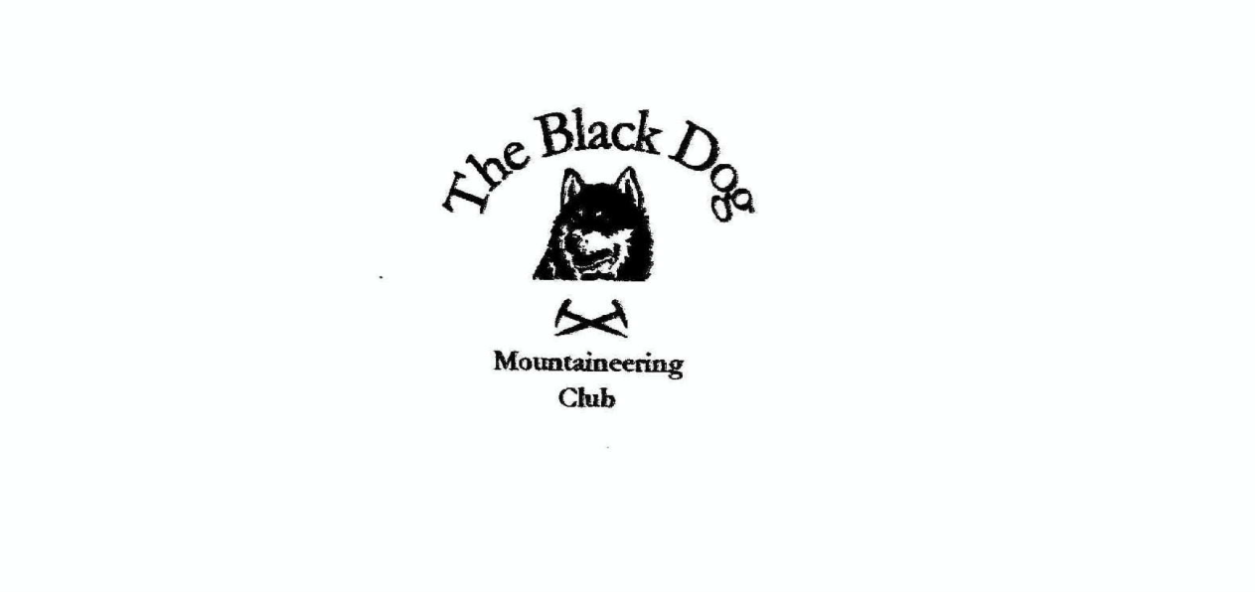

**Black Dog Meet**

**No. 238 Great Glen**

**Munro Compleation - James**

**Friday 1st – Sunday 3rd July 2022**

**In Attendance**

James Yeats, Rachel Yeats, David Cameron, Tony Smith, Lorna Smith, Charles Alexander, Gerry Feeney, Peter Robertson, Owen Clark, Gillian Clark, Valerie Inglis, Wull Clark, Bill Clark, Richard Marwood, Ruth Marwood, David McKay and Jamie Cochran (guest)

# **Hills Climbed**

**Friday**

Gerry & Charles Beinn Mholach (841m)

**Saturday**

All except Rachel and Gillian Gairich (919m)

Tony added Beinn Bheag (339m) and Meall a’Chait (304m)

**Weather**

Misty and wet for the main event.

**Notes / Highlights**

**Friday**

Gerry and Charles did the Corbett Beinn Mholach. They cycled in from Dalnaspidal, following the Walk Highland route up and found the going much less boggy than predicted. They took a short cut on the way out and that was very dry as well.  
They saw water voles, the first time they had seen them for years, and a covey of grouse on their first unsteady flight. The weather was dry, bright and breezy all the time they were out but there was a heavy shower just as they got back into the car.

**Saturday**

James’ “Compleation” Meet Report

July, Gairich and James is out to complete

His last mountain that stands above 3000 feet

Hares set loose setting the pace

Hounds to follow taking up the chase

And at the top with champagne and cheers they meet.

The Hares; Parked up at Loch Quoich Dam approx. 08:00 am.

The day was grey and misty and wet gear and rain covers were immediately put in play. The walk began by crossing over the top of the dam and turning right onto green grassy banks that would be better described as a tilted swamp. Trying to keep feet dry in such terrain seemed like such an effort that before long all the hares were squelching in unison. Declarations of “that’s us past the worst of it” were soon met with worse disproving said declaration and doing nothing to improve the pace. Tony broke off from the hares (I would like to say in a self-sacrificing attempt to throw the hounds off our scent but it was not that type of a chase) and ventured off the track, initially to the south, to pick up a bump or two while the remaining hares lopped on towards the first rise. At the high point beyond the bealach the path did dry out a little as we headed down towards the forestry plantation.

Our dry spell vanished once more as we started our ascent of the mountain heading up the east ridge on an obvious if wet path. By 10:00am first breakfast had run out and a wee break on a less wet rocky outcrop was had and second breakfast enjoyed. At this point we clearly had the mountain to ourselves not another living thing in sight.

As we resumed our trek, we began to encounter small plovers protesting loudly at our intrusions and escorting us off their little patch of hill. Some of them letting us get quite close to them before flying back to their claims. Looking back, we get a glimpse of the hounds crossing the lower bealach through the mists. Tony reappears behind us and after a short while caught us up in time for elevenses.

The path is now steepening as we begin to gain the upper slopes and underfoot we encounter frogs (clearly too wet for them on the lower slopes) living dangerously as they hop out from under boot. We drop our pace now and adopt a “pole pole” approach. Soon we are scrambling up steep wet sections passing comment on how much fun they would be on the descent. Height is quickly gained regardless of our pace and we make short work of the tricky section and break out onto the top of the hill proper.

As we leave the shelter of the ridge the wind and rain drives straight into us making us even wetter than we were. We see the summit cairn ahead and we stop within striking distance and find a sheltered dip to sit and await the hounds. Some more food was consumed (why not) and layers and gloves applied in an effort to ward off the cold and wet.

At last, the hounds emerge from the mists grinning widely despite the weather and the hares grinned back as we knew the cold wait was over and the celebrations could begin!

In short order poles formed an arched avenue for our compleater James to walk through accompanied by much cheering and banging on said poles. Summit reached, speeches made, applause, hugs and shaking of hands before corks popping and bubbles flowing. Cold and wet forgotten as we joined James in celebration of the completion of his Munro quest. And not a helicopter in sight…

**Helicopter James**

My good man James does things proper

But once he nearly came a cropper

The day was so very hot

James perspired such a lot

He was whisked off the hill in a chopper

Hounds and Hares turned their backs to the wind and began a slow and at first careful descent until safer ground was reached and the precession became more leisurely as the weather improved. A loose line of various conversations was formed and we quickly lost the path only to find it again somewhat further down the mountain. The earlier rain had done nothing to improve the ground underfoot and most of what we were walking on would best be described as moving water. One consolation was the wee river crossing was not so wee on the return bringing a smile to at least one face.

One of the hounds (who shall remain nameless) decided to get closer to the ground in the form of a spectacular slip ensuring that he was muddy as well as wet. However, the weather conspired against him by sending a final downpour which unfortunately was not localised to just him. It cleaned him up and undid all the drying the rest of us were enjoying. Final march across the dam and returned to cars for a change of clothes and heading home to the Great Glen Hostel approx. 17:00

Celebrations continued (after showers) at the Great Glen Hostel where Rachel and Gillian had laid out a table for a group dinner and proceeded to wine and dine us with fantastic food and company.

Speeches were made, wee mementos given and a wonderful cake (baked by Lorna) was brought out to complete the celebrations!

[Great Glen Photos](https://www.flickr.com/photos/190421987@N07/albums/72177720302411359)

**Next Meet**

Ullapool 22nd to 24th July

Meet organiser – James Yeats