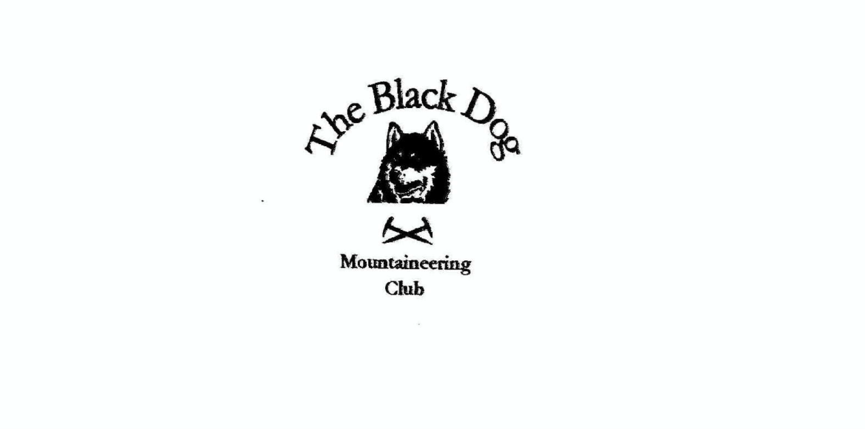

**Black Dog Meet**

**No. 247 Crianlarich**

**Friday 31st March to Sunday 2nd April 2023**

**In Attendance**

Charles Alexander David Cameron

Owen Clark Wull Clark

Rachael Clark Val Inglis

Alan Sewell Lorna Smith

James Yeats Tony Smith

# **Mountains Climbed**

**Friday**

Valerie & Davie. Beinn Dubhcraig (978m)

Lorna, Tony & Charles Am Bacan (612m)

Alan Beinn Chaorach and Beinn a’ Mhaniach (709m)

**Saturday**

Wull & Valerie Ben Starav (1078m), Stob Coire Dheirg (1028m) and

Ghlas Bheinn Mhor (997m)

Davie Beinn Fhionnlaidh (959m)

Alan Doune hill (734m), Cruach an t-Sidhean (684m),

Beinn Eich (703m) and Beinn Dubh (Mid Hill) (657m)

Lorna, Tony & Charles Creag Mac Ranaich (809m), Meall Sgallachd (707m) and Meall Reamhar (671m)

Owen, Rachael & James Beinn Oss (1029m) and Beinn Dubhcraig (978m)

**Sunday**

Lorna, Tony & Charles Meall nan Fiadh (far East top 619m)

**Weather**

A fine weekend. Quite breezy, good visibility and cool but very settled.

**Notes / Highlights**

**Friday**

David and Valerie climbed Beinn Dubhgraig, a relatively accessible hill from Glasgow. It was decided to meet at Dalrigh and access Beinn Dubhcraig from here, passing the only profitable gold mine in Scotland, last time I heard they were drilling East for more gold. Ben Oss was left for another time, perhaps the upcoming meet in Tyndrum.

Alanclimbed Beinn Chaorach and Beinn a’ Mhaniach from the Fruin Glen, in a clockwise direction - as a new forest track has been ploughed up the glen with subsequent Sitka planted on the east side of the Strone ridge. The weather was kind with some views from the summits.

Tony, Lorna and Charles climbed Am Bacan (612m) and its associated tops. “We started from the south loch road just outside Killin and followed good forest tracks through the extensive woodland (once we had found the right trail, but that's another story!). Thereafter it was the usual grass and heather and making use of animal trails over our three summits before descending to another useful access road for our return.

**Saturday**

David climbed Beinn Fhionnlaidh, a very straightforward Munro from Glen Etive, where the hydro scheme building was not as intrusive as expected, however “van life” is!

Val and Wull headed off early for the drive down Glen Etive. We followed the new bulldozed track created by the hydro scheme all the way to where the track headed up Ben Starav. There was a lot of cloud swirling around towards the top so no views, but it started to break up on the ridge over to the second Munro of the day. It was a great day out made better by the fact that we had the mountains largely to ourselves. And whilst the mess the hydro schemes make is pretty awful, they made the ascent and descent easier by avoiding the worst of the bog and swamp at the base of these hills.

James, Owen and Rachael started out from the Dalrigh car park following the track over the railway and turned down to the footbridge over the Allt Gleann Auchreoch. Once over the river we were in the trees following a soggy path by the river up to Beinn Dubhcraig. From the summit we dropped steeply down to Bealach Buidhe and on to the ridge up to Ben Oss. The return journey was retracing our steps back up towards Beinn Dubhcraig and following the same path back to the car park.

Alan climbed Doune hill (734m), Cruach an t-Sidhean (684m), Beinn Eich (703m) and Beinn Dubh (Mid Hill) (657m) from Glen Douglas. Good walking conditions, cool but with good views. The first time I’ve done 4 Grahams in a day.

Tony, Charles and Lorna completed an excellent circuit from Lochearnhead using the old railway track to access Glen Kendrum for the initial accent to the Corbett Creag Mac Ranaich and then returning south via higher ground over a total of five summits.

Sunday

Tony, Lorna and Charles climbed Meall nan Fiadh from a very busy car park in Glen Lednock for an easy circuit out by a good works track (signed route over to Loch Tay) and back more directly over typical moorland.

Overall this was a good weekend. The only niggle about the hostel is the kitchen space (about which I have commented to HS). Again another good meet and good cheer and good food. However the low point was that some of us got an unshakeable cough.

*David*