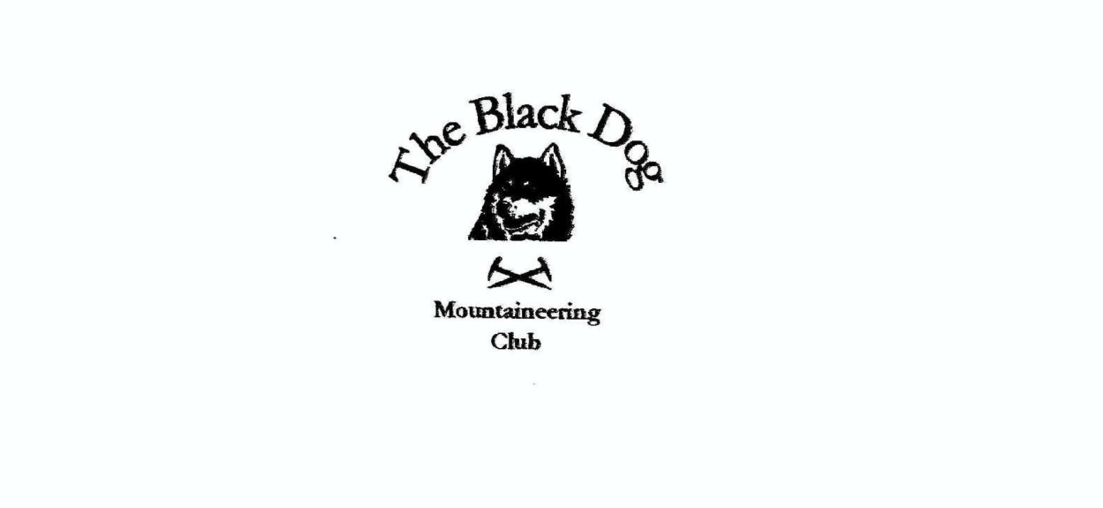

**Black Dog Meet**

**No. 250 Torridon**

**Friday 2nd – Sunday 4th June 2023**

**In Attendance**

Charles Alexander, David Cameron, Owen Clark, Wull Clark, Valerie Inglis, Eliz Kennedy, John McGill

Alan Sewell, Tony Smith, James Yeats, Liam Hutchinson (guest) and Jamie Wright (guest)

# **Hills Climbed**

**Friday**

Valerie & Wull: Beinn Eighe - Sail Mhor (980m), Coinneach Mhor (976m),  Coinneach Mhor (1974 top - 954m), Ruadh-stac Mor (1010m), Spidean Coire nan Clach (993m), Sgurr Ban (970m),

Sgurr Nan Fhir Duibhe (963m) & Creag Dhubh  (910m)

Davie & Jamie: Sgurr Choinnich (999m) & Sgurr a' Chaorachain (1053m)

John & Liam: Aonach Eagach – Meall Dearg (952m) & Sgorr nam Fiannaidh (968m)

Eliz: Tom a’Choinich (1112m) & Toll Creagach (1054m)

James & Owen: Lurg Mhor (986m), Meall Mor (974m) & Bidein a'Choire Sheasgaich (945m)

Charles & Tony: Carn na Feola (759m)

**Saturday**

Valerie, Wull & Alan: Meall Dearg (955m) & Mullach an Rathain (1023m)

John: Meall Dearg (955m)

Davie: Maol Chean-dearg (933m)

James: Beinn Damh (903m)

Eliz, Charles & Tony: Cuirn Liatha (601m) & Beinn Liath Beag (737m)

Jamie: Liathach – Mullach an Rathain (1023m) & Spidean a’ Choire Leith (1055m)

**Sunday**

Jamie & Liam Beinn Eighe – Ruadh-stac Mor (1010m) & Spidean Coire nan Clach (993m)

**Weather**

Brilliant (if a little on the warm side!) all weekend.

**Notes / Highlights**

**Friday**

Valerie reports: Wull and I climbed the whole Beinn Eighe ridge, with thanks to Tony for assisting to leave a car at Kinlochewe and transport back to the start. We walked into the Corrie underneath the triple buttress, walked round the lochan and headed up grassy slopes in a SW direction to the col south of Sail Mhor and easily bagged the first top. The mist swirled around a bit but we could clearly see the scramble on to the end of the triple buttress. Wull led the way and after some choice words from me we arrived on our second top of the day. The walk over the two Munros was without issue and was superb. The main challenge of the day was navigating the ‘bypass path’ around the Black Carls, which included a couple of ‘interesting’ choices of direction, appropriate retracing of our steps, Wull losing the backside out his trousers and an interesting ’thrutchy’ chimney. Long walk off but a great day out. On arrival back at the hostel, when we told the warden what we’d done, he just said ‘animals’!!

Tony: Having dropped off Wull’s car Charles and I followed Valerie and Wull on the well worn trail up Coire Dubh Mor from the busy car park. Bearing left at the fork we headed more or less directly for the east end of Beinn Dearg to, eventually, arrive on the ridge just south of the summit of Carn na Feola. Having admired the very fine view for some time we decided that the whole ridge would be ‘a step too far’ and elected to simply return via the outward route.

Liam and John did the Aonach Eagach Ridge. This was Liam's first big scramble and, says John, “he handled it well”.

Davie: I drove to forest car park at Craig, where I found Jamie who had stayed the night in his van. Weather “Scorchio” and a tough pull after a substantial walk in.  Good access track, but always helpful with a PushIron. I met Jamie again at the summit of Sgurr Choinnich. We continued along a relatively easy but airy ridge between the two Munros and had a chat and a laugh on the very steep walk off Sgurr a' Chaorachain down to the track at Pollan Buidhe, where Jamie picked up his bike.

Eliz: I climbed in Glen Affric and also enjoyed a beautiful day and good views. I then travelled to Torridon via the Coop in Beauly to buy a cake for the 250th meet celebration. “Charles the Caterpillar”, the best on offer, was quickly dispatched later!

James: We set off from the Attadale Car Park on mountain bikes, after 2 km we were off the bikes pushing uphill for mostly the next 4 km, eventually arriving at the Allt Coire na Soma bridge and happily abandoned the bikes. We then followed the river to Loch Calavie and headed uphill to the bealach between Bidein a'Choire Sheasgaich and Lurg Mhor. On reaching the bealach we climbed up Lurg Mhor first and I went on to the top Meall Mor. On returning to Lurg Mhor we headed back to the bealach and up onto Bidein a'Choire Sheasgaich. Thereafter taking the southwest ridge back to the Coire na Soma bridge and the bikes. With reluctance we set off on the bikes for a few km before we are off pushing again. On reaching the highpoint it was back on the bikes for a hair-raising descent down the steep rubble surface for most off the remaining journey, getting back to the car park after 11 hours.

Alan: On Friday I climbed at Stone Valley Crags with James, Mike, and Tam. The routes were:

Open Secret HS 4b ***

Flaming June VS 5a

Schiltrom E1 5b*

Burnt Offering E2 5b *

Bold as Brass E2 5C **

**Saturday**

Valerie: Alan, John, Wull and I set off early and walked into Coire na Caime via Coire Dubh Mor, which has to be one of the most beautiful corries, with a stunning lochan, surrounded by the peaks of Liathach. An incredible place, although John, after claiming that Torridon was one of his favourite places, stepped into a bog, and thereafter said “this is s***e” for the rest of the day. It was a gruelling slog up to the notch between the top and the Northern Pinnacles leading up to the Munro. The top itself was a little airy but not quite as dramatic as the guide book had suggested. John headed back down having bagged his top whilst Alan led Wull and I, suitably roped and helmeted, over the Northern Pinnacles and onto the Munro Mullach an Rathain. I surprised everyone, and more myself, when I said “I loved that”!! We had planned to do the whole traverse to Spidean but Wull was suffering with cramp and so we headed down instead back to the hostel for a well earned beer. Thanks again to Al for making that possible.

Davie: I set off again for Strathcarron and climbed Maol Chean-Dearg from Coulags, passing one of the most well kept bothies that I have come across. This hill was surprisingly quiet and has fantastic views from NW to NE of all of the Torridon hills and beyond. Indeed the panoramic window in the lounge at Torridon Youth Hostel has a very good view of the summit of this hill.

Tony: Eliz joined Charles and I for what amounted to a tour of the Coulin Lodge estate. Initially along the main estate road our route took us by the Lodge and onto a good path SW up into Coire an Leth-uillt and onto the stony summit of Cuirn Liatha. We enjoyed another lovely sunny day with great views of Liathach and Beinn Eighe on the traverse round to Beinn Liath Bheag before descending steeply east to rejoin the estate road for the pleasant but long walk back via Loch Coulin and Loch Clair.

James: After yesterday’s ordeal and not getting up until 09:00 the plans were to do a less demanding walk, Beinn Damh was decided on and we set off to the Torridon Hotel Car Park. The trees provided shade for the first 1.5 km. On reaching a fork in the path Owen decided to opt for a low level walk to the river and waterfalls. James continued on to the top of Beinn Damh and enjoyed the great views.

In the evening those present gathered to ‘celebrate’ the 250th Club meet. After a short speech by founder member Alan we enjoyed cake and fizz for the toast to the future.

Sunday

Most of us headed home whilst Jamie, with Liam, continued his quest to complete the six main Torridon Munro summits on this trip (successfully concluding with Beinn Alligin on Monday).

A good weekend in a good location!

*Tony*