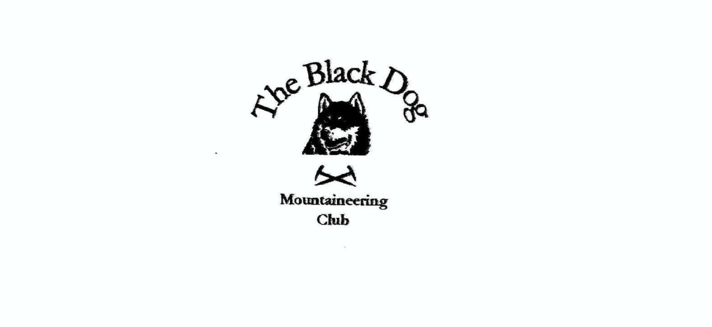

**Black Dog Meet**

**No. 254 Inchnadamph**

**Friday 15th – Sunday 17th September 2023**

**In Attendance**

James Yeats, Rachel Yeats, David Cameron, Tony Smith, Lorna Smith, Charles Alexander, Valerie Inglis, Wull Clark, Alan Sewell, Owen Clark, Gerry Feeney, Liz Kennedy and Alice Cottis (guest)

# **Hills Climbed**

**Friday**

Lorna, Liz, Gerry & CharlesBreabag (815m)

Tony Glas Choire Beag (715m)

James, Alice Cul Beag (769m)

David C Glas Bheinn (776m

Alan Beinn Dhorain (628m)

Val & Wull Sgurr Fiona (1060m) and Sgurr Creag an Eich (1017m)

**Saturday**

Lorna, Tony & Charles Cul Mor (849m) and Creag nan Calman (828m)

David C Arkle (787m)

AlanBeinn Reidh (567m) and Beinn Garbh (539m)

James, Liz, Gerry & Alice Spidean Coinich (764m), Sail Gorm (764m) and

Sail Gharbh (808m)

Owen Seana Bhraigh (927m)

Val & Wull Ben More Assynt south top (960m), Ben More Assynt (998m) and Conival (987m)

**Sunday**

Tony & Lorna Creag na h-Iolaire (357m)

**Weather**

Friday started of cloudy but cleared as the day went on. Saturday and Sunday were nice clear days.

**Notes / Highlights**

**Friday**

**David C**

From Inchnadamph hostel car park I climbed Glas Bheinn in mixed weather. Misty on the top with a few light showers.

**Alan**

Climbed Beinn Dhorain in Glen Loth on Friday. This must be one of the easiest Grahams - 50min to the summit and 30mins down. I then took a leisurely trip back west to Inchnadamph via Strath Oykel.

**Tony, Lorna, Liz, Gerry and Charles**

We all walked as far as the caves from the busy car park but a short way further on, and after a food stop, Tony turned off to head directly for Breabag North Top whilst others continued to the Corbett. From the south the top (Simm) is guarded by very rough boulders, which made for hard going, but had a wonderful feel of isolation and a great view toward the nearby Conival and Ben More Assynt. The direct descent back towards the agreed meeting place by the caves was, fortunately, far more straightforward.

**James and Alice**

Parked on the A835 and followed the old road and ATV track towards Lochan Fada then directly across the boggy ground which changed to a steep heather slope onto Meall Dearg, there onwards past Lochan Uaine and up the final climb to Cul Beag. A nice clear day with fantastic views all round.

**Val and Wull**

After a very early departure from Dalwhinnie, we set off for Dundonnell to settle some unfinished business on An Teallach. We followed the Walk Highlands route up the ridge over Meall Garbh which seemed to take forever. There was some cloud on the summits as we walked up but it came and went and luckily cleared for us. We bypassed Bidein a Ghlas Thuill and headed straight for Sgurr Fiona. The pinnacles looked amazing and terrifying along the ridge. From the Munro we headed west to the outlying Munro top, Sgurr Creag an Eich, which was a wonderful, fairly narrow, but flat-topped ridge - a thoroughly marvellous addition to the day.

Time didn’t allow for the other outlying top we had in our sights, but a good excuse to go back another day.

**Saturday**

**David C**

I climbed Arkle on what was a very muggy start, with lots of flies. Long slog to the first top, with a 70m drop and rise, plus 1.5km out to the real summit of Arkle. Long tough day but a lovely wee mountain in one of Scotland’s outstanding areas.

**Alan**

I climbed the Marilyn Beinn Reidh and its NW top Beinn Garbh. The most difficult part of the day was crossing the river Loanan, but the 360 panoramic views from the summit made the effort worthwhile.

**Tony, Lorna and Charles**

We headed for the Corbett Cul Mor up the excellent and popular stalkers' path from Knockan Crag on the main road. After taking in the fine views (particularly of Suilven) we walked along the ridge to claim the two adjacent Simms. First the north western top before returning to the col to climb steeply to Creag nan Calman and descending from there to rejoin the outward route.

**James, Liz, Gerry and Alice**

Quinag - From the car park we headed up the east ridge of Spidean Coinich on the top we stopped to take in the views and numerous photographs. A steep descent to Bealach a Chornaidh followed by a steady climb to Sàil Gorm. We retraced our footsteps back to the bealach for the final climb up to Sàil Gharbh. After a short break we headed back in the direction of the bealach turning towards Lochan Bealach Cornaidh and the path back to the car park.

**Val and Wull**

We set off direct from the hostel - one of the few Munro days without a drive. We walked in through the col underneath the huge shoulder at the southern end of Conival and past Dubh Loch Mor. Not a soul in sight other than a few tiny figures on the summits above us. From there we had what can only be described as a punishing ascent up on to the ridge south of our outlying top. From there the climbing got a bit easier and the ridge gave great walking. A couple of wee narrow sections that turned the air blue from me, but altogether a fine route. The Munros got a bit busier from there and we took in Ben More Assynt and Conival before the long descent and walk back to the hostel.

Great weekend.

**Owen**

Inchnadamph

Scotland's far north west

Scenery is the best

Should you doubt me

Come up there with me

And we shall put those doubts to rest.

08:30 start; Set off from Inverlael carpark following the forest track along the river Lael.

The track breaks off Northeast and rises steeply through the trees until breaking out on to heathland before levelling out. It is a bright morning and the views back to the West are stunning. The track is clear and well defined as it makes its way through the remote wilderness towards my goal; Seana Bhraigh.

As the day goes on the weather deteriorates and my hill is temporarily lost from view only to clear again as I make the final approach. Some Red Deer pause to watch my march through their land as I make a final push to the summit. Here there are views in all directions.

Refuelled courtesy of some jelly babies I resume my march retracing my steps for the long haul back out to civilization. There is a threat of rain to the north of me but nothing from the sky gets me. I meet some fellow walkers as I return mostly following in my footsteps heading towards the remote summit of Seana Bhraigh.

I return to the car approx. 16:30.

**Sunday**

**Tony and Lorna**

We climbed Creag na h-Iolaire just west of Quinaig. A 'wee gem' of a hill offering a panoramic view out to the western isles and a close-up of the impressive cliffs on the adjacent hill. However available notes suggested that the clearly marked access track was "difficult to follow initially but soon opens out". No kidding. The roadside gate looked as if it hadn't been opened all season and a rather vague trail through the high bracken deteriorated further as we reached the gorse and scrub trees. Must bring a machete next time (there won't be a next time though).

*James*

**Next Meet**

Mull 20th to 23rd October

Meet organiser – Peter