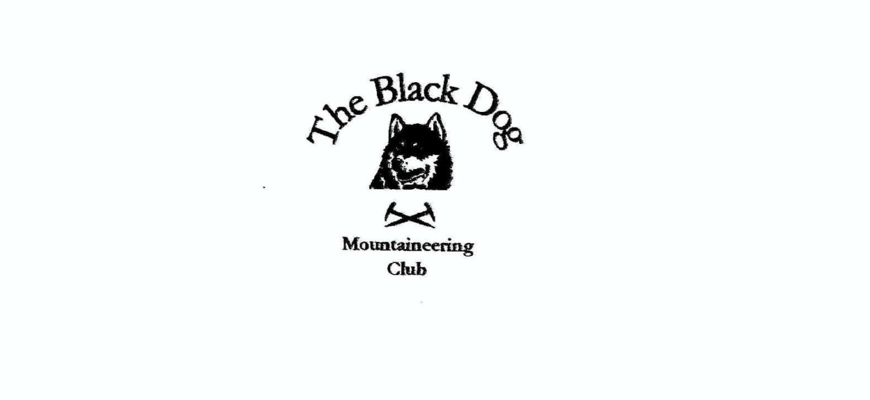

**Black Dog Meet**

**No. 255 Dalwhinnie**

**Friday 17th – Sunday 19th November 2023**

**In Attendance**

James Yeats, David Cameron, Tony Smith, Charles Alexander (part), Valerie Inglis (part), Wull Clark, Owen Clark, David Mackay, Liz Kennedy

# **Hills Climbed**

**Friday**

Tony & Charles (part)Am Meadar (803m) and Meall na Spianaig (621m)

**Saturday**

Tony Meall nan Ruaig (579m) and Glas Mheall Beag (882m)

David C, David M, Wull & Liz The Fara (910m)

Owen & James Geal Charn Mor (824m)

**Sunday**

Tony Geal Charn (890m), Creag na h-Iolaire (814m), Glac a'Chaise (579m) and Creag nan Abhag (590m)

**Weather**

Friday and Sunday generally fair. Saturday very wet with a cold wind higher up.

**Notes / Highlights**

**Friday**

**Tony and Charles (part)**

Parked just off A9 by Dalnacardoch Lodge for the longish estate road tramp north towards Gaick. Wonderful early conditions with a mix of low mist and bright clear skies. On reaching Sronphadruig Lodge (ruin) we took a rising NW line up the steepening slopes of Am Meadar to a broad flat and very windy plateau to visit several 'embedded rocks' one of which was the summit!

Thereafter we turned south to return to the track which Charles took directly back whilst I added the second Simm as a quick(ish) out and back by the edge of the wood.

**Saturday**

**David C, David M, Wull and Liz**

The Fara (Corbett) - The original plan was to walk down the track beside Loch Ericht to Ben Alder lodge and walk east along the ridge to the summit. However, given the rain, low cloud and wind we headed straight up to the ridge through the fire break just beyond the gate house. We had a snack and piled on extra dry clothes at a cairn David M declared to be the summit. Fortunately, before we headed down, Wull checked and discovered we were about 100 yards from the true summit. After touching the appropriate summit we headed down and back to the hostel to get dried off.

**Tony**

Drove to Layby 70 on A9 and sat waiting for the forecast break in the rain which of course never came. Charles decided to head home but I elected to continue as planned. Walked back beyond the Wade Stone to easily gain the first hill via a decent track. The next 4k or so was a rather different story; persistent rain, thick mist and frequently very boggy ground (a classic "why am I doing this" day). However I did eventually make the summit and found the promised ATV track alongside the grouse butts which improved things a bit for the descent.

**Owen and James**

Lynwilg car park up the track weather was OK. By time we got to the cairn on the track to turn towards the summit it was pouring and very windy but we continued to the summit and hurried back to the car.

**Sunday**

**Tony**

Completed an excellent circuit from the Glen Banchor car park in welcome fair weather (except, very annoyingly, for the final 20 minutes so again arrived wet back at the car). The new footbridge was essential to cross the Allt a'Chaorainn in spate so I followed a quad track to the ridge south of Geal Charn rather than the marked path to the north which extended the route somewhat. Interesting terrain for the lower hills and the fort looks very impressive from above.

**Highlight**

Owen kindly made stovies (meat and veggie) for all participants on the Saturday evening. Thanks Owen for your excellent meal which was topped off with an epicurean collection of cheeses - Epoisses; Cashel Blue; Ossau Iraty & Ashcome. This feast was washed down with a copious quantity of refreshments and an excellent evening was had despite the soaking on the hills.

*Liz*

**Next Meet:** Mull 1st to 4th December**.** Meet organiser – Tony