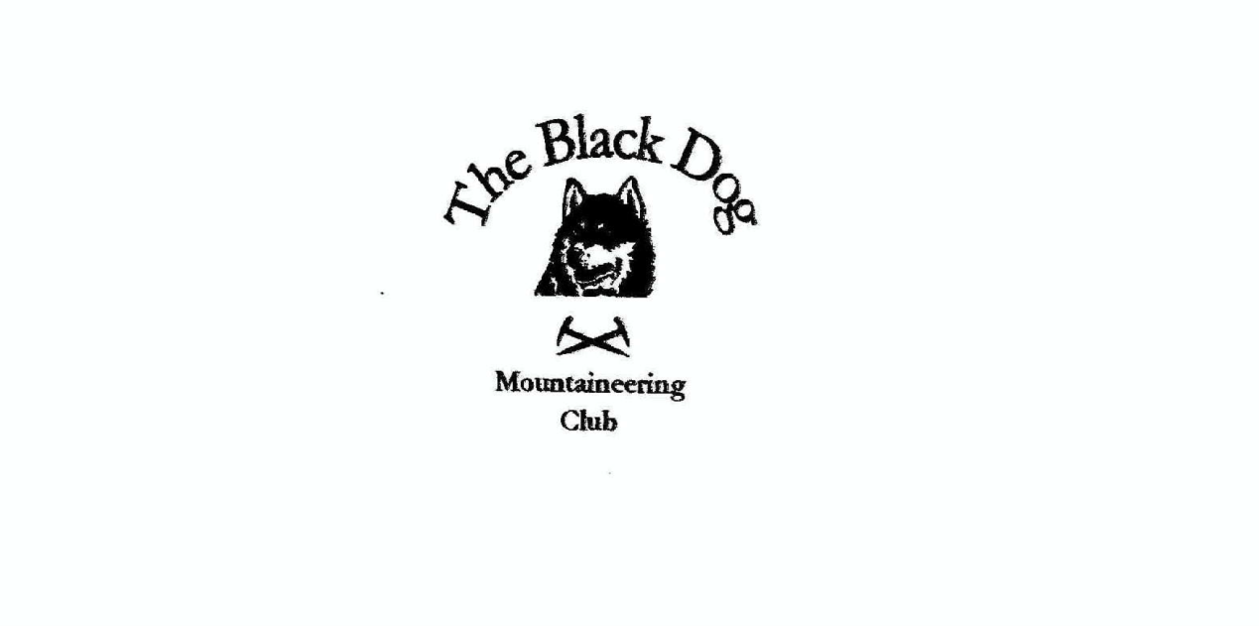

**Black Dog Meet**

**No. 259 Corran**

Friday 23rd to Sunday 25th February 2024

**In Attendance**

David Cameron Wull Clark

Owen Clark Val Inglis

David Mackay James Yeats

Lorna Smith Tony Smith

# **Mountains Climbed**

**Friday:**

Valerie, Wull & David C Beinn Maol Chaluim (907m)

James Beinn Stacath (771m)

Lorna & Tony Meall Dail Min (536m)

**Saturday:**

Valerie, Wull & David C Beinn Resipol (845m)

James Mam na Gualainn (796m)

Owen & David M Buachaille Etive Beag;

Stob Coire Raineach (925m) & Stob Dubh (958m)

Lorna & Tony Glas Bheinn (642m) & North top (626m)

**Sunday:**

Lorna & Tony Beinn Chaorach (475m)

**Weather**

Friday was a bit mixed but generally better further East. Saturday and Sunday were great winter days.

**Notes / Highlights**

**Friday**

Wull:

Friday Valerie, David C and I went to climb Beinn Maol Chaluim the Corbett down Glen Etive. Met David C at the lay-by at the start of the route. A steep start to the hill soon eased to a more gradual ascent with plenty of snow around the higher we got. The approach got steeper again as we neared the 848m point. We went off route slightly and had to traverse across a very steep slope with very deep snow, so we took the decision to head back to less steep ground. After a wee conflab we took the decision to turn back. The snow was very deep and it was slow going wading through the snow.

James:

Parked up at Glen Buckie beside Ballimore Farm and followed the right of way to Brig o'Turk via Glen Finglas. The path was very wet and boggy but was able to cross the river with no problem. The bright morning changed to overcast with drizzle and sleet. I met the snow line at around 600m which was wet and made the climb a bit of a slog. It was a bit windy and cold on the top so did not hang around and set of back the way I came up.

Tony:

We stopped by Blair Atholl for a short walk up one of the local Humps with, it has to be admitted, most of the height gain being achieved before we reached the parking area above Tirinie farm.

**Saturday**

Wull:

Saturday Valerie, David C and I took the ferry to Ardgour to climb Beinn Resipol. Got to the start of the route with the weather looking promising. Headed off from the Resipol campsite, a very nice but very boggy walk through the forest. Got out the forest and looked towards the mountain which looked very nice with a good covering of snow. Followed the river up to the start of the large gully and made the steepish ascent up the gully with Valerie making light work of breaking the trail. As we approached the summit, with some good route finding required to reach it the cloud closed in. After about five minutes on the summit it cleared with some excellent views. Returned the same way. An excellent and recommended day out.

James:

Parked close to Callert house on Loch Leven and headed up the boggy path through the trees, after about 1.5km I headed up on to the ridge and encountered snow at around 600m which gradually got deeper ranging from ankle to knee deep. Eventually came across the fence which I followed to top. Weather not to cold but overcast occasionally. Returned by the same route.

Owen:

Glencoe and David Mackay

I forgot my boots was his cry

Not funny at the time

but brings much mirth down the line

And laughter and tears to the eye

08:00 start; Set off from Beehive carpark after an initial wee set back resulting from David’s boots being back in the Bunkhouse drying room rather than in the boot of my car. Never a funny moment but guaranteed much mirth further down the line. Fortunately, I had packed a spare pare of winter boots; more fortunately they were a good fit for David, so much so it was looking doubtful that I would ever get them back.

The walk up the glen on a good path began in the shade. Almost immediately we were surrounded by Red Deer as we made our way along the glen. It was not long before, as we gained height, the path succumbed to snow and our route, although distinctive, took on a winter feel. As we approached the bealach we moved from shade to bright sunshine and the day transformed into one of those special days on the hill. On the bealach some mountain skills practitioners had made a snow shelter/igloo which had to be properly investigated before we continued.

We were early out and saw few people on route to Stob Dubh, our first Munro of the day, but the few we did see were as enthralled with the views as we were.

Our hill was attracting many more visitors on our return to the bealach and again the smiles were many as our fellow Munroists enjoyed the best day of 2024 thus far.

The ascent to Stob Coire Raineach was very steep and equally as snowy so the going was tougher than usual, but we got there and claimed our second Munro of the day. Descending once again to the bealach before retracing our steps back down to the carpark. Fantastic day on the hill! Back in plenty of time to watch Scotland beat England in the Rugby Six Nations.

David added “I was contemplating sending a picture of my boots and inviting club members to a caption competition. I think the words ‘you’re a tube’ might have been frequently used.

 Suffice to say it was a fantastic day out and your contingency planning was much appreciated. I’ve been up those hills many times winter and summer. That was the best. I’m still smiling.”

Tony:

Taking the ferry over to Ardgour we headed down to Kingairloch. Parking by Loch Uisge we took a direct route NE using a rough quad trail where possible. Eventually the grass/heather slopes gave way to snow covered terrain above ca 500m. This was hard work in the soft deeper sections, but the summit gave us fine visibility. Out and back to the North top before retracing our steps.

**Sunday**

Tony:

Beinn Chaorach is only a very short distance from the main road on Rannoch (a “pensioners’ hill” as another member commented) but is really a very good 360⁰ vantage point for the adjacent mountains and moor.

*Wull Clark*