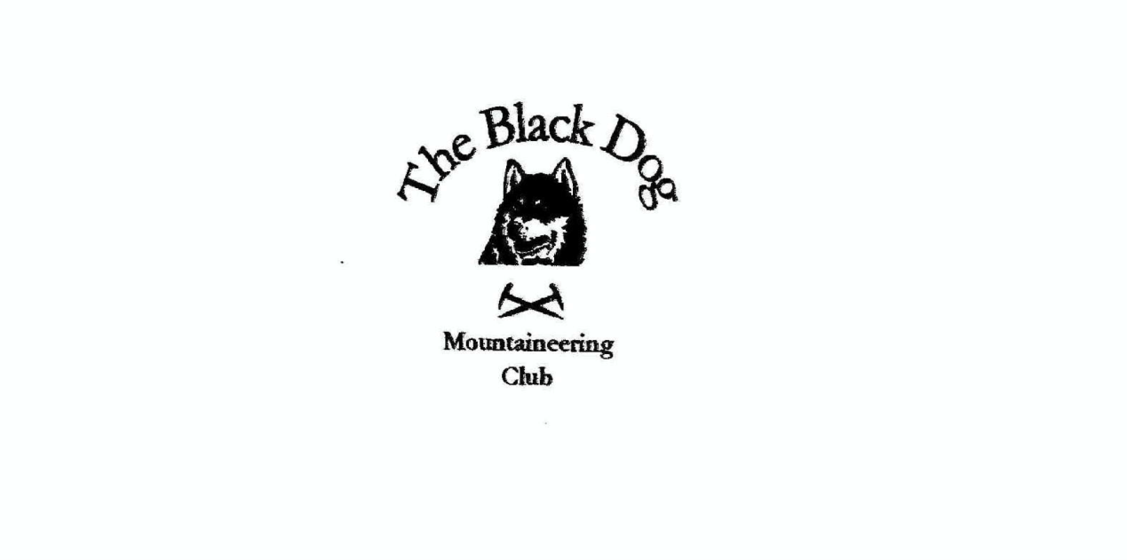

**Black Dog Meet**

**No. 260 Crianlarich.**

Friday 15th to Sunday 17th March 2024.

**In Attendance**

James Yeats David Cameron

Owen Clark Wull Clark

Liz Kennedy Val Inglis

Lorna Smith Tony Smith

Peter Robertson

# **Mountains Climbed**

**Friday:**

Liz Cruach Ardrain (1046m)

Lorna & Tony Cruachan Cruinn (Fiarach South Top) (588m).

**Saturday:**

Wull & Valerie Carn Mor Dearg (1220m)

Davie Ben More (1174m) and Stob Binnein (1165m)

Lorna, Tony & Liz Sron nan Colan (590m), Drochaid an Droma (569m)

and Meall Odhar (657m)

Owen & James Ben Lui (1130m) and Beinn a’Chleibh (916m)

**Sunday:**

Lorna & Tony Twenty Shilling Hill (146m)

**Weather**

Heavy rain and squalls on Friday morning, but a lovely day on Saturday with mixed cloud and a strong cold wind on the tops. Saturday early evening it started to rain by which time everybody was safely off. Sunday a bit mizzly early on but generally dry for the drive home.

**Notes / Highlights**

**Friday**

Liz managed to escape Glasgow and climbed Cruach Ardrain behind the weather front.

Weather was kind for Tony & Lorna too on Cruachan Cruinn. Parked at the busy Falls of Falloch car park to access the hill via a wet (very in places) ATV track under the adjacent railway. This was a straightforward moorland walk on a fine if breezy afternoon, returning by essentially the same route.

**Saturday**

Tony, Lorna and Liz, were walking together and noted: -

A very pleasant circuit from Tyndrum starting at the lower station to follow a waymarked path alongside the railway and then steeply up through the old mine workings onto the 'ridge' heading west towards Ben Lui. From the Graham we dropped directly to the obvious gap in the trees to reach the Cononish track and an easy return to the station. Another fine day with excellent clear visibility.

Owen & James commented: -

Parked at the Glen Lochy car park. We managed to keep our feet dry by bringing wellingtons for crossing the river. After hiding the wellies, we set off up the side of the Eas Dàimh, and through the felled area to the track. At the bridge over the Fionn Choir we headed up through the trees on an extremely boggy path to the gate at the end of the trees. From the gate we headed up the east ridge towards the top. At around 1000m we encountered snow and ice which made the going hard. From the top we descended the ridge leading to Beinn a'Chlèibh. The conditions underfoot improved quickly due to the lack of snow making the climb up to Beinn a’Chlèibh a lot easier than the previous hill. From the top we returned to the bealach and back down to the trees and the muddy path. Owen could not be bothered with putting his wellies on at the river and opted to cross in his boots.

Valerie & Wull observed: -

We climbed Carn Mor Dearg from the North Face car park at Torlundy. Even at 8.30am the car park was packed to the gunnels and we got the last space. It was quite nice weather low down but really windy and freezing cold on the ridge and hard work walking into the wind with the spin drift and snow devils.

The Ben looked stunning in the sun, snow and black swirling cloud.

Good day!

Davie C said: -

Short drive to Ben More Farm from Inverardran. Straight off the climbing starts and is fairly relentless until past the corrie. Cracking stone stepped path for most of the way. Just after the corrie, crampons went on and improved confidence. Summit had lots of snow and ice with a very cold wind, too cold to stop, so on to the col bellow Stob Binnein. Snow much lower down and deeper on the way up so crampons on earlier (those without looking on oddly). Snow deep at the top and again very cold, cloud completely dropped at this point so zero visibility in all directions. Off course the cloud cleared on the way off but two cracking hills with no rain. Braw!

We stayed at the Ochil MC Cottage at Inverardran. Very well equipped with space for 18. The kitchen was big, well stocked and it's a very cosy wee place. Nice atmosphere. Would go again.

Peter Robertson arrived shortly after 18:00, to join the merry bunch.

**Sunday**

Tony wrote: -

A quick walk in the woods by Comrie on the way home (felt we could then justify cake with the coffee in Crieff!).

Peter reported; -

Less said about my efforts on the Sunday the better! Didn't summit either of intended two Munros on north side of Glen Dochart. Someone had apparently moved them. This was a further attempt in learning (fail). Primary takeaway - if eschewing modern gadgetry and using map and compass consider following:  a "handrail" feature rather than long sectors on a bearing over difficult ground when visibility extremely limited!

*Davie Cameron.*

**Next Meet**

Knoydart 19th to 22nd April. Organiser Valerie.