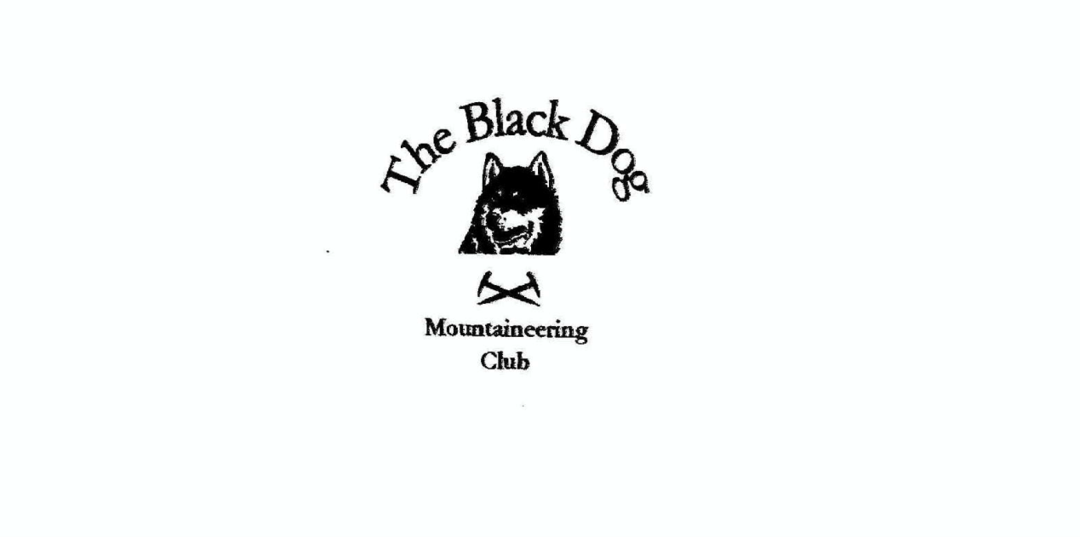

**Black Dog Meet**

**No. 263 Aviemore**

Friday 7th to Sunday 9th June 2024

**In Attendance**

Charles Alexander David Cameron

Owen Clark Wull Clark

Val Inglis Lorna Smith

Tony Smith James Yeats

David MacKay

# **Mountains Climbed**

**Friday:**

James Carn a'Chuilinn (816m)

Charles, Lorna & Tony Cnoc Monzie (446m), Meall Mor (512m), Creag Eallaich (509m) & Creag nan Ceard (432m)

Valerie & Wull Creag Mhor (895m)

**Saturday:**

David M & Owen Braeriach (1296m)

James Carn na Saobhaidhe (811m)

Charles, Lorna & Tony Stac na h-Iolaire (743m) & Creag nan Gall (622m)

Valerie, Wull & David C Creag Liath (743m)

**Weather**

Variable! Depending upon which hills it was either clear with only very occasional showers or heavier rain, sleet and snow. Brisk wind and feeling very cool for the time of year.

**Notes / Highlights**

**Friday**

James  
Parked in the long layby in Glen Doe and cycled the adjacent path to the hydro track. I passed lots of construction sites and vehicles on the way. At a junction around 600m it was off the bike and following the rough track heading southwest for 1km then crossing the Allt Coire an t-Seilich to get up on to the ridge and the large cairn at the Carn a'Chuilinn summit. The return route was the same as the approach.

Tony

Arriving at Loch Moraig (Beinn a’Ghlo) we find only three other cars in the huge new car parking area (£5 per day). Getting ready to set off we are greeted with a heavy shower of rain so opt for lunch in the car instead. Our plan is a clockwise circuit of the loch taking in three tops (we added a fourth en-route) starting with a rather insignificant heathery lump only a few hundred metres off the main track. Thereafter we found easy grass, animal trails and short heather all the way round, generally managing to avoid agricultural and forestry obstructions, on a very pleasant walk.

Valerie

We parked at Glenmore Lodge and thought we were prepared for the long walk into the Lairig an Laoigh. In reality it felt far further than we had anticipated. Cold and windy, with rain and hail, it seemed to take for ever with our target hiding in the mist in the distance. But we got to the foot of Creag Mhor in 3.5 hours for the 25-minute ascent to the summit. And then there was nothing for it other than to turn round and hoof it back out again.

**Saturday**

Owen

**Aviemore**

Cairngorms in June a summers day

Look to the hills in bleak dismay

Wind is blowing and hail is falling

And still that last Munro is calling

Braeriach majestic beneath the grey

08:30 start from Whitewell turning left at Lochan Deo towards the Lairig Ghru. Walking through the forest on a good path watched by finches from the branches above. Initial dry conditions gave way to the promised damp of a rather wintry looking summers day. Waterproofs on we soon left the trees behind as we gained height and entered the Lairig Ghru proper.

We stopped for second breakfast just beyond the Creag a’ Chalamain gap. We are sheltered here but the first hail of the day sends us reaching into our packs for warm layers ahead of beginning the ascent up the northern ridge of Sron na Lairige. We meet our first fellow mountaineers of the day here.

The path is excellent and the ascent kindly gradual; the only cause for concern is the clouds skipping across the summits above our heads. As we ascend, we start to meet other parties coming back down off the hill. “It’s really windy up there” they tell us, but they are smiling as they do so, giving us confidence that the wind may yet allow us to stand when we are up there.

We reach the snow-covered plateau (indeed it is still snowing) and we make the long traverse towards our mountain. The clouds are breaking up now and we are in and out of the mists. Suddenly the clouds lift and the views open up around us. The Lairig Ghru is deep and long below us and to the east we can see Beinn Mheadhoin with its distinctive tors. A truly beautiful and remote place. Braeriach (my last Munro in the Cairngorms) does not disappoint.

Photos taken we move on looking for our route west off the plateau around Coire an Lochain. As we move across the mountain an alternative (and more direct) route offers itself to us. A north ridge between Coire Ruadh and Coire an Lochain. The going is easy and looks to have been well used by others. All goes well until we are cast off the ridge into the mists of a seemly endless boulder-field. Heading towards the obvious landmark of Beanaidh Bheag the rough ground undoes any gains we made from our impromptu shortcut off the plateau. After a river crossing, we stop to eat hoping that the dark clouds approaching hold off a little longer. Alas they arrive all to quickly bringing more hail. We set off eventually reaching a path below Cairn a’ Phris-ghiubhais and finally regain our formal route in Gleann Eanaich.

Back on a solid path our pace picks up and we make steady progress down the glen keeping to the river and re-entering the forest and its welcome shelter from the wind and hail. It’s a long trek but we reach Whitewell approximately 8.5 hours after our starting time.

We return to the Aviemore Youth Hostel to be greeted with a cheer from our fellow Black Dogs. Fantastic welcome home and the beer, comfy seat and hot shower were very welcome too.

James  
I Parked at the entrance to Dunmaglass Estate and as there are good tracks most of the way to the top, I opted to cycle in. The first 4k is wide well-made windfarm access road followed by an ATV track. I managed to cycle up to 730m altitude leaving a short climb to the top.

Valerie

Wull, David and I climbed Creag Liath from Newtonmore. The theme of the day was, once again, cold and windy with a combination of rain, sleet and hail and a few dry spells. It was a good walk along the track and lovely up beside the burn round the back of the Graham and to the summit. A nice wee hill.

Tony

Thanks to a welcome early morning lift from Wull we can start our walk at high level in the Coire Cas car park whilst leaving our car by Glenmore Lodge for the return.

The start of the marked trail heading towards Lochan na Beinne is not immediately obvious but does eventually lead all the way to the 737m spot height – a cracking viewpoint over Strath Nethy to the Bynacks.

The route north to the target Simms is on good ground but the detour (because it’s there!) via a minor intermediate hill (point 692) proves to be somewhat more challenging with a very steep gully to be crossed in each direction.

From the final top we aim northeast seeking to avoid the very steep ground above An Lochan Uaine but the 1km back to the main track seems much further ‘on’ (or rather ‘in’!) unavoidable very deep heather and tussock grass. The 4km walk back via the lochan to Glenmore is a relief to end a fine route with excellent all-round views.

*Tony*