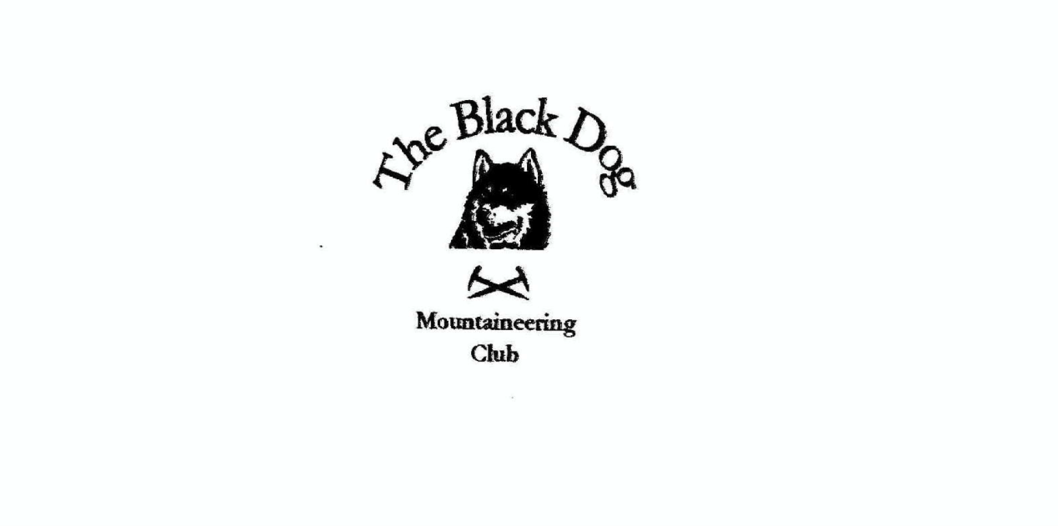

**Black Dog Meet**

**No. 264 Corran**

Friday 21st to Sunday 23rd June 2024

**In Attendance**

David Cameron Wull Clark

Bill Clark Val Inglis

Alan Sewell Lorna Smith

Tony Smith James Yeats

Barry Smith

# **Mountains Climbed**

**Friday:**

Alan Leagag (601m)

**Saturday:**

Valerie & Wull Binnein Mor (1130m) & Na Gruagaichean (1054m)

David Stob na Broige (956m) & Stob Dearg (1021m)

Alan Beinn Bhreac (708m), Mam Hael (726m), Beinn Morlurgainn (690m) and Beinn Mheadhonach (715m)

Lorna & Tony Glas Bheinn Mhor (998m)

Barry Beinn nan Aighenan (960m) and

Glas Bheinn Mhor (998m)

Gerry & James Stob-Coire a’ Chearcaill (771m)

Bill Sgurr a’ Mhaim (1099m)

**Sunday:**

James Am Bathach (798m) and Ciste Dhubh (979m)

**Weather**

A very mixed weekend with some poor conditions resulting in cancelled or changed plans.

Major travel disruption due to closure of A82 in Glencoe following midday accident.

**Notes / Highlights**

**Friday**

Tony

Given the rain and poor visibility we postponed our Glen Etive plan and had a short afternoon walk round the Ardgour House estate after spending the morning in Fort William

Alan

I climbed Leagag (601m) from Bridge of Gaur. Weather was a mixture of sunshine and showers. A bit blustery on top too.  
  
Wull

Me, Valerie and David set off to attempt Meall Dearg from the north but decided against it as the weather was atrocious. So, it was breakfast and shopping in Fort William instead (David – “I bought a new rucksack, because my trusty Deuter isn’t quite up to it anymore”).

**Saturday**

Gerry  
James and I climbed Stob-Coire a’ Chearcaill on Saturday from Loch Eil. We headed up a Land Rover track then left it to reach the ridge. A long plod out in mist and rain to the summit before returning the same way.

Alan

On Saturday I climbed Beinn Bhreac, Mam Hael, Beinn Morlurgainn and Beinn Mheadhonach. On descent I was happy to find the foot bridge over the river Esragan shown on the 1:25000 map was still intact. The weather was, again, a mixture of sunshine and showers.

Tony

Lorna, Barry and I headed round to Glen Etive (camping central as ever). Parking at the Coiletir road end we followed the usual route on the path to the west of the Allt Mheuran to the bealach. From there Barry set off for Aighenan whilst Lorna and I decided to miss this out and take a short break before climbing directly to Glas Bheinn Mhor via the intermediate “minor grassy top” (a SIMM). More by good luck than a specific plan we all arrived back at the bealach at about the same time and agreed that Barry would go on bag his second Munro (reaching 250 in total) whilst Lorna and I ‘ambled’ back to the car.

By the time we got back up the glen the A82 was open again, so we were very lucky to avoid the long detour.

Wull

Me and Valerie headed round to Kinlochleven to climb Binnein Mor and Na Gruagaichean. Set off from the Grey Mares car park through the forest, low cloud clinging to the mountains. It was showery all the way so waterproofs on/off quite a few times. We got on to the excellent stalkers path to the summit of our first hill, Binnein Mor, on the way up the weather decided to throw a little wind into the mix so now wet and windy. We picked up two tops on the way to the summit, Sgurr Eilde Beag (955m) and Binnein Mor south top (1062 m). After bagging Binnein Mor walked round the ridge to Na Gruagaichean. The cloud occasionally broke but we were in the cloud most of the day. Headed back down the bsteep hillside to the track back to the car.

Bill

I climbed Sgurr a’ Mhaim from Glen Nevis. Most of the day was pleasant but it was rainy for a wee while and a bit windy on top. A good day.

David

I set off to do Stob na Broige. A nicely maintained path along the Lairig Gartain and partly up the corrie.  It soon becomes very rocky and steep, with section around two thirds up that was very wet, steep in parts with not a lot of flat places to put your feet.  Got over that and went on to the summit.  
  
After putting on some dry layers I decided to carry on and do Stob Dearg. Quite a lot of height lost and gained because of the tops on the ridge.  In the col before Stob na Doire I noticed that all the traffic was at a standstill heading North, I feared the worst after hearing the helicopter. I later found out there had been an RTC with a biker fatality.  My travel to Corran should have taken less than half an hour but took nearly four via Connel!

**Sunday**

Gerry

Today was a bigger adventure but not the way I would've wanted it! When it came time to leave, I couldn't find my car key. Despite my efforts and those of the cleaning staff, it couldn't be found.

I called the AA, long story short, a guy from a garage in Spean Bridge managed to insert a metal rod between the back door and the body of a car. He then used it to flip down the back seat and get into the boot. He unzipped the lid of the rucksack where the spare key was and pushed the unlock button to let me open the door and retrieve the key! Miraculous!!!

I finally left Corran just before 12 but when I got on the A9, the road was closed both ways at Bruar. I had to drive back up to Aviemore then over the Lecht to Deeside then Cairn o Mount. Took 8 hours!!

James

Started from the layby on the north side of the A87 close to the Clunie Inn and headed up the grassy ridge to gain the summit of Am Bathach. From the top I continued along the ridge to Bealach Chòinnich and on to Ciste Dhubh, the return route was to the Bealach Chòinnich and following the boggy path west of Am Bathach back to the car park. The weather was a clear and sunny

Tony

A ‘tourist day’ for us round Ardgour and Moidart, taking in a walk round Kentra Bay towards the Singing Sands.

*Wull*