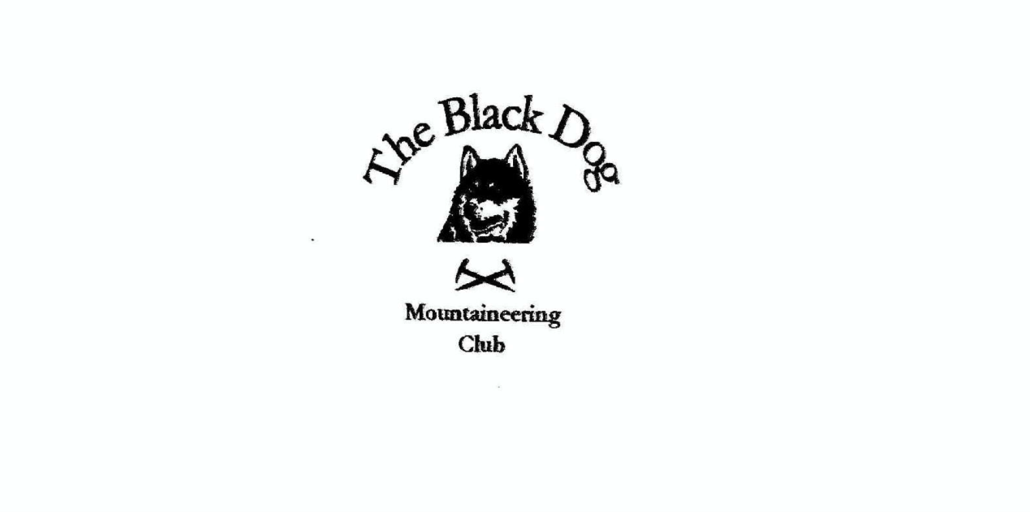

**Black Dog Meet**

**No. 265 Torridon**

Thursday 25th to Sunday 28th July 2024

**In Attendance**

Charles Alexander David Cameron

Owen Clark Bill Clark

Wull Clark Gerry Feeney

Val Inglis Elizabeth Kennedy

David Mackay Alan Sewell

Tony Smith James Yeats

# **Mountains Climbed**

**Friday:**

Alan & Charles Seana Mheallan (437m)

James       Beinn Liath Mhòr a' Ghiubhais Li (768m)

Liz & Gerry Meall a' Ghiubhais (887m)

Val, David & Wull Maoile Lunndaidh (1005m)

Tony Beinn na h-Eaglaise (South top 676m)

**Saturday:**

Alan Ben Shieldaig (534m) and An Staonach (516m)

James & Tony        Beinn Dearg (914m) and Stuc Loch na Cabaig (889m)

Liz & Charles Beinn Damh (903m)

Wull, David, Bill & Val Slioch (981m)

Owen & David M Maoile Lunndaidh (1007m)

**Sunday:**

Tony Meall an Tuirc (626m)

**Weather**

Generally, a very good weekend although there were showers and early mist.

**Notes / Highlights**

**Friday**

Alan

Charles and I climbed Seana Mheallan from the west, crossing the river Torridon and weaving our way up scrambly steps to the summit. We were rewarded with great views of the surrounding higher hills and a passing eagle.  
James  
I parked at the Torrandhu bridge on the A835 and followed the track roughly following the Abhainn an Torrain Dubh, after 2km I headed east up the southeast slope of Beinn Liath Mhòr a' Ghiubhais Li. The ground was rough grassy tussocks and heather most of the way with some stony ground near the summit. The return route was the same as the way up. The weather was bright and clear to begin with but rained for a short while later.

Gerry and Eliz

Set out to do Ruadh-stac Beag and Meall a' Ghiubhais from the Beinn Eighe Visitor Centre. The very steep boulders and scree close to the top of the former defeated us but we continued, in good visibility and generally pleasant conditions, to the top of the latter where we encountered a couple of very heavy showers. We had almost dried out by the time we got back to Gerry's car in the midge infested car park.

Wull, David and Valerie

Maoile Lunndaidh - Some clouds and a little rain around but altogether not a bad day and better than forecast. Walked in the usual route from Craig and had the hill largely to ourselves. Good views from the summit down into the Loch Monar area. A good day.

Tony

Starting from the Torridon hotel I walked a steep route up the east side of the river to join the main Coire Roill path (thus avoiding possible issues with crossing the river). Headed directly for the south top and returned via the main track to the hotel (bar).

**Saturday**

Alan

I climbed Ben Shieldaig and An Staonach from Glen Shieldaig. The weather was better than forecast and the views didn’t disappoint. The stalkers path shown on the map, although intermittent, is worth seeking out.

James and Tony  
Parked at the Beinn Alligin car park and followed the good path towards Horns of Alligin after this the path was wet and boggy to reach the bottom of Stuc Loch na Cabhaig. The climb up Stuc Loch na Cabhaig was steep and pathless for a lot of the way, but eventually reached the top. Fortunately, the weather cleared and we could see the path following the ridge to the top of Beinn Dearg. After a short discussion we decided to continue following the ridge east taking in the scrambling and down climb to reach the grassy bealach and a steep descent to the good stalkers path and back to the car park.

Charles and Liz

Climbed Beinn Damh in what looked initially to be rather misty weather. However, the sun came out and we had great views from the summit and on the descent. We rewarded ourselves with a coffee in the Torridon Hotel.

Wull, David, Bill and Val

Slioch - The walk in was through super high bracken well over head height and it's incredible that none of us got even one wee tick. Maybe the huge cattle lurking in the undergrowth had attracted them all. A few showers and windy and quite cold high up. Some mist on the summit but good views at the summit and along the ridge to the subsidiary top. Great day out.

Owen and David M

We set off in light rain using pushbikes to access the base of the mountain.  Weather improved greatly as we began our ascent to offer fantastic views from the ridge.

**Sunday**

Tony

A good circuit of the hills above Alness on the way home, principally to bag another Simm, initially aided by the wind farm road.

Owen

Set out for Fisherfield but access deteriorated into an 18km bike ride (up to the Loch and back) a ~1.5km bike push along the loch and a ~1km pannier carry to a vantage point. The vantage point showed very clearly that I was gaining no advantage.  There was not even an appealing campsite in view. Standing in my midge hat/net covered in cleggs looking out at unfriendly terrain it was clear that the effort to continue along the loch was greater than imagined. I decided that retreat was the best way forward.  Disappointed for sure but, given how my legs felt yesterday, the right thing to do.

*Tony*