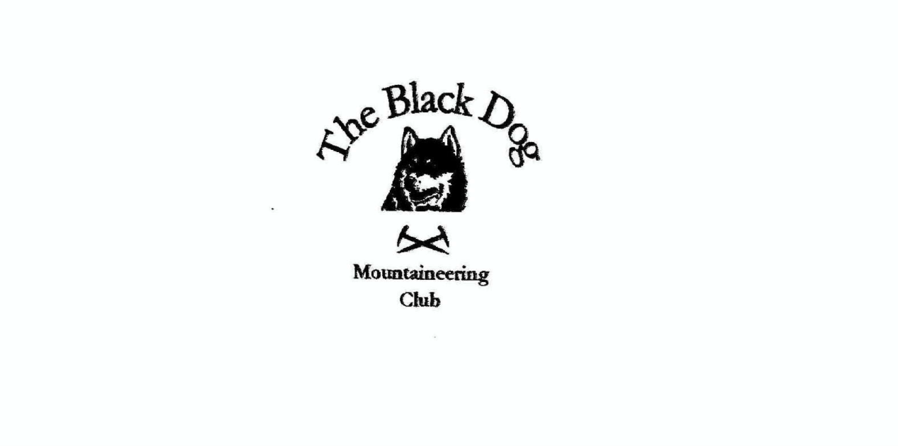

**Black Dog Meet**

**No. 266 Ratagan**

Friday 30th August to Sunday 1st September 2024

**In Attendance**

Charles Alexander David Cameron

Owen Clark Wull Clark

Gerry Feeney Val Inglis

Elizabeth Kennedy David Mackay

Alan Sewell Tony Smith

James Yeats

# **Mountains Climbed**

**Friday:**

Charles & Tony Meall Tarsuinn (659m)

Alan Burrach (605m)

James Beinn Tharsuinn (863m) and Sgùrr na Feartaig (862m)

Wull, David C & Val Stob a' Choire Mheadhoin (1105m) and Stob Coire Easain (1115m)

**Saturday:**

Charles & Tony Slat Bheinn (Skye) (627m)

Alan Meall nan Eun (667m) and Slat Bheinn (Knoydart) (701m)

Liz, Gerry & James Sgurr Gaorsaic (838m)

Wull, David C, David M & Val A' Chralaig (1120m) and Mullach Fraoch-choire (1101m)

Owen A' Ghlas-bheinn (918m)

**Sunday:**

Charles & Tony Meall an Uillt Bhain (607m)

**Weather**

A good weekend!

**Notes / Highlights**

**Friday**

Alan

I did the Graham, Burach, from Fort Augustus.

Valerie

A beautiful day out on the hill and hardly a soul in sight until later in the day. You forget just how far out along the ridge the second summit is, but it was worth it.

James  
Parked at the Craig carpark and cycled the 6km to stalkers path at the Allt a’Chonais, then followed the path to Bealach Bhearnais and up onto the ridge of Beinn Tharsuinn. From the summit I went back along the ridge back to the Bealach and picked up the old stalkers path to the top of Sgùrr na Feartaig. The route of the hill was the same as up back to Bealach Bhearnais and the Allt a’Chonais where I picked up the bike and cycled back to Craig car park. The weather was cloudy with a cold wind.

Tony

Good going initially on the track from Achnasaul then a long pull up the shoulder of Meall Coire nan Saobhaidh to contour round, as far as was possible, to the col for the final ascent.

**Saturday**

Alan

Knoydart was great – I had a big day on Meall nan Eun and Slat Bheinn - in glorious sunshine - absolutely stunning. I was pummelled by the time I got back to the car though.

Gerry

We set off from Morvich, followed the track through Gleann Choinnichean to the col, descended to Loch a Bhealaich then on to the summit from the east side of the loch.

Valerie

I had encouraged my friend Laura to join us with a view to bagging 2 of her remaining 4 Munros and we couldn't have asked for a better day. Hardly a cloud in sight, enough breeze to keep away the midges and prevent over-heating. The views into Glen Affric were wonderful - just a stunning and perfect day.

Tony

Headed over to Skye and round to Loch Slapin. Followed the Bla Bheinn path (as busy as ever) up before branching left for a loop over Slat Bheinn (away from the crowds).

Owen

Early start in good weather saw me gain height early in the day and have the hill mostly to myself.  Fantastic views all around as the day continued to improve and the late summer heat increase. Descent was longer than expected with little or no obvious path to follow before reaching Bealach na Sroine.  From the bealach the path returned and made for a swift return.

**Sunday**

Tony

Another Simm detour and the Kinloch Hourn road doesn’t get any easier. Path from Loch Coire nan Cnamh difficult to find and very boggy initially, otherwise a good if breezy walk.

*Tony*