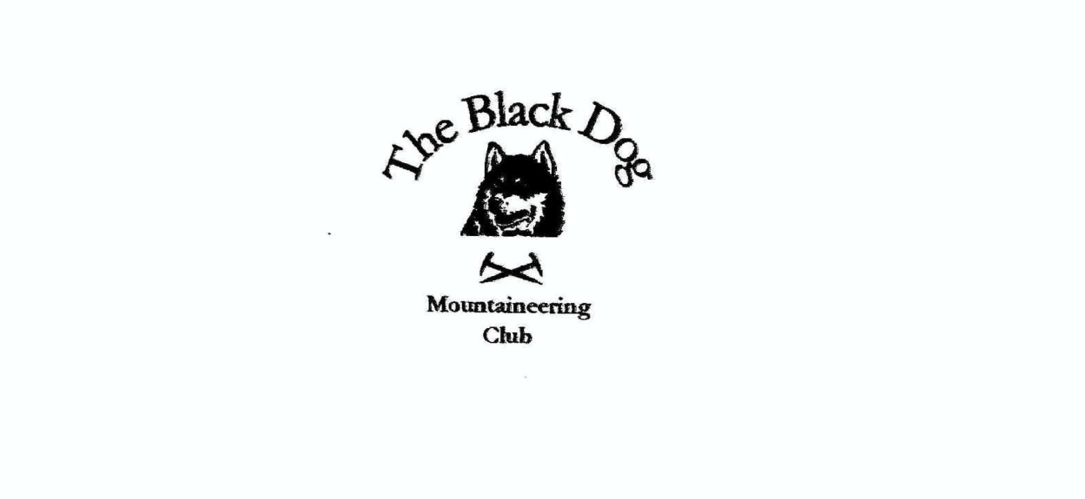

**Black Dog Meet**

**No. 267 Achmelvich**

Friday 20th – Sunday 22nd September 2024

**In Attendance**

James Yeats, David Cameron, Charles Alexander, Valerie Inglis, Wull Clark, Owen Clark, Gerry Feeney, Liz Kennedy and Alice Cottis (guest)

# **Hills Climbed**

**Friday**

Val & David C Glas Bheinn (776m)

Owen Ben Wyvis (1046m)

Gerry & Liz Cul Mor (849m) & Cul Beag (769m)

Charles Cul Mor (849m)

**Saturday**

James & Alice Arkle (787m)

Valerie, Gerry, Charles & Liz Beinn Leoid (792m) & Meallan a' Chuaill (750m)

Owen Glas Bheinn (Assynt) (776m)

**Weather**

Cloud inversion in places, but bright and clear further north.

**Notes / Highlights**

**Friday**

David and Val

On the Friday we climbed Glas Bheinn (776m) from Inchnadamph. The weather was very clear, and it was a nice temperature to walk in. There is a reasonable path most of the way. It is a bit boggy at the loch. There was a reasonable path up to the scree then it was a final push to the top.

Gerry, Liz and Charles

On Friday Charles Liz and Gerry met at Knockan Crag to climb Cul Mor. We were surprised to arrive in cool misty conditions with a stiff breeze. Fortunately, the mist lifted, and the breeze abated as we started to gain height. The opposite of what normally happens! We were rewarded with sunshine and panoramic views when we reached the summit.

We retraced our steps back to the cars. Charles left to have a relaxing afternoon while Liz and Gerry headed round to Linnerainech to climb Cul Beag. It was tough going until we found a path which took us steeply up to the summit. We returned to the car by way of the path.

Owen

Achmelvich

Deer cleggs in the sky

Winged ticks that fly

No time to pause

Within reach of their jaws

To outrun them or cry

Climbed Ben Wyvis. Late start on the hill; too late to get a space in the carpark and as a result had to set off from the parking space ¼ mile further north. Weather was fantastic as was the path up the hill. Met quite a few walkers descending as I hit the steep part. Soon at the top enjoying the views. A nice short day of only 4.5 hours.

**Saturday**

James and Alice

Parked at the carpark and followed the track to the derelict cottage and the pinewood plantation beyond to gain the Meall Aonghais ridge. From the plateau cairn at 758m there is a steep descent to reach the final narrow ridge to Arkle summit with great views all round. We returned by the same route. Nice bright day with cloud inversion to the south.

Valerie, Gerry, Charles and Liz

Set off from the start point south of Loch More. We set off in misty conditions and although the sun kept threatening to break through, it wasn't until we were well up the Graham, Meallan a' Chuaill before it broke through. We descended back into the cloud then back up to reach the summit of Beoin Leoid, again we found ourselves back in the sunshine. We descended back to the col and by way of careful navigation took a more direct route back to the cars

Owen

Climbed Glas Bheinn (Assynt). The walk up the glen on a suggestion of a path began in the sun. Beautiful views back towards Quinag. My route took me round to the Northeast of the hill before reaching a bealach on a stalkers path. From the bealach a short pull to the broad summit. Descent was directly back to the starting point; a short route fortunately as the deer cleggs were out in numbers.

The hostel is in a gorgeous location, although it was a bit chaotic as they were building a new car park, needed really. Another place that is going to be a victim of its own success, as it was overrun by NC500 users and the caravan site.

Also, there was a bit of Modern-Day Highway Robbery going on as we were getting charged £5.00 a night to park on the farmer’s land.

*James*

**Next Meet**

Great Glen 18th to 20th October

Meet organiser – James