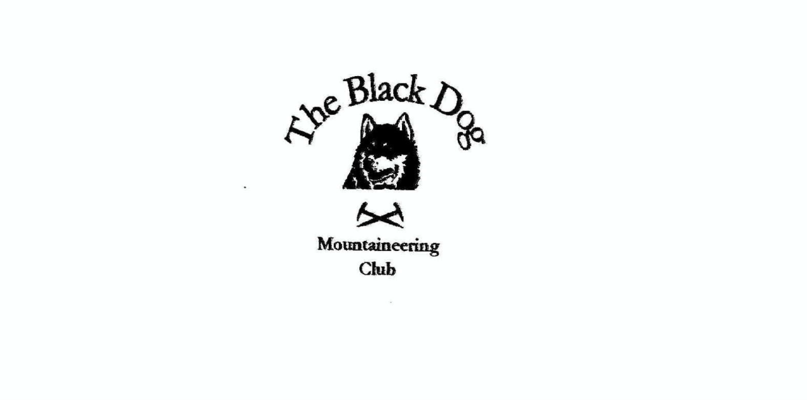

**Black Dog Meet**

**No. 269 Moffat**

Friday 15th to Sunday 17th Nov 2024

**In Attendance**

David Cameron Val Inglis

Alan Sewell Lorna Smith

Tony Smith James Yeats

John McGill Charles Alexander

# **Mountains Climbed**

**Friday:**

Lorna, Charles & Tony       Great Hill (466m) & Chalk Rig Edge (500m)

Alan Herman Law (614m) & Trowgrain Middle (628m)

Val & David Hart Fell (808m), Saddle Yoke (735m) , Under Saddle Yoke (745m)

**Saturday:**

Lorna, Charles, Valerie, David

& Tony   Broad Law (840m), Cramalt Craig (830m), Hunt Law (639m) & Birkside Law (594m)

James & Alan Nether Coomb Craig (724m), Swatte Fell (729m), Falcon Craig (724m), Hart Fell (808m), Under Saddle Yoke (745m), Saddle Yoke (735m)

John Well Hill (606m)

**Sunday:**

Lorna, Charles & Tony     Castle Hill (483m)

Charles & Tony               Craighead Hill (429m)

James Broad Law (840m)

John Green Hill (588m)

**Weather**

A mixed weekend. Showery, windy and cloudy on Fri and Sat. Sunday was a frosty clear blue sky day.

**Notes / Highlights**

**Friday**

Lorna, Charles and Tony

We parked just by the Devil's Beef Tub and walked part of the Annandale Way along the ridge which eventually leads to Hart Fell. Rather misty conditions obscured much of the view but the Tub itself is quite impressive looking steeply down from the path.

Alan

After flying in from Malaga in the morning, I climbed Herman Law and Trowgrain Middle from the top of the A708 at Birk Hill. Hills were clagged-in and a bit moist.  
  
Val and David  
David and I climbed Hart Fell from Saddle Yoke. Steep, muddy and slippy ascent and a long walk in thick mist to the summit. Decided not to do the full circuit in the murky conditions.

**Saturday**

Lorna, Charles, Valerie, David & Tony

This was a good anticlockwise 10 mile loop starting up the Landrover track from Hearthstane Farm to the summit radar station (which looked like something out of ET through the thick mist as we approached). We paused briefly at the trig to add extra layers to combat the cold damp wind before heading NE skirting Polmont Craig towards Cramalt. After the short detour to the summit (in case Valerie decides to bag Donalds one day) we continued on a mix of tracks and short grass to the remaining hills. A new unmarked track aided our descent to Polmont Burn which we crossed on a new bridge to join the estate road back to our start point..

Alan and James

Walked the Hart Fell ridges horseshoe taking in the Corbett two Donalds and three Donald Tops. We parked at Blackshope Farm and headed across the field to the Hang Burn ravine. The path at this point was extremely slippery but improved as the sloped eased as we reached the plateau at the Donald Top, Nether Coomb Craig. We had to take a slight detour to gain Swatte Fell and on to Falcon Craig enroute to Hart Fell. We followed the fence line round to the ridge of Upper Saddle Yoke and Saddle Yoke and back down to the car. The weather was cold with occasional drizzle spells with strong winds.

John

So called Graham Well Hill following the fence line up to the summit in less than 1 hour.

Val kindly organised a meal for us all at the local Italian restaurant (Claudio’s) in Moffat. This proved to be very good and is highly recommended. It may be worth considering this for future Xmas meets in the event Braemar is unavailable.

**Sunday**

Lorna, Charles and Tony

Given the great weather conditions we stopped, firstly in Crawford and then Abington, to add a couple of smaller hills on the way home.

James

Parked at the Megget Stone and followed the fence line to the top of Broad Law. Came back the same way. The ground was frozen but weather clear and cold. Very short day 2 hours.

John

Marilyn Green Hill from Wanlockhead. Barely an hour up and down. Original target was not accessible from chosen start point, fence with barbed wire.

Alan

**Next Meet**

*13th-15th Dec Braemar (meet organiser Val)*