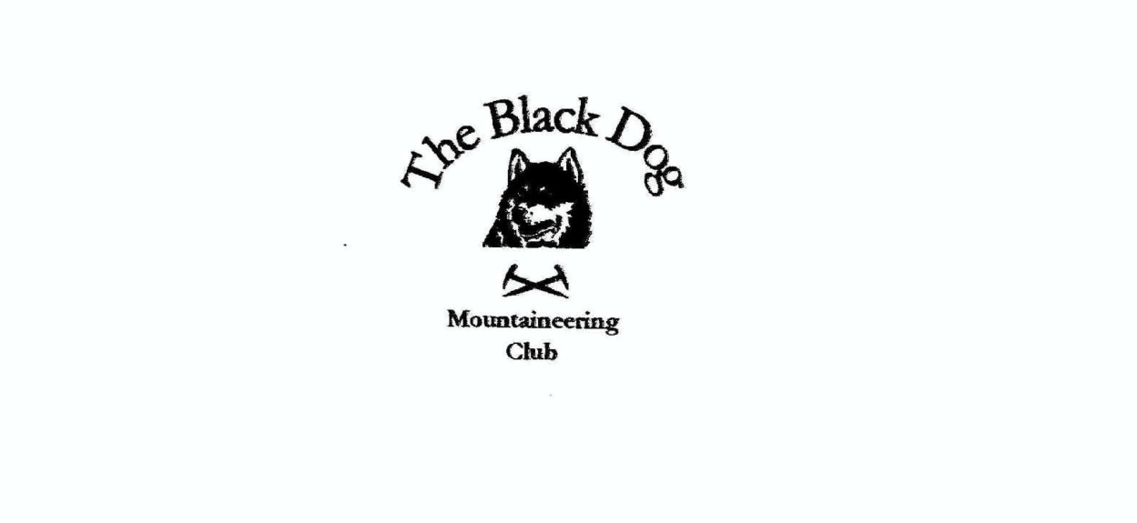

**Black Dog Meet**

**No. 262 Skye**

**Friday 10th – Sunday 12th May 2024**

**In Attendance**

Alan Sewell, David Cameron, Wull Clark, Valerie Inglis,

Richard Marwood, Ruth Marwood, James Yeats, Kevin Hill (Guest)

# **Hills Climbed**

**Friday**

Val, Wull, Alan & David: Am Basteir (934m), Bhasteir Tooth (917m), Bruach na Frithe (958m)

James: Beinn nan Caorach (774m), Beinn na h-Eaglaise (805m)

**Saturday**

James: Garbh Bheinn (808m), Belig (702m)

Valerie, Wull, Alan &David Inaccessible pinnacle (Sgurr Dearg) (986m)

Kevin: Sgurr MhicCoinnich (948m)

Richard & Ruth: Preshal Beg (Tump) 345m

**Sunday**

James: Sgurr Mhic Bharraich (779m)

Richard & Ruth: Ben Tianavaig (413m)

**Weather**

Good sunny spells with a strong breeze.

**Notes / Highlights**

**Friday**

**Valerie, Wull, Alan and David:**

**Val -** I went to Skye hopeful to get the last of the Cuillin for my 4th round of the Munros. Alan had very kindly offered his services to help me with Am Basteir and the Inn Pin.

David, Wull, Al and I stayed at Carbost on the Thursday night for an early start on the Friday.

Thanks to Al, with his skill, expertise and encouragement we had a smashing day on Am Basteir, the Basteir Tooth and Bruach na Frithe. It was ideal weather and there weren't too many folk around for the walk in from Sligachan and the ascent to the ridge. The notorious 'bad step' en route to the summit was made easier with the use of a rope and guidance from Alan and Wull (who went over the edge first for the down climb), and Am Basteir was the first summit of the day. This was followed by our first abseil and the walk round for the ascent of the Tooth. A grand place to stop for lunch. Probably the most difficult part of the day (for me anyway) was the descent through King's Cave - not much to hold on to and slimy wet rock deep inside the cave. But we all got through fine and prepared for the last abseil of the day down to the base of the chimney. Great fun.

As it was still early and the sun was shining, we carried on to the summit of Bruach na Frithe, before the walk back to Sligachan and the Inn for a few well earned beers.

**James:**

Parked at Corran and started the walk by following the track along the River Arnisdale to a track leading towards Beinn nan Caorach. From the top was an easy walk across the Druim nam Bo ridge and a short climb up to Beinn na h-Eaglaise. The route down followed an old fence line through a gully which was rough going back to the track on the route out with only 1km back to the car park.

**Saturday**

**Richard & Ruth:**

Richard and Ruth walked a 6 – 7 hour “rugged circuit, a real adventure” from nearby Talisker hamlet up to the highest part of the Minginish coastal cliffs. Then summiting Preshal Beg (345m), an outcrop remarkable for its Ayers Rock (Uluru) like appearance, and its extensive hexagonal basalt columns, reminiscent of Staffa. High winds were troublesome, but the recent spell of dry weather made this potentially very boggy and slippy journey a delight underfoot.

**Valerie, Wull, Alan and David:**

**Val -** we all set out early for the Inn Pin. Nerves made me feel pretty sick to be honest, and the climb to the base of the Pin was tough going. Luckily when we got there, there was no queue, so no time to think about it any more. Alan climbed up in no time to make it safe for the 3 of us to go together. With my eyes glued on the rock in front of me, we made it safely to the first belay point and then on to the summit. The abseil off was magic and I was super relieved to get back on to safer ground.

Massive thanks to Al who made it possible. Total superstar and with the patience of a saint. I did say there wouldn't be a 5th round of Munros after it - but who knows how the memory may fade in another few years.

**James:**

Set off from the lay-by near the Eas a Bhradain waterfall and crossed the boggy moorland towards the Druim Eadar Da Choire ridge leading to the ridge of Garbh Bheinn which narrows and becomes a bit rocky which requires some easy scrambling to get to the top. The route down required some more scrambling and scree to Bealach na Beiste. The route up Belig followed a drystone dyke to the top. Great views from the top, followed the ridge down and across the moorland back to the car park. The strong wind kept the temperature down as it was a hot sunny day.

**Kevin:**

Kevin had a good day on Sgurr MhicCoinnich from Coire Laggan. He had to dash back home afterwards to fix a couple of cars!

**Sunday**

**James:**

Started from the Shiel Bridge car park, following the Gleann Undalainn track to a cairn at Loch Coire nan Crogachan. Heading north from this point across the rough ground to reach the top of Sgurr Mhic Bharraich. From the top I headed east straight down the hill to meet up with the Gleann Undalainn track

**Richard & Ruth:**

Had a beautiful walk from sea-level at Braes (where we witnessed a very large search and rescue situation in progress – missing person, outcome unknown) climbing the dramatic escarpment next to sea cliffs to summit Ben Tianavaig. Great views all round. Much recommended.

**Monday**

**Richard & Ruth:**

Went by boat (The Misty Isle – excellent) from Elgol to Coruisk. Full circuit of Loch Coruisk. Immaculate. Midges already coming out in early evening, and it was only 13th May.

**Summary Comments**

A disappointing turn out for this meet, with numerous cancellations. 16 bunks booked originally with only 8 attendees in the end.

[Skye photos](https://www.flickr.com/photos/190421987@N07/albums/72177720317736897)

Alan